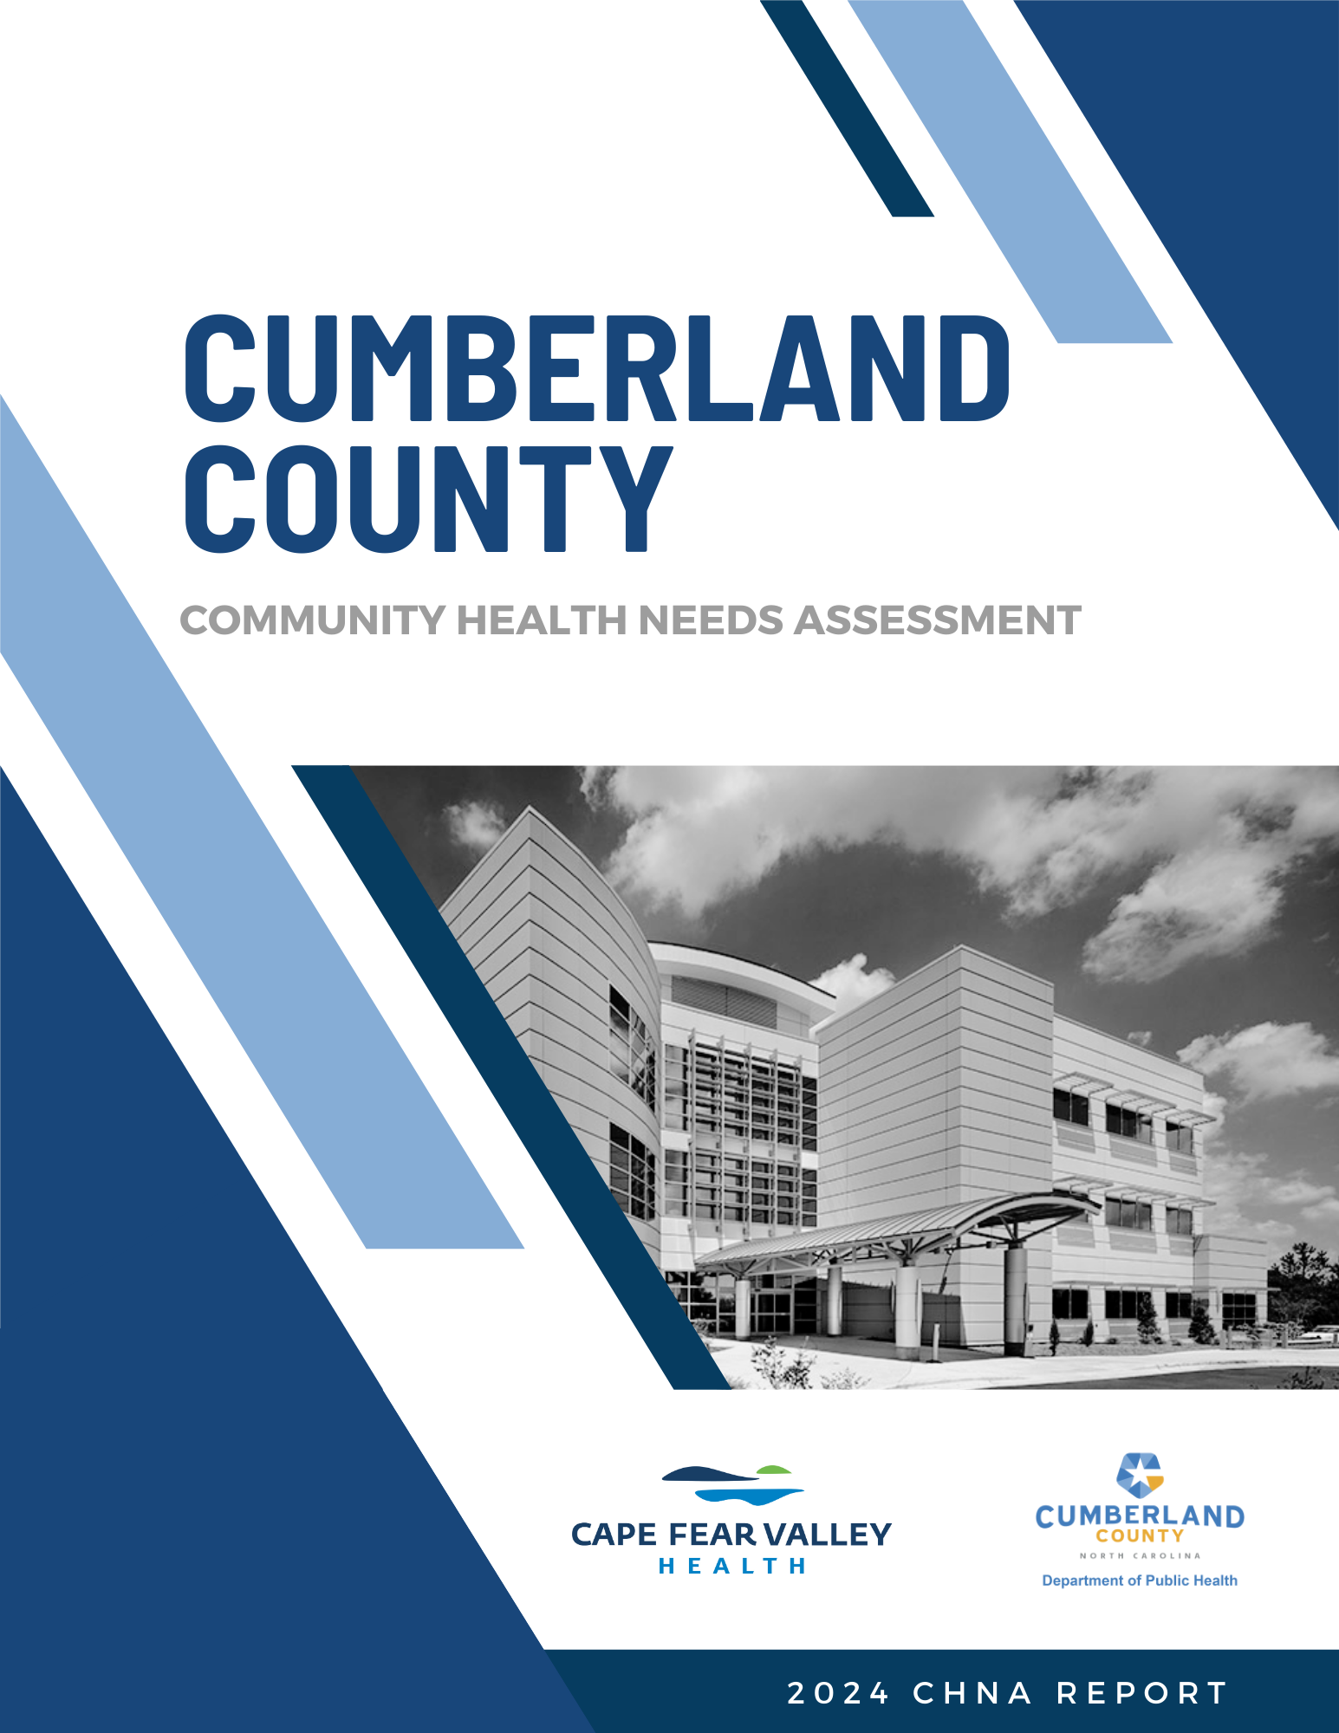

Cumberland County
2024 Community Healteeds Assessment

ACKNOWLEDGEMENTS

This Community Health Needs Assessment (CHNA) represents the culmination of work completed by multiple individuals and groups. Health ENC – a group of stakeholders who help find ways to collaborate and share resources to improve the health of the population in eastern North Carolina – served an integral role in making this comprehensive assessment possible. To provide focused guidance throughout the assessment process, Health ENC convened a smaller decision-making group, which will be referred to as the Steering Committee throughout this CHNA. The Steering Committee would like to extend its gratitude to all the focus groups participants, health leaders, and community members who provided information used in the development of this assessment.

The Health ENC CHNA Steering Committee

Name | Title | Organization
Lorrie Basnight | Executive Director | Eastern Area Health Education Center (AHEC)
Amanda Betts | Public Health Education Coordinator | Albemarle Regional Health Services (ARHS)
April Culver | Vice President, External Affairs | University of North Carolina Health Johnston
Caroline Doherty | Community Health Consultant | Roanoke Chowan Community Health Center (RCCHC)
Laura Ellis | Health Education | Halifax County Health Department
Sandra McMasters | Community Benefit Project Manager | Sentara Health
Claire Mills | Director | Eastern AHEC
Emmanuelle Quenum | Health Education Director | Greene County Department of Public Health (DPH)
Rose Ann Simmons | Administrator, Community Health Improvement | East Carolina University Health
Michelle Wagner | Public Health Educator | Dare County Department of Health & Human Services (DHHS)

In addition to the Steering Committee, the Cumberland County 2024 CHNA was developed in partnership with representatives from Cumberland County Department of Public Health and Cape Fear Valley Health System.

Cumberland County CHNA Stakeholders

Special acknowledgements go to the Cumberland County Center of NC Cooperative Extension and Fayetteville State University for their support in identifying priority populations, survey distribution and focus group participation. We would also like to acknowledge the support of some of our partners in assisting with survey distribution, including the Cumberland County Public Libraries, Stedman-Wade Health Services, Inc., Partnership for Children, Cumberland County HIV Task Force, Inc., Mid-Carolina Regional Council, Tokay Senior Fitness Center, Bill Crisp Senior Center, local churches, and many others.

Additional acknowledgements to key community stakeholders and organizations who contributed to priority selection and assessment review:

Contributing Organizations
Alliance Health
Cape Fear Valley Health System
Cape Fear Valley Health System
Cape Fear Valley Health Transformers Group
City of Fayetteville
Cool Spring Downtown District
Cumberland County Board of Commissioners
Cumberland County Board of Commissioners
Cumberland County Department of Public Health
Cumberland County Department of Public Health
Cumberland County Department of Public Health: Health Education Division
Cumberland County Emergency Management
Cumberland County Schools
Cumberland HealthNET
Fayetteville Fire Department
Justice Services
Fayetteville Senior Center East
Marius Maximus
Piedmont Health Services and Sickle Cell Agency
Stedman-Wade Health Services
Town of Linden
Town of Stedman
Town of Wade

We also would like to thank the many individuals who responded to the 2024 Cumberland County Community Health Needs Assessment and participated in focus groups. The goal was to gather the opinions of residents and take this perspective into consideration when choosing health priorities and using statistical data to develop the upcoming Community Health Improvement Plan.

In addition, the Steering Committee would like to thank Ascendient Healthcare Advisors for directing the CHNA process and developing the content of this report.

TABLE OF CONTENTS

ACKNOWLEDGEMENTS i
TABLE OF CONTENTS iii
EXECUTIVE SUMMARY 1
INTRODUCTION 4
Background 4
Timeline 6
Process Overview 7
Report Structure 8
Evaluation of Prior CHNA Implementation Strategies 9
Summary Findings: Cumberland County 2024 Priority Health Need Areas 15
CHAPTER 1 | METHODOLOGY 17
Study Design 17
New (Primary) Data 17
Existing (Secondary) Data 17
Comparisons 18
Population Health Framework 18
Prioritization Process Overview and Results 20
Study Limitations 22
CHAPTER 2 | COUNTY PROFILE 24
Geography 24
Population 24
Age and Sex Distribution 25
Race and Ethnicity 26
Economic Indicators 29
Social Determinants of Health 31
CHAPTER 3 | PRIORITY NEED AREAS 40
Priority Need: Behavioral Health (Mental Health & Substance Use) 40
Context and National Perspective 40
Secondary Data Findings 43
Primary Data Findings – Community Member Web Survey 44
Primary Data Findings – Focus Groups 47
Priority Need: Maternal & Infant Health 48
Context and National Perspective 48
Secondary Data Findings 49
Primary Data Findings – Community Member Web Survey 49
Primary Data Findings – Focus Groups 51
Priority Need: Physical Health 52
Context and National Perspective 52
Secondary Data Findings 53
Primary Data Findings – Community Member Web Survey 55
Primary Data Findings – Focus Groups 57
CHAPTER 4 | HEALTH RESOURCE INVENTORY 59
CHAPTER 5 | NEXT STEPS 63
APPENDIX 1 | STATE OF THE COUNTY HEALTH REPORT 64
Results-Based Accountability Framework 64
APPENDIX 2 | SECONDARY DATA METHODOLOGY AND SOURCES 70
Methodology 70
Data Sources 71
APPENDIX 3 | SECONDARY DATA COMPARISONS 92
Description of Focus Area Comparisons 92
Detailed Focus Area Benchmarks 93
APPENDIX 4 | PRIMARY DATA METHODOLOGY AND SOURCES 100
Methodologies 100
Focus Groups 100
Community Member Web Survey 102
APPENDIX 5 | DETAILED PRIMARY DATA FINDINGS 114
APPENDIX 6 | SUMMARY OF DATA FINDINGS ACROSS SOURCES 138

EXECUTIVE SUMMARY

A Community Health Needs Assessment (CHNA) helps health leaders evaluate the health and wellness of the community they serve and identify gaps and challenges that should be addressed through new programs, services and policy changes. This report was created in compliance with North Carolina Local Health Department Accreditation standards, as well as Internal Revenue Service requirements for not-for-profit hospitals.



Several local health organizations came together to help develop this CHNA, including Cumberland County Health Department and Cape Fear Valley Health System.

Secondary (existing) data is an important piece of the CHNA process. Secondary data was identified and sourced from external data sources, including the Centers for Disease Control and Prevention (CDC) and the North Carolina Data Portal. These external datasets provide a valuable and robust collection of public health indicators that were compiled and examined to identify common themes and trends. The Population Health Model was used as a framework to examine the health factors and outcomes that influence the well-being of the community. This model allows for a comprehensive view of how various determinants of health contribute to overall health status, and it was particularly useful in identifying key areas for intervention. Key categories and focus areas were defined to guide our understanding of the county’s priority health needs. These categories include:
- Length of Life
- Quality of Life
- Clinical Care
- Health Behaviors
- Physical Environment
- Social & Economic Environment

Each data measure was also compared to state or national benchmarks to identify areas of specific concern for Cumberland County. Top community needs identified through secondary data analysis included:
- Behavioral Health: Mental Health
- Community Safety
- Diet & Exercise
- Employment & Income
- Family, Community & Social Support
- Food Access & Security
- Healthcare: Access & Quality
- Length of Life
- Maternal & Infant Health
- Physical Health (Chronic Diseases, Cancer, & Obesity)
- Sexual Health
- Tobacco Use
- Transportation & Transit
Primary (new) data were collected through focus groups and a web-based survey for community members, and included feedback from 1,258 people who live, work or receive healthcare in Cumberland County. A total of four focus groups were conducted, either virtually or in person, with a variety of community members from different backgrounds, age groups and life experiences. Primary data identified behavioral health (specifically mental health), employment and income, healthcare access and quality, and physical health (chronic diseases, cancer, obesity) as top needs that impact the health and well-being of people living in Cumberland County.
Representatives from Cumberland County worked together to identify the priorities the county should focus on over the following three-year period. Leaders evaluated the primary and secondary data collected throughout the process to identify needs based on the size and scope, severity, the ability for hospitals or health departments to make an impact, associated health disparities, and importance to the community. Although it was not possible for every single area of potential need to be identified as a priority, Cumberland County selected three top priority health needs (Behavioral Health – Mental Health & Substance Use, Maternal and Infant Health, and Physical Health), which are shown here in alphabetical order:
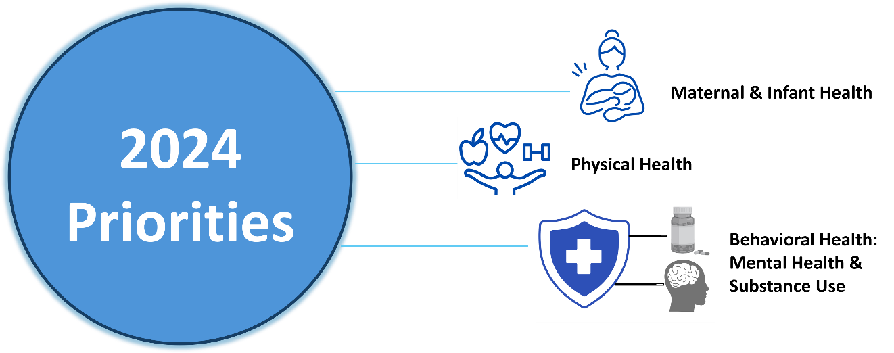
These priorities have been identified as significant by the Board of Health based on an assessment of community needs, stakeholders' input, and public health data.
- Cumberland County Department of Public Health 2023-2027 Strategic Plan
Cumberland County also compiled a Health Resources Inventory, which describes a variety of resources available to help Cumberland County residents meet their health and social needs.
Following completion of this report, health leaders throughout Cumberland County will utilize the findings of the Community Health Needs Assessment to collaborate with community organizations and local residents to develop effective health strategies, new implementation plans and interventions, and action plans to improve the communities they serve.

INTRODUCTION

Background
To illustrate its commitment to the health and well-being of the community, the Health ENC CHNA Steering Committee has completed this assessment to understand and document the greatest health needs currently faced by local residents. Guidance was also provided by local representatives from Cumberland County Health Department and Cape Fear Valley Health System. These organizations helped gather the focus group and survey data that are detailed in this report. The CHNA process helps local leaders continuously evaluate how best to improve and promote the health of the community. It builds upon formal collaborations between the Steering Committee and other community partners to proactively identify and respond to the needs of Cumberland County residents.

This report was created in compliance with the State of North Carolina’s Local Health Department Accreditation (NCLHDA) Board’s accreditation standards. The accreditation process allows local health departments to assess how they are meeting national and state-specific standards for public health practice and provides opportunities to address any identified gaps. It also ensures that local health departments have the ability to deliver the 10 essential public health services, as described in Figure I.1 below. In its demonstration of data and prioritization of Cumberland County’s community needs, this report aligns with all NCLHDA standards for accreditation, including the need to:

- Provide evidence of community collaboration in planning and conducting the assessment;

- Reflect the demographic profile of the population and describe socioeconomic, educational and environmental factors that affect health;

- Assemble and analyze secondary data to describe the health status of the community;

- Collect and analyze primary data to describe the health status of the community;

- Use scientific methods for collecting and analyzing data, including trend data to describe changes in community health status and in factors affecting health;

- Identify population groups at risk for health problems;

- Identify existing and needed health resources;

- Compare selected local data with data from other jurisdictions; and

- Identify leading community health problems.

Figure I.1: The 10 Essential Public Health Services

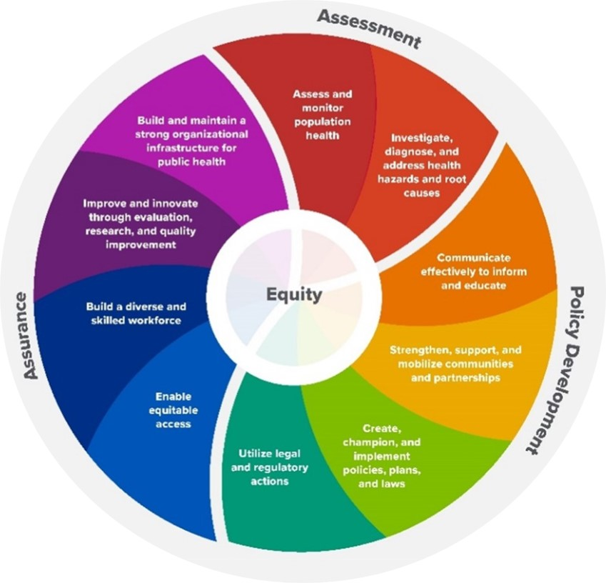

Further, this process complies with Internal Revenue Service (IRS) requirements for not-for-profit hospitals to complete a CHNA every three years to maintain their tax exemption. Specifically, the IRS requires that hospital facilities do the following:

- Define the community it serves;

- Assess the health needs of that community;

- Through the assessment process, take into account input received from people who represent the community’s broad interests, including those with special knowledge of or expertise in public health;

- Document the CHNA in a written report that is reviewed and adopted by the hospital facility’s authorizing body; and

- Make the CHNA widely available to the public.

Timeline
The Health ENC 2024 CHNA process for all participating counties, including Cumberland County, began in January 2024 with the convening of the Steering Committee and continued throughout the year. The process concluded in December 2024 with the delivery of final CHNA reports. A high-level summary of activities conducted throughout the year can be found in Figure I.2 below.
Figure I.2: Health ENC 2024 CHNA Milestones
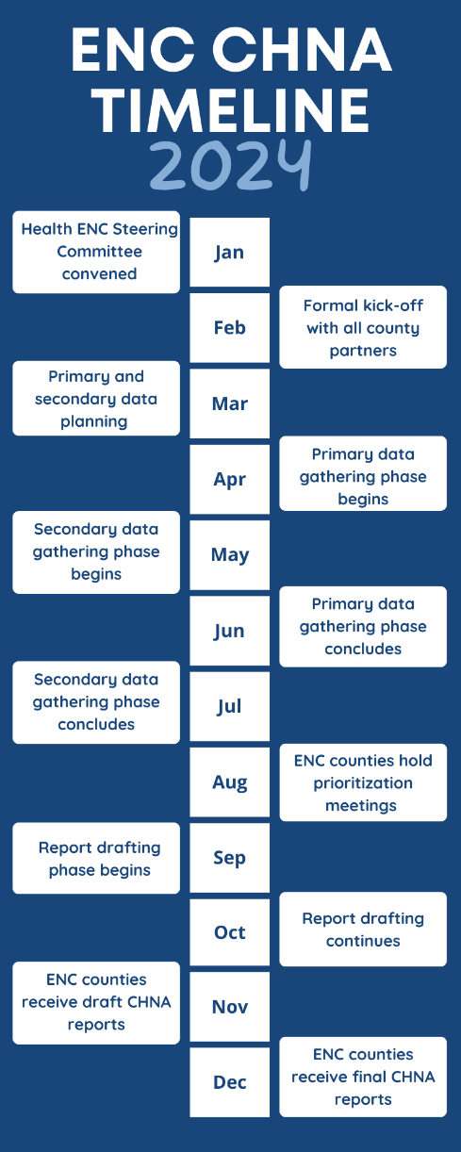

Process Overview
A significant amount of information has been reviewed during this planning process, and the Steering Committee has been careful to ensure that a variety of sources were used to deliver a truly comprehensive report. Both existing (secondary) data and new (primary) data were collected directly from the community throughout this process. It is also important to note that, although unique to Cumberland County, the sources and methodologies used to develop this report comply with the current NCLHDA and IRS requirements for health departments and not-for-profit hospital organizations.

The purpose of this study is to better understand, quantify, and articulate the health needs of Cumberland County residents. Key objectives of this CHNA include:

- Identify the health needs of Cumberland County residents;

- Identify disparities in health status and health behaviors, as well as inequities in the factors that contribute to health challenges;

- Understand the challenges residents face when trying to maintain and/or improve their health;

- Understand where underserved populations turn for services needed to maintain and/or improve their health;

- Understand what is needed to help residents maintain and/or improve their health; and

- Prioritize the needs of the community and clarify/focus on the highest priorities.

There are ten phases in the CHNA process, as described in Figure I.3 below. Results of the first seven phases are discussed throughout this assessment and the development of community health action plans and subsequent phases will take place after the completion of the CHNA report.

Figure I.3: The CHNA Process

CHNA

Report Structure
The outline below provides detailed information about each section of the report.

- Methodology – The methodology chapter provides an overall summary of how the priority health need areas were selected as well as how information was collected and incorporated into the development of this CHNA, including study limitations.

- County Profile – This chapter details the demographic (such as age, gender, and race) and socioeconomic data of Cumberland County residents.

- Priority Health Need Areas – This chapter describes each identified priority health need area for Cumberland County and summarizes the new and existing data that support these prioritizations. This chapter also describes the impact of health disparities among various sub-groups in Cumberland County.

- Health Resource Inventory – This chapter documents existing health resources currently available to the Cumberland County community.

- Next Steps – This chapter briefly summarizes the next steps that will occur to address the priority health need areas discussed throughout this document.

In addition, the appendices discuss all of the data used during the development of this report in detail, including:

- State of the County Health Report – Detailed information about actions taken to address the priority health needs identified in previous CHNAs are presented in Appendix 1.

- Detailed Summary of Secondary Data Measures and Findings – Existing data measures and findings used in the prioritization process are presented in Appendices 2-3.

- Detailed Summary of Primary Findings – Summaries of new data findings from community member surveys as well as focus groups are presented in Appendices 4-5.

Evaluation of Prior CHNA Implementation Strategies

A CHNA is an ongoing process that begins with an evaluation of the previous CHNA. In 2021, Cumberland County completed its previous assessment. Associated implementation strategies focused on four priority areas, as listed below:

Figure I.4: Cumberland County 2024 Priority Need Areas
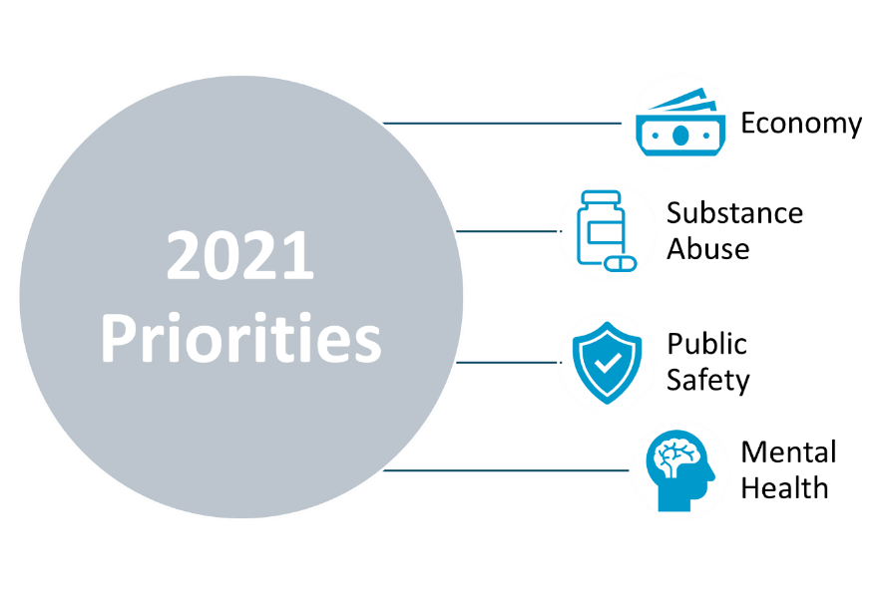

Local organizations developed goals and implementation plans to address these priority health needs. Below are brief summaries of each organization’s most recent CHNA implementation plans.

Cape Fear Valley Health System – Cape Fear Valley Medical Center
At Cape Fear Valley Health System (CFVHS), the goal is to improve the quality of every life touched by providing exceptional healthcare for all patients. To achieve that, CFVHS’s doctors, surgeons and staff are committed to excellence in every aspect of the healthcare process. CFVHS’ values of patient-centeredness, integrity, innovation, teamwork, diversity, accountability, and education help create a better experience for every patient, every time. System medical facilities include Cape Fear Valley Medical Center, Highsmith-Rainey Specialty Hospital, Cape Fear Valley Rehabilitation Center, Behavioral Health Care, Bladen County Hospital, Hoke Hospital, Central Harnett Hospital, Betsy Johnson Hospital, as well as several medical offices and clinics spread throughout the Cape Fear region. The doctors at CFVHS proudly serve a seven-county region of southeastern North Carolina, including Fayetteville, Fort Liberty, Hope Mills, Raeford, Lumberton, Elizabethtown, Clinton, Lillington, Dunn, and beyond. CFVHS provides exceptional medical care, serving more than 1 million patients annually – each of whom is treated to knowledgeable, personal care.

Cape Fear Valley Medical Center (CFVMC) opened in 1956 and has since grown into a robust medical center specializing in cardiac care, cancer treatment, surgical services, neuroscience, pediatrics, rehabilitation, orthopedics, imaging, and more. CFVMC also boasts a full-service Family Birth Center and a Level-III Neonatal Intensive Care Unit (NICU). In addition, over 50 ambulatory clinics specializing in primary care, internal medicine, and other specialties serve the population of Cumberland County and beyond. From pediatrics to geriatrics, CFVMC’s physicians are proud to serve the members of their community – at every age and stage of life.

Cumberland County Health Department

The Cumberland County Health Department (CCHD) is guided by its mission to provide high-quality service in a professional, efficient, and fiscally responsible manner while improving the health of the community. In addition to tracking and monitoring disease outbreaks, CCHD offers a range of social and clinical services, including food access programs, transportation resources, family/maternity planning, immunizations, early childhood support, and health education. CCHD also operates a medical laboratory, a pharmacy, and several clinics specializing in care areas ranging from epidemiology to child health to teen wellness to sexually transmitted infections. Patients can receive medical screenings and diagnoses, treatment, and any necessary counseling at these specialty clinics.

Previous CHNA Priority: Economy

- NC MedAssist Over the Counter Medicine Program: CFVHS participated in the NC MedAssist Over the Counter Medicine Program. NC MedAssist aims to eliminate the barriers for homebound patients who would like to participate in a scheduled Mobile Free Pharmacy event by providing a process to select over-the-counter medicine items without physically attending the event. Over-the-counter medications available through NC MedAssist include allergy, cough, cold, pain relief, vitamins, and children’s medications.
- Emergency Rental Assistance Program: Cumberland County and The City of Fayetteville launched the Emergency Rental Assistance Program (ERAP) to distribute federal funds received through Consolidated Appropriations Act of 2021. Allocated funds aid eligible residents unable to meet housing and utility payments as a result of economic constraints from COVID-19 pandemic. Through this collaborative effort between the city and county, many families participating in ERAP will progress toward greater household stability and gain access to resources that help meet their basic needs.

Previous CHNA Priority: Substance Use

- Opioid Stewardship Program: CFVHS has established a system-wide Opioid Stewardship Program which exists to reduce opioid use, decrease harm related to opioid use, and identify patients with potential opioid use disorders. These goals are met by educating patients, identifying and monitoring high risk patients, systemic screening, and providing alternative treatment options. Ordering practices of physicians are monitored regularly and alternatives for pain control are offered in the Emergency Departments. Kits are provided through the outpatient pharmacy to dispose of opioids safely. Additionally, safe drug disposals are located at CFVHS pharmacies for prescription take-back during operating hours. Narcan is available for use on EMS Transport Vehicles. CFVHS has established several community partnerships to address substance use issues in the area such as Fighting Addiction through Community Empowerment Teams with Southeastern Regional Area Health Education Center (SRAHEC) & Cumberland-Fayetteville Opioid Response Team (C-FORT).
- Peer Support Specialists: In May of 2023, CFVHS Emergency Departments implemented Peer Support Specialists. These specialists interact with emergency department patients who have existing drug and/or alcohol issues to help patients identify community assets. Training modules are being developed for healthcare professionals for prescribing opioids for pain based on recent CDC guidelines.
- Cumberland-Fayetteville Opioid Response Team: C-FORT was established to improve the opioid response in the Fayetteville and Cumberland County areas. Through a collaborative effort among local government and community stakeholders, the Cumberland-Fayetteville Opioid Response Team’s overall goals are to launch a treatment center focused on supporting community members battling opioid addiction, establish a recovery response center, and build a strong, effective coalition. C-FORT is committed to identifying strategies that will address the opioid crisis while creating a sustainable, long-term community response.
- Medication Assisted Treatment Program: The Cumberland County Department of Public Health and the Cumberland County Detention Center collaborated to develop the Medication Assisted Treatment (MAT) Pilot Program. The purpose of this program is to provide individuals currently detained and in recovery with access to medication that supports their recovery from substance use disorders or other addictions that require maintenance medication. A Licensed Clinical Social Worker and a Peer Support Specialist work to support individuals while incarcerated and following discharge. Staff provide assistance with reentry for individuals transitioning back into the community. Further assistance is provided to help individuals continue MAT with their provider, maintain access to human services, utilize the Cumberland County Recovery Support Center, and connect with community partners through NCCare360 referrals and/or C-FORT.

Previous CHNA Priority: Public Safety

- Vaccines: CFVHS’ outpatient pharmacies continued the mission of vaccinating the public against COVID-19 and influenza with both new vaccinations and boosters. CFVHS has provided over 183,000 vaccines to members of the community since the COVID-19 vaccine was made available. Further, CFVHS administered 17,679 influenza vaccines systemwide in 2023. The ease of online scheduling and walk-in options led to very short wait times and increased availability of these life-saving vaccines. CFVHS hosted regular clinics at its hospitals, community pharmacies, and clinics, and also hosted events at local high schools for adults and students, as well as multiple other community events.
- Connected Care Program: The Connected Care Program (CCP) is a collaborative project between the Cumberland County Department of Public Health and the Cumberland County Department of Social Services to focus on addressing social determinants of health in an effort to improve overall health outcomes and well-being for individuals and families. Each team will provide case management and care coordination services in person (both in the home or in an office setting) by telephone or virtually. Services include follow-up on healthcare discharge plans, coordination of public health and/or community resources for healthcare, housing, education and employment readiness. Assistance in applying for food and nutrition benefits (food stamps), Medicaid, childcare subsidies and other assistance programs at the Cumberland County Department of Social Services. Families and individuals also receive support in the implementation of case management plans to achieve desired outcomes identified by program participants. CCP aims to work with individuals and families in the program until the overall health and well-being of the family or individual referred to the program has improved or stabilized.

Previous CHNA Priority: Mental Health

- Adolescent Behavioral Health Expansion: With the support of the Dorothea Dix state allocated funds, Cape Fear Valley Medical Center in Cumberland County built and opened 16 additional adolescent behavioral health beds that became operational in June of 2022. These beds have since been supporting youth in need of behavioral health services. As awareness of the new service offering has grown, the average daily census has continued to increase.
- NCCARE360: NCCARE360 is leveraged in Cumberland County to facilitate streamlined connections with community partners when referrals are made. This platform ensures clients gain access to the appropriate resources and services needed to address their specific needs, promote coordinated care, and comprehensive support. Cumberland County partners with over 100 in-network organizations to ensure a holistic approach to health care and extend access to a wide range of services.

Summary of Other Activities

- Outreach and Education Events: CFVHS hosted many Breast Cancer Awareness outreach events throughout the year, educating members of the community about Breast Care Education and Breast Cancer Awareness. CFVHS Friends of the Cancer Center also continued to provide funding for mammograms to catch breast cancer in earlier stages. Hands-only CPR instruction and Blood Pressure checks are offered at most outreach events, reaching over 6,166 community members across four counties (including Cumberland County) in 2023. Over 3,100 community members participated in sponsored blood drives that offered education and blood donation to CFVHS hospitals. CFVHS also hosted eighteen educational events, including Making Rounds LIVE which provides education from doctors and leaders to members of the community. Stroke education events were held to educate over 220 members of the community on identifying and preventing strokes as well as caring for yourself and others after a stroke.
- Step Up 4 Health & Wellness Expo: A partnership between Cape Fear Valley Health Foundation and Methodist University, the event was hosted for its second year on April 15, 2023, in Fayetteville, NC. Over 500 participants and 50 vendors were present. A 4k or 1 mile route was available for attendees to participate in which required a registration fee where registrants could choose the beneficiary (Friends of the Cancer Center, Children’s Services, etc.). This health-related educational festival featured informational booths for CFVHS services as well as food trucks, music, and sponsor tables. Participants learned about hands-only CPR and received free wellness checks and other health-related goodies.
- Community Paramedicine: CFVHS continues to utilize and expand its community paramedicine program which provides home visits to patients with chronic conditions to prevent readmissions and to maintain stable health outcomes. A grant was received to support the expansion of this program. This program provides patients and families with additional education and routine support in managing their conditions.
- Residency Program: The provider residency program at CFVHS boasts 13 programs and over 275 residents. Program areas offered by the health system include the traditional rotating internship, internal medicine, family medicine, emergency medicine, surgery, psychiatry, OB/GYN, podiatry, pharmacy, and orthopedics. Fellows in the Cardiology and Adolescent Psychiatry Fellowship program have grown 30% since 2022. More than half of eligible residents have committed to work at CFVHS upon completion of their residency. The residency program at CFVHS fosters outreach amongst residents and raises awareness of the residency program and its expected impact. CFVHS will continue its aggressive outreach efforts to help educate patients about the various risk factors associated with all the identified needs. CFVHS continues to strengthen its relationships with local health departments, area churches and the school systems to better identify areas of future community impact.
- School of Medicine: On February 27, 2023, Methodist University and CFVHS announced their intent to establish a state-of-the-art School of Medicine on the campus of Cape Fear Valley Medical Center. The new medical school will combine the expertise and resources of both institutions to provide students with unparalleled educational and clinical experiences. The partnership will have a mission that focuses on providing better medical care for rural and underserved populations and diversifying the physician workforce. This partnership between CFVHS and Methodist University is a significant milestone in the history of medical education in Southeastern North Carolina. The new medical school will be an important contributor to the healthcare industry, addressing the shortage of healthcare professionals and improving the quality of healthcare delivery. Students will be given the opportunity to learn in a collaborative and innovative environment, with access to innovative technologies and new, state-of-the-art facilities constructed at CFVMC. Students will be given the opportunity to work alongside experienced faculty and healthcare professionals, gaining valuable real-world experience that will prepare them for their future careers. Construction on the medical school building began in early 2024. The building is scheduled for completion in late 2025. The first class (Class of 2030) will matriculate in July 2026. Recruitment of students will begin pending receipt of preliminary accreditation from the Liaison Commission on Medical Education (LCME) in the spring of 2025. The school will start with 80 students per year and grow to 120 students per year.
- Center for Medical Education & Research and Neuroscience Institute: In January 2023, CFVHS opened the Center for Medical Education & Research and Neuroscience Institute, a state-of-the-art education and research center for medical residency programs that will benefit medical students for generations to come. The Center for Medical Education & Research and Neuroscience Institute spans five floors and 120,000 square feet and includes lecture halls, classrooms, and simulation labs to provide resident medical students with hands-on, applied learning with sophisticated technology. The facility was under construction for several years and has been a wonderful additional to the community since its opening in January 2023. The new Center for Medical Education allows CFVMC to expand to its full educational capacity; thus, the residency program is poised to bring hundreds of new doctors to the region in the next decade.
- Clinical Pharmacist Practitioners: Pharmacy has continued to expand into the outpatient clinics through the integration of Clinical Pharmacist Practitioners, or CPPs, who provide services in four Cape Fear Valley outpatient clinics including Fayetteville Family, Senior Health Services, the Diabetes and Endocrine clinic, and the Medical Oncology clinic at the main campus. These advanced practice providers offer patients in-depth medication counseling to improve outcomes and help ease the burden of heavy caseloads for providers. Since the introduction of the CPP in the Diabetes and Endocrine Center, patient A1C levels were dramatically decreased in patients receiving medication counseling from the pharmacist. In 2023, six clinical pharmacist practitioners joined the health system in outpatient pharmacies and clinics.
- 988 Suicide and Crisis Hotline (Media Campaign): Mental health was identified as a "high target" issue in 2021-2022, prompting a shift to a "high focus" topic by 2023. This shift led CCDPH to incorporate a Mental Health Section within its Health Education Division to address the various concerns related to mental health within the community. As part of the initiatives led by the Mental Health Section, the health department expanded its outreach efforts and improved the distribution of 988 messaging and materials across various channels. Since early 2023, 988 materials have been shared with numerous community partners, including Fayetteville State University, Alliance Health, Veterans Bridge Home, Mid-Carolina, the Boys and Girls Club, Cumberland County Schools, Partnership for Children, Parks and Recreation, Army Community Service (ACS), the Department of Social Services (DSS), and various local churches. These collaborations aim to increase the visibility and impact of the 988 initiatives within different sectors of the community. In addition to social media, printed materials, email campaigns, and community presentations have been utilized to expand the campaign’s reach. Customized resources tailored to partner needs further ensure effective engagement and collaboration. Since its inception, the 988 media messaging campaign has been strategically developed and implemented to increase awareness and accessibility of mental health resources in our community. Leveraging social media platforms such as Facebook and Instagram, the campaign ensures inclusivity across all generations by tailoring content to resonate with diverse audiences. Specific posts have been shared on our accounts to align with key dates and themes, such as posts for 988 Day on September 8, 2024, and September 6, 2024, as well as content for Brain Injury Awareness Month in March, focusing on Warfighter Brain Health. Additionally, in support of 988, various posts centered around the #BeThe1To campaign were shared throughout September to help the community connect to support systems and encourage proactive mental health care. Looking ahead, the campaign will focus on evaluating its impact through social media metrics and feedback from partners while exploring additional outreach methods to engage underserved populations. By strengthening partnerships and developing culturally competent materials, the 988 initiatives will continue addressing mental health as a critical priority within the community.
- Triple P (Positive Parenting Program): The Triple P Parenting Program is a vital resource that provides evidence-based strategies to help parents and caregivers, and those with justice-involved cases manage children's behavior and promote positive family relationships. Between 2022 and 2023, over ten facilitators were trained to deliver Triple P classes, ensuring that more clients, including those in need of support due to justice involvement, have access to the program. Triple P offers a range of parenting courses, including Triple P Online, Triple P Seminar for children (ages 0-12) and Triple P Teen, which are held throughout the year at the CCPHD and other partnering agencies. These classes are designed to help parents develop effective parenting skills, reduce stress, and improve communication, contributing to healthier family environments and better long-term outcomes for children.
- Naloxone (NARCAN®) Distribution Initiative: In 2021, the CCDPH began distributing naloxone (NARCAN®) after receiving funding approval from the Cumberland County Commissioners and Alliance Health. This initiative is part of the C-FORT’s efforts to improve the opioid response in the county and reduce the impact of drug overdoses. NARCAN® kits are available at no charge through the agency's pharmacy, while supplies last. These kits are offered to individuals at risk of drug overdose, as well as to family members or friends assisting those at risk. To further expand access, the Cumberland County Detention Center installed a NARCAN® vending machine in 2022, in collaboration with CCDPH, North Carolina Harm Reduction Coalition, and C-FORT. The vending machine can carry up to 300 NARCAN® kits, each containing two doses of the overdose reversal drug, along with instructions for proper use and handling. The vending machine is available 24 hours a day, 7 days a week, providing free, immediate access to life-saving resources. Additionally, each kit includes information about treatment and support services, helping individuals connect to further assistance.

Additional detail about previous implementation plans, as captured in the NCLHDA State of the County Health (SOTCH) report, can be found in Appendix 1.

Summary Findings: Cumberland County 2024 Priority Health Need Areas
To achieve the study objectives in the 2024 assessment, both new and existing data were collected and reviewed. New data included information from web-based surveys of adults (18+ years) and focus groups; various local organizations, community members, and health service providers within Cumberland County participated. Existing data included information regarding the demographics, health and healthcare resources, behavioral health, disease trends, and county rankings. The data collection and analysis process began in January 2024 and continued through July 2024.

Throughout Cumberland County, significant variations in demographics and health needs exist within the county. At the same time, consistent needs are present across the whole county and serve as the basis for determining priority health needs at the county level. This document will discuss the priority health need areas for Cumberland County, as well as how the severity of those needs might vary across subpopulations based on the information obtained and analyzed during this process.

Through the prioritization process, the CHNA Steering Committee identified Cumberland County’s priority health need areas from a list of over 100 health indicators. Please note that the final priority needs were not ranked in any order of importance and county health leaders will engage in each of the three priority need areas. After reviewing all relevant data and feedback from the CHNA Steering Committee, the Cumberland focus areas identified as countywide priorities for the 2024 CHNA are Behavioral Health: Mental Health & Substance Use, Physical Health, and Maternal &Infant Health, as seen in Figure I.5.

Figure I.5: Cumberland County 2024 Priority Health Needs

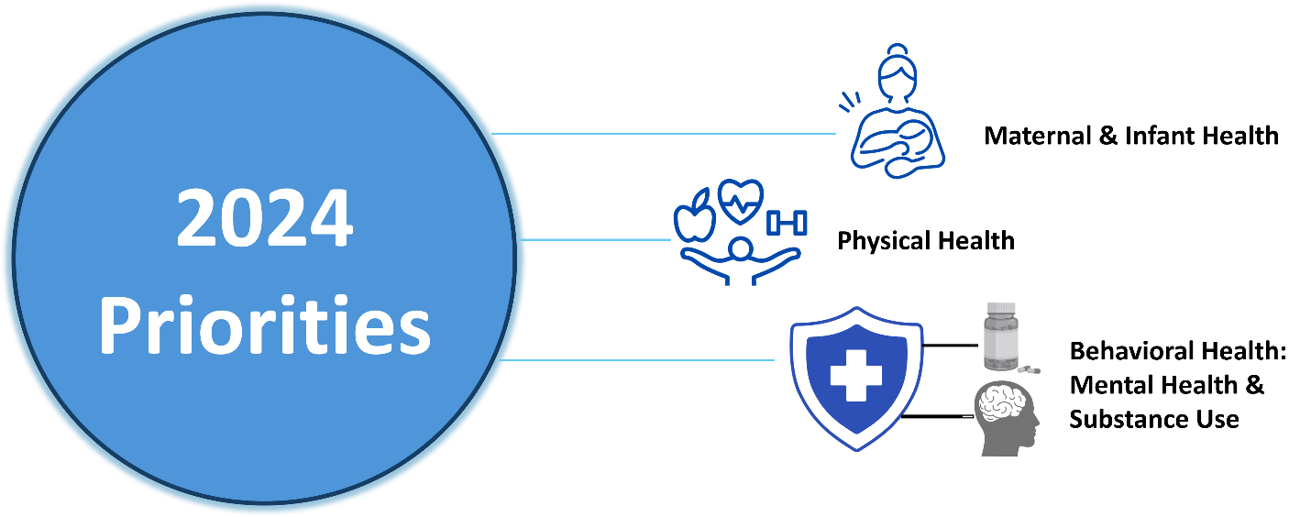

Health, healthcare and associated community needs are very much interrelated, and often impact each other. Although this CHNA process considered these areas separately, their impact on each other should be considered when planning for programs or services to address community needs.

Many health needs are also related to underlying societal and socioeconomic factors. Research has consistently shown that income, education, physical environment, and other such demographic and socioeconomic factors affect the health status of individuals and communities. This CHNA acknowledges that link and focuses on identifying and documenting the greatest health needs as they present themselves today. As plans are developed to address these needs, the Committee’s goal is to work with other community organizations to address underlying factors that could drive long-term improvements to the county population’s health.

For additional discussion of current priority needs and the data that supports those priorities, please see Chapter 3.

CHAPTER 1 | METHODOLOGY

Study Design

The process used to assess Cumberland County’s community needs, challenges, and opportunities included multiple steps. Both new and existing data were used throughout the study to paint a more complete picture of Cumberland County’s health needs. While the CHNA Steering Committee largely viewed the new and existing data equally, there were situations where one provided clearer evidence of community health need than the other. In these instances, the health needs identified were discussed based on the most appropriate data gathered. Data analysis, community feedback review, and stakeholder engagement were all used to identify key areas of need.

Specifically, the following data types were collected and analyzed:

New (Primary) Data

Public engagement and feedback were received through a web-based community member survey along with community focus groups and significant input and direction from the CHNA Steering Committee. The Steering Committee worked together to develop the survey questions for the web-based survey, and county leaders were provided with a set of target numbers based on their county population’s race, ethnicity and age distribution to encourage recruitment of a representative sample of the community. Community members were asked to identify the most significant health and social needs in their community, as well as asked questions about topics specific to Cumberland County, including income, mental health, safety, and substance use disorders. Focus group participants were asked a standard set of questions about health and social needs, in order to identify trends across various groups and to highlight areas of concern for specific populations. In total, the input was gathered from over 1,270 Cumberland County residents and other stakeholders. This included web survey responses from over 1,250 community members and four focus groups that included over 20 community members and other people who live, work or receive healthcare in Cumberland County.

For more information regarding specific questions asked as part of the focus groups and surveys, please refer to Appendix 4.

Existing (Secondary) Data

Key sources for existing data on Cumberland County included information provided by the Steering Committee and a variety of public data sources related to demographics, social and economic determinants of health, environmental health, health status and disease trends, mental/behavioral health trends, and individual health behaviors. Key information sources leveraged during this process included:

- North Carolina Data Portal, a joint effort by the North Carolina Department of Health and Human Services and the University of Missouri Center for Applied Research and Engagement Systems

- County Health Rankings, developed in partnership by Robert Wood Johnson Foundation (RWJF) and University of Wisconsin Population Health Institute

- The Opportunity Atlas, developed in partnership by the U.S. Census Bureau, Harvard University, and Brown University

- Food Access Research Atlas, published by the U.S. Food and Drug Administration

- Social Vulnerability Index, developed by the CDC and the Agency for Toxic Substances and Disease Registry (ATSDR)

- Environmental Justice Index (EJI), developed by the CDC and the ATSDR

- American Community Survey, as collected and published by the U.S. Census Bureau

- Data provided by CHNA Steering Committee members and other affiliated organizations, including CHNA reports from Cumberland County in 2019 and 2021.

For more information regarding data sources and data time periods, please refer to Appendix 2.

Comparisons
To understand the relevance of existing data collected throughout the process, each measure must be compared to a benchmark, goal, or similar geographic area. In other words, without being able to compare Cumberland County to an outside measure, it would be impossible to determine how the county is performing. For this process, each data measure was compared to outside data as available, including the following:

- County Health Rankings Top Performers: This is a collaboration between the RWJF and the University of Wisconsin Population Health Institute that ranks counties across the nation by various health factors.

- State of North Carolina: The Steering Committee determined that comparisons with the state of North Carolina were appropriate.

Population Health Framework

This assessment was developed in alignment with the RWJF population health framework, originally developed by the University of Wisconsin’s Population Health Institute. Population health focuses on health status and outcomes among a specific group of people, and can be based on geographic location, health diagnoses or common health providers. The population health framework recognizes that the issues that affect health in a community are complex; there are many factors that have the potential to impact health outcomes, including both length and quality of life, within a population. Broadly, these factors include the clinical care available to community members, individual health behaviors, the physical environment, and the social and economic conditions in the community.

Using the population health framework as a guide for the CHNA process helps categorize many individual pieces of data in a way that connects the dots between health status and social drivers of health, in a way that helps local leaders better understand and address the health and well-being of the communities they serve. This understanding is critical in identifying potential interventions to address priority needs in the community, and to helping develop partnerships across sectors that can help drive these interventions forward. Figure 1.1 below illustrates the broad categories and sub-categories within the population health framework.

Figure 1.1: Population Health Framework
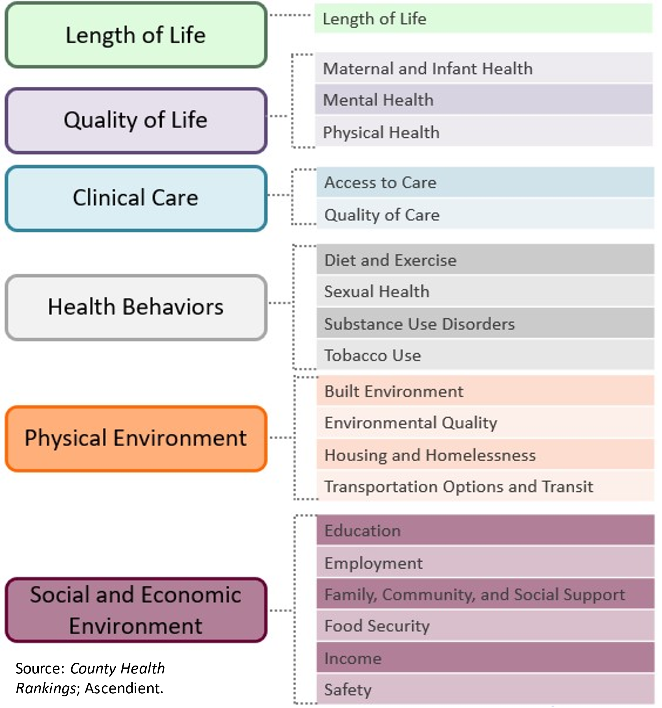

Figure 1.2: Social Determinants of Health
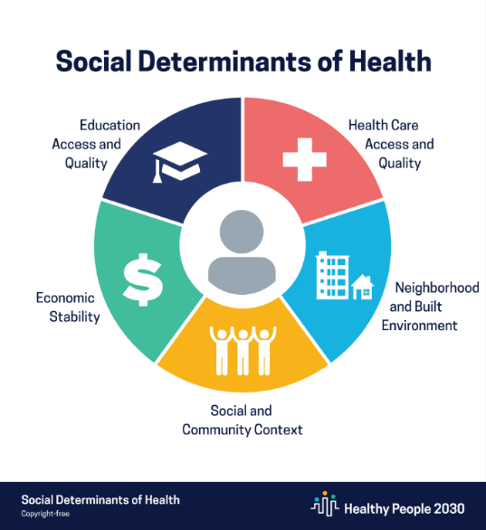
Throughout the process, the Steering Committee also considered Healthy People 2030’s “Social Determinants of Health and Health Equity.” The CDC defines social determinants of health (SDoH) as the conditions in the environments where people are born, live, learn, work, play, worship and age that affect a wide range of health, functioning and quality of life outcomes and risks. These factors can include healthcare access and quality, neighborhood and built environment, social and community context, economic stability, and education access and quality, as outlined in Figure 1.2.

Recognizing that SDoH have an impact on health disparities and inequities in the community was a key point the Steering Committee considered throughout the CHNA process. Figure 1.3 describes the way various social and economic conditions may affect health and well-being.

Figure 1.3: SDoH and Health Disparities
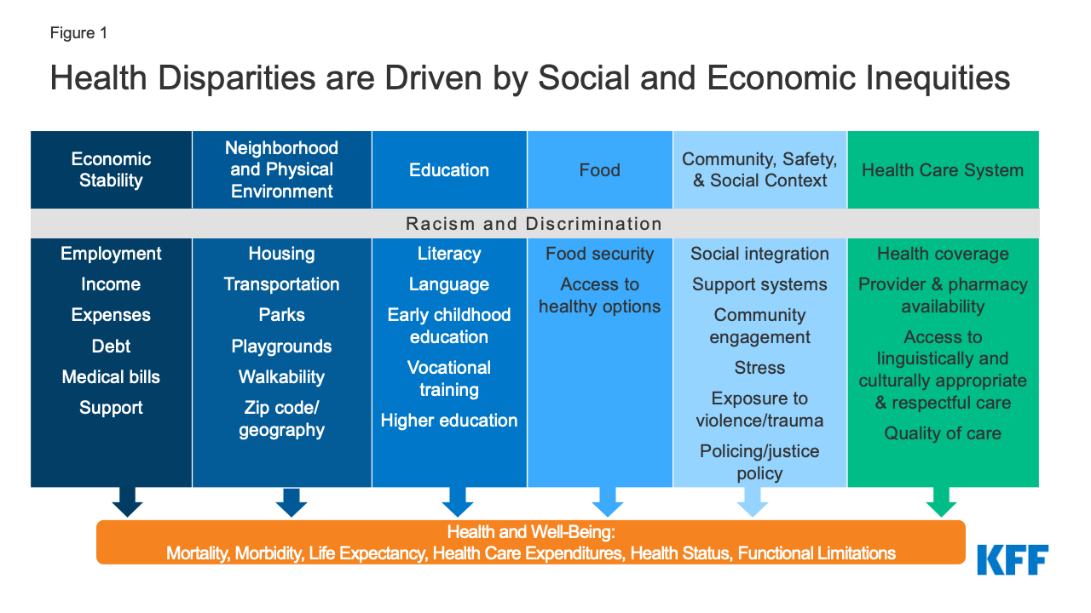

Prioritization Process Overview and Results
The process of identifying the priority health needs for the 2023-2024 CHNA began with the collection and analysis of hundreds of new and existing data measures. In order to create more easily discussable categories, all individual data measures were then grouped into six categories and 20 corresponding focus areas based on “common themes” that correspond to the Population Health Model, as seen in Figure 1.4. These focus areas are detailed further in Appendix 2.

Since a large number of individual data measures were collected and analyzed to develop these 20 focus areas, it was not reasonable to make each of them a priority. The Steering Committee considered which focus areas had data measures of high need or worsening performance, priorities from the primary data, and how possible it is for health departments or hospitals to impact the given need to help determine which health needs should be prioritized.

The Steering Committee utilized the multi-voting technique to determine Cumberland County’s priority need areas. This technique was chosen to build commitment to the Committee’s choices, to limit participants feeling pressured by others to rank concerns in a particular way, to ensure that quieter members of the group have equal representation, to make consensus visible, and to allow for increased opportunity for greater discussion. An initial list of four priorities was generated following review of the secondary and primary data. The Committee then added four additional priorities. Participants were then split into groups of no more than four to discuss all eight potential priorities. Each participant then individually voted for the four priorities they felt were the most significant, utilizing the key considerations for prioritization of needs. These included:

- Size and scope of the health need;

- Severity and intensity of the health need;

- Whether possible interventions would be possible and effective;

- Health disparities associated with the need; and

- Importance the community places on addressing the need.

After the first round of voting, four top priority areas of need emerged. Following additional small group discussion, participants had a second round of voting, which identified the final priority need areas for Cumberland County.

The final priority need areas were not ranked in any particular order of importance, and each will be addressed by the Steering Committee. The following three focus areas (Behavioral Health: Mental Health & Substance Use, Physical Health, and Maternal & Infant Health) were identified as Cumberland County’s top priority health needs to be addressed over the next three years, as seen in Figure 1.4 below:

Figure 1.4: Cumberland County 2024 Priority Health Needs

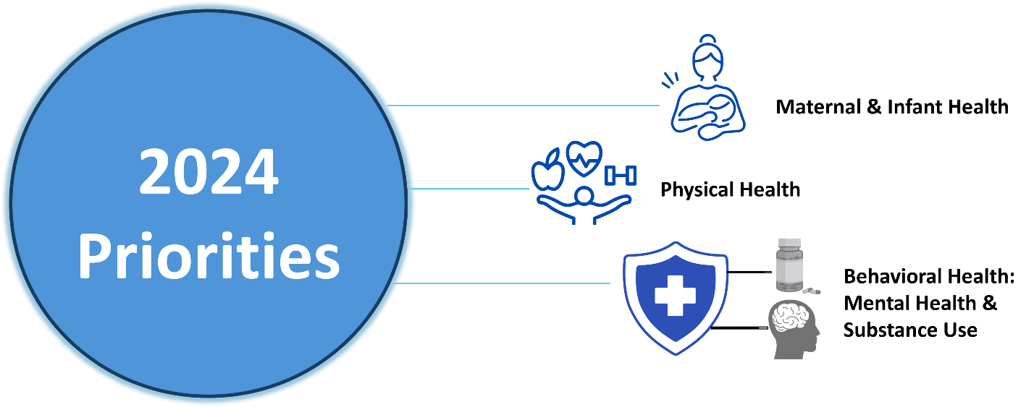

The following organizations participated in the prioritization voting process:

- Alliance Health
- Cape Fear Valley Health System
- City of Fayetteville
- Cumberland County Board of Commissioners
- Cumberland County Department of Public Health
- Cumberland County Schools
- Cumberland HealthNet
- Justice Services
- Marius Maximus Foundation
- Stedman Wade Health Services
- Town of Wade

Study Limitations

Developing a CHNA is a long and time-consuming process. Because of this, more recent data may have been made available after the collection and analysis timeframe. Existing data typically become available between one and three years after the data is collected. This is a limitation, because the “staleness” of certain data may not depict current trends. For example, the U.S. Census Bureau’s American Community Survey is a valuable source of demographic information, however data for a particular year is not published until late the following year. This means 2022 data on community characteristics, such as languages spoken at home, did not become available until late fall 2023. The Steering Committee tried to account for these limitations by collecting new data, including focus groups and web-based community member surveys. Another limitation of existing data is that, depending on the source, it may have limited demographic information, such as gender, age, race, and ethnicity.

Given the size of Cumberland County in both population and geography, this study was limited in its ability to fully capture health disparities and health needs across racial and ethnic groups. Efforts were made to include diverse community members in survey efforts, and the composition of survey respondents in terms of race and ethnicity were largely similar to that of the county as a whole. Roughly 44% of all respondents were White compared to 39% of the Cumberland County population reported as being White. Another 41% of respondents were Black or African American, exceeding the county population reported as being 37%. Only 8% of respondents identified as Hispanic, which is less than the reported county population level of 12.4%. Additionally, there was representation in the survey of other races, including 1.4% of survey respondents identified as American Indian and Alaska native (equivalent to the portion of the population in the county that is Indigenous), 1.2% of respondents identified as Asian (less than the 2.9% of the county population), 5% identified with some other race, and 4.3% identified with two or more races.

Although survey respondents could choose from multiple race or ethnicity categories, limited responses were received from these groups. This made it difficult for the Steering Committee to assess health needs and disparities for other racial/ethnic minority groups in the community.

In addition, there are existing gaps in information for some population groups. Many available datasets are not able to isolate historically underserved populations, including the uninsured, low-income persons, and/or certain minority groups. Despite the lack of available data, attempts were made to include underserved sub-segments of the greater population through the new data gathered throughout the CHNA process. For example, the Steering Committee chose to focus on Spanish-speaking members of the community by providing a Spanish language version of the web-based community survey. Paper surveys were also distributed in an effort to reach as much of the community as possible. To increase future survey responses, members of the Steering Committee should consider working directly with partner organizations in the community who can connect directly with populations who are hard to access through traditional outreach methods, including people with disabilities, the uninsured and people who are disengaged.

In the future, assessments should make efforts to include other underserved communities whose needs are not specifically discussed here because of data and input limitations during this CHNA cycle. Of note, residents in the disabled, blind, deaf, and hard-of-hearing communities can be a focus of future new data collection methods. Using a primarily web-based survey collection method might have also impacted response rates of community members with no internet access or low technological literacy. Additionally, more input from both patients and providers of substance use disorder (SUD) services would also be helpful in future assessments.

Finally, parts of this assessment have relied on input from community members and key community health leaders through web-based surveys and focus groups. Since it would be unrealistic to gather input from every single member of the community, the community members that participated have offered their best expertise and understanding on behalf of the entire community. As such, the CHNA Steering Committee has assumed that participating community members accurately and completely represented their fellow residents.

CHAPTER 2 | COUNTY PROFILE

Geography

Cumberland County is located in the Inner Coastal Plain region of North Carolina, characterized by the presence of low-lying areas, winding rivers, and rolling hills. It covers a total of 659 miles, including 653 square miles of land and six square miles of water. Cumberland is comprised of nine municipalities: Town of Eastover, City of Fayetteville, Town of Falcon, Town of Godwin, Town of Hope Mills, Town of Linden, Town of Spring Lake, Town of Stedman, and Town of Wade. Fort Liberty, located just west of Fayetteville, is the largest U.S. Army base by population, serving approximately 475,000 active-duty soldiers and their families. Its proximity to Fayetteville makes the base a significant contributor to the economy of both the city and the broader Cumberland County region. Nearly 14% of Cumberland County’s population resides in rural areas.

Population

Population figures discussed throughout this chapter were obtained from Esri, a leading GIS provider that utilizes U.S. Census data projected forward using proprietary methodologies.

At just over 337,000, Cumberland County makes up just over 3% of the population of North Carolina.

Table 2.1: Total Population, 2023
 | Cumberland County | North Carolina | United States
Population | 337,037 | 10,765,678 | 337,470,185

Cumberland County has a population density of 520.3 persons per square mile – more than double the population density for North Carolina (214.7 persons per square mile). Fayetteville is the most densely populated area in the county.

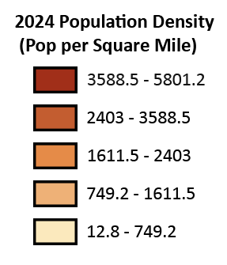
Figure 2.1: Cumberland County Map: Population Density4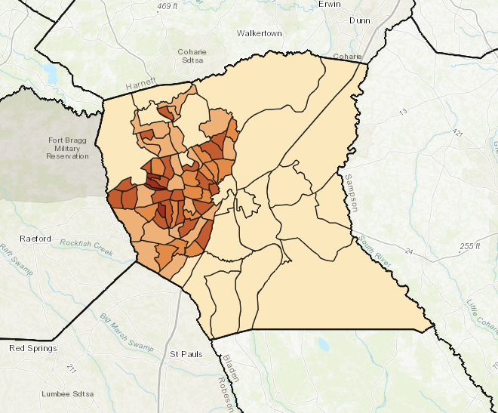

In total, the population of Cumberland County is projected to grow 0.08% annually between 2024 and 2029. Areas in the southern part of the county are experiencing greater growth.
Figure 2.2: Cumberland County Map: Population Growth4
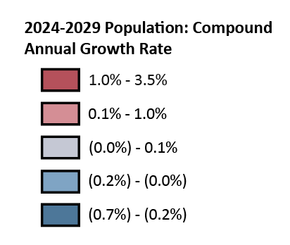
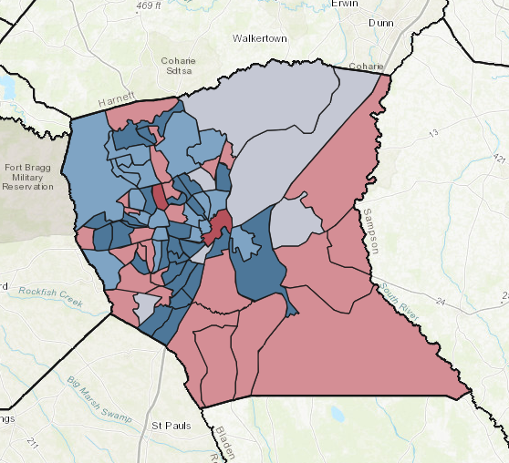

Age and Sex Distribution

Data on age and sex helps health providers understand who lives in the community and informs planning for needed health services. The age distribution of Cumberland County skews younger than the state and the country, with 20.2% of residents under 15 and 44.7% aged 15 to 44. The county has a lower percentage of residents aged 65 and older (13.6%), which may reduce immediate demand for senior services but emphasizes the need for resources focused on children, young adults, and working-age individuals.

Table 2.2: Age Distribution, 20234
 | Cumberland County | North Carolina | United States
Percentage below 15 | 20.2 % | 17.9 % | 18.1%
Percentage between 15 and 44 | 44.7 % | 39.3 % | 39.5 %
Percentage between 45 and 64 | 21.5 % | 25.1 % | 24.6 %
Percentage 65 and older | 13.6 % | 17.7 % | 17.8%

Cumberland County has a notably higher proportion of females than males, with a nearly 10% gap, exceeding both state and national averages.

Table 2.3: Sex Distribution, 20234
 | Cumberland County |  | North Carolina |  | United States
 | Count | Pct. of  Total | Count | Pct. of  Total | Count | Pct. of  Total
Female | 183,495 | 54.4% | 5,489,419 | 51.0% | 170,118,720 | 50.4%
Male | 153,542 | 45.6% | 5,276,259 | 49.0% | 167,351,465 | 49.6%

Race and Ethnicity

Data on race and ethnicity help us understand the need for healthcare services as well as cultural factors that can impact how care is delivered. Cumberland County has a more diverse racial composition compared to state and national averages, with 38.0% of the population identifying as Black (Non-Hispanic), significantly higher than both North Carolina (20.4%) and the U.S. (12.5%). In Cumberland County, the percentages of Asian, American Indian and Alaska Native (AIAN), and Native Hawaiian and Pacific Islander (NHPI) residents are similar to those of North Carolina. Additionally, 10.4% of residents identify as two or more races, closely mirroring the national average

Table 2.4: Racial Distribution, 20234
 | Cumberland County |  |  | North Carolina |  | United States
 | Count | Pct. of Total |  | Count | Pct. of Total | Count | Pct. of Total
Black (Non-Hispanic) | 127,934 |  | 38.0 % | 2,199,488 | 20.4 % | 42,132,758 | 12.5 %
White (Non-Hispanic) | 139,961 |  | 41.5 % | 6,590,161 | 61.2 % | 204,562,590 | 60.6 %
Asian | 10,131 |  | 3.0 % | 379,374 | 3.5 % | 21,088,177 | 6.2 %
AIAN | 5,704 |  | 1.7 % | 133,820 | 1.2 % | 3,831,126 | 1.1 %
NHPI | 1,525 |  | 0.5 % | 9,214 | 0.1 % | 712,229 | 0.2 %
Some Other Race Alone | 16,735 |  | 5.0 % | 677, 338 | 6.3 % | 29,432,586 | 8.7 %
Two or More Races | 35,047 |  | 10.4 % | 776,283 | 7.2 % | 35,710,719 | 10.6 %

By ethnicity, 12.4% of Cumberland County’s population is Hispanic. This is higher than the proportion of Hispanic residents in North Carolina.

Table 2.5: Ethnic Distribution, 20234
 | Cumberland County |  |  | North Carolina |  | United States
 | Count | Pct. of Total |  | Count | Pct. of Total | Count | Pct. of Total
Non-Hispanic | 295, 076 |  | 87.6 % | 9,465,874 | 88.6 % | 271,934,049 | 80.6 %
Hispanic | 41,961 |  | 12.4 % | 1,299,804 | 11.4 % | 65,536,136 | 19.4 %

The proportion of foreign-born individuals residing in Cumberland County is a little over 6%, lower than state and national averages.

Table 2.6: Foreign Born Population, 2022,
 | Cumberland County | North Carolina | United States
Foreign Born | 6.1% | 9% | 13.9%

The diversity of Cumberland County is reflected in the languages that residents speak at home. According to the most recent American Community Survey (ACS), approximately 12% of Cumberland County residents speak a language other than English at home. This percentage is similar to the state average for North Carolina. Nearly 8% of county residents speak Spanish at home, also comparable to state rate.
Table 2.7: Language Spoken at Home, 20226
 | Cumberland County | North Carolina | United States
English Only | 87.6% | 87.3% | 78%
Spanish | 7.9% | 7.9% | 13.3%
Indo-European Languages | 1.8% | 2.1% | 3.8%
Asian and Pacific Islander Languages | 2.0% | 1.9% | 3.6%
Other Languages | 0.7% | 0.8% | 1.2%

Disability Status
Data on disabilities helps us understand how to create fair and equal opportunities for everyone in the county. In addition, individuals with disabilities may require targeted services and outreach by health and other service providers. Nearly one in five Cumberland County residents have a disability. This rate is higher than both state and national figures.

Table 2.8: Disability Status, 20225,6
 | Cumberland County | North Carolina | United States
Population with a Disability | 18% | 13.3% | 12.9%

Veteran Status
Military veterans often need special services and support, so it is important to collect data about them to be better able to meet their specific needs. Veterans make up nearly 20% of Cumberland County's population, which may be attributed to having a large military installation located in the county. This proportion is more than double the percentage of veterans in both North Carolina and the United States as a whole.

Table 2.9: Veteran Status, 20225,6
 | Cumberland County | North Carolina | United States
Veterans | 19% | 7.8% | 6.2%

Economic Indicators

In addition to demographic data, socioeconomic factors in the community such as income, poverty, and food scarcity play a significant role in identifying health-related needs. The median household income in Cumberland County is $54,416, nearly $10,000 less than the median household income of North Carolina.

Table 2.10: Median Household Income, 20234
 | Cumberland County | North Carolina | United States
Median Household Income | $54,416 | $64,316 | $72,603

In 2023, approximately 12% of Cumberland County households were below the federal poverty level (FPL), higher than state and national figures. Poverty has a significant impact on health. Across the lifespan, people who live in impoverished communities have a higher risk of poor health outcomes, including mental illness, chronic diseases, higher mortality and lower life expectancy. Poverty is a concern across the lifespan; children who live in poverty are at risk for developmental delays, toxic stress and poor nutrition, and are likely to live in poverty as adults as well. Unmet social needs, including having low or no income, can also limit people’s ability to access healthcare when they need it, or to provide for basic necessities needed to live healthy lives, such as safe housing or healthy food.

Table 2.11: Percent of Households Below the Federal Poverty Level, 20234
 | Cumberland County | North Carolina | United States
Percent Below FPL | 12.1 % | 10.1 % | 9.5 %

At more than double the percentage of households below the FPL, approximately 26% of Cumberland County households received Food Stamps/SNAP (Supplemental Nutrition Assistance Program) in 2022. This is more than twice the percentage observed at both the state and national levels.

Table 2.12: Households Receiving Food Stamps/SNAP, 20226,
 | Cumberland County | North Carolina | United States
Number of Households Receiving Food Stamps/SNAP | 33,639 | 575,860 | 16,072,733
Total Number of Households | 130,969 | 4,299,266 | 129,870,928
Percentage of Households receiving Food Stamps/SNAP | 25.7 % | 13.4 % | 12.4 %

Cumberland County has a higher percentage of residents with some college education (28.7%) compared to both state (21.1%) and national (14.6%) averages. The county also has a slightly higher proportion of associate's degree holders (10.8%) than the state and national figures. However, Cumberland County has lower percentages of residents with bachelor's degrees (16.7%) and graduate/professional degrees (8.9%) compared to state and national averages.

Table 2.13: Educational Attainment, 2020
 | Cumberland County | North Carolina | United States
Less than 9th Grade | 2.4% | 6.0% | 3.5%
Some High School/No Diploma | 6.1% | 5.5% | 5.3%
High School Diploma | 22.8% | 21.2% | 28.5%
GED/Alternative Credential | 3.6% | 4.3% | *
Some College/No Diploma | 28.7% | 21.1% | 14.6%
Associate’s Degree | 10.8% | 9.9% | 10.5%
Bachelor’s Degree | 16.7% | 20.4% | 23.4%
Graduate/ Professional Degree | 8.9% | 11.6% | 14.2%

The overall unemployment rate in Cumberland County (7.9%) is higher than the state (5.1%) and nearly double the national (3.9%) average. The age group with the highest unemployment rate is 16 to 24 years old at 16.6%, which exceeds both state (12.4%) and national (11.0%) figures. Unemployment rates for all age groups in Cumberland are higher than corresponding state and national rates.

Table 2.14: Unemployment, 20226,
 | Cumberland County | North Carolina | United States
Percentage unemployed ages 16 to 24 | 16.6 % | 12.4 % | 11.0%
Percentage unemployed ages 25 to 54 | 7.7 % | 4.7 % | 3.4%
Percentage unemployed ages 55 to 64 | 3.4 % | 3.3 % | 2.7%
Percentage unemployed ages 65 or more | 3.4 % | 3.0 % | 2.9%
Total unemployment | 7.9 % | 5.1 % | 3.9%

Cumberland County's overall uninsured rate of 10.8% is lower than both state (15.0%) and national (12.0%) averages. However, the county shows variations across age groups. The uninsured rate for ages 18 and below (4.0%) is lower than state and national figures, while the rate for ages 19 to 34 (20.0%) is higher than the state average (15.5%). For ages 35 to 64, Cumberland County's rate (14.3%) is higher than both the state (12.5%) and national (9.9%) percentages. This data highlights that while the county performs better overall, young and middle-aged adults face higher rates of uninsurance compared to state averages.

Table 2.15: Health Insurance Status, 20226
 | Cumberland County | North Carolina | United States
Percentage uninsured ages 18 or below | 4.0 % | 5.2 % | 5.4 %
Percentage uninsured ages 19 to 34 | 20.0 % | 15.5 % | 13.6 %
Percentage uninsured ages 35 to 64 | 14.3 % | 12.5% | 9.9%
Total % Uninsured | 10.8 % | 15.0% | 12.0%

Social Determinants of Health
Figure 2.3: Social Determinants of Health
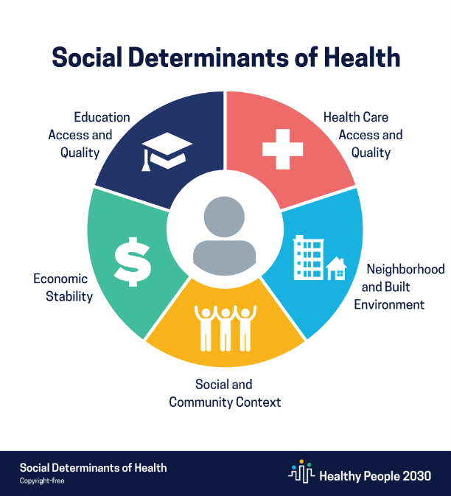
In addition to the considerations noted above, there are many other factors that can positively or negatively influence a person’s health. The Steering Committee recognizes this and believes that, to portray a complete picture of the county’s health status, it first must address the factors that impact community health. The CDC defines social determinants of health (SDoH) as the conditions in the environments where people are born, live, learn, work, play, worship and age that affect a wide range of health, functioning and quality of life outcomes and risks. According to the CDC’s “Social Determinants of Health” from its Healthy People 2030 public health priorities initiative, factors contributing to an individual’s health status can include the following: healthcare access and quality, neighborhood and built environment, social and community context, economic stability, and education access and quality.

As seen in Figure 2.3, many of the factors that contribute to health are hard to control or societal in nature. As such, health and healthcare organizations need to consider many underlying factors that may impact an individual’s health and not simply their current health conditions.

It is widely acknowledged that people with lower income, social status and levels of education find it harder to access healthcare services compared to people in the community with more resources. This lack of access is a factor that contributes to poor health status. Further, people in communities with fewer resources may also experience high levels of stress, which also contributes to worse health outcomes, particularly related to mental or behavioral health.

An analysis of the racial and geographic disparities that emerged in the information obtained and analyzed during this process is detailed below. The CHNA Steering Committee also collected new data via focus groups and surveys to ensure that residents and key community health leaders could provide input regarding the needs of their specific communities. This information will be presented in detail later in this report.

Disparities

Recognizing the diversity of County, as discussed above, the Steering Committee evaluated factors that may contribute to health disparities in its community. These included racial equity; racial segregation; financial barriers; nutrition; social, behavioral, and economic factors that influence health; and English language proficiency.

Residential segregation is measured by the index of dissimilarity, a demographic measure ranging from 0 to 100 that represents how evenly two demographic groups are distributed across a county’s census tracts. Lower scores represent a higher level of integration. Cumberland County has significantly lower residential segregation than North Carolina and the U.S, as seen in Figure 2.4.

Figure 2.4: Residential Segregation

Source: Robert Wood Johnson County Health Rankings 2024

Income inequality is measured as the ratio of household income at the 80th percentile to household income at the 20th percentile. Communities with greater income inequality may have worse outcomes on a variety of metrics, including mortality, poor health, sense of community, and social support. As seen in Figure 2.5, the income inequality ratio for Cumberland County is lower than that of North Carolina and the U.S.
Figure 2.5: Income Inequality Ratio12

People with limited English proficiency (LEP) may face challenges accessing care and resources that fluent English speakers do not. Language barriers may make it hard to access transportation, medical, and social services as well as limit opportunities for education and employment. Importantly, LEP community members may not understand critical public health and safety notifications, such as safety-focused communications during the COVID-19 pandemic. Fewer people are not fluent in English in Cumberland County compared to the state and country, as seen in Figure 2.6.

Figure 2.6: Percent of Population with Limited English Proficiency6
Source: ACS 2018-2022 5-Year Estimates

Social Vulnerability Index

One resource that can help show variation and disparities between geographic areas is the Social Vulnerability Index (SVI), which was developed by the CDC and the Agency for Toxic Substances and Disease Registry (ATSDR). Social vulnerability refers to negative effects communities may experience due to external stresses that impact human health, like natural or human-caused disasters, or disease outbreaks. Socially vulnerable populations are at especially high risk during public health emergencies.

The SVI uses 16 U.S. Census variables to help local officials identify communities that may need support before, during, or after a public health emergency. Communities with a higher SVI score are generally at a higher risk for poor health outcomes. Instead of relying on public health data alone, the SVI accounts for underlying economic and structural conditions that affect overall health, including SDoH. SVI scores are calculated at the census tract level and based on U.S. Census variables across four related themes: socioeconomic status, household characteristics, racial and ethnic minority status, and housing type/transportation. Figure 2.7 outlines the variables used to calculate SVI scores.

Figure 2.7: SVI Variables

The United States SVI by county is shown in Figure 2.8 below. As shown, a lot of variation exists across the country, and even within individual states.

Figure 2.8: United States SVI by County, 2022
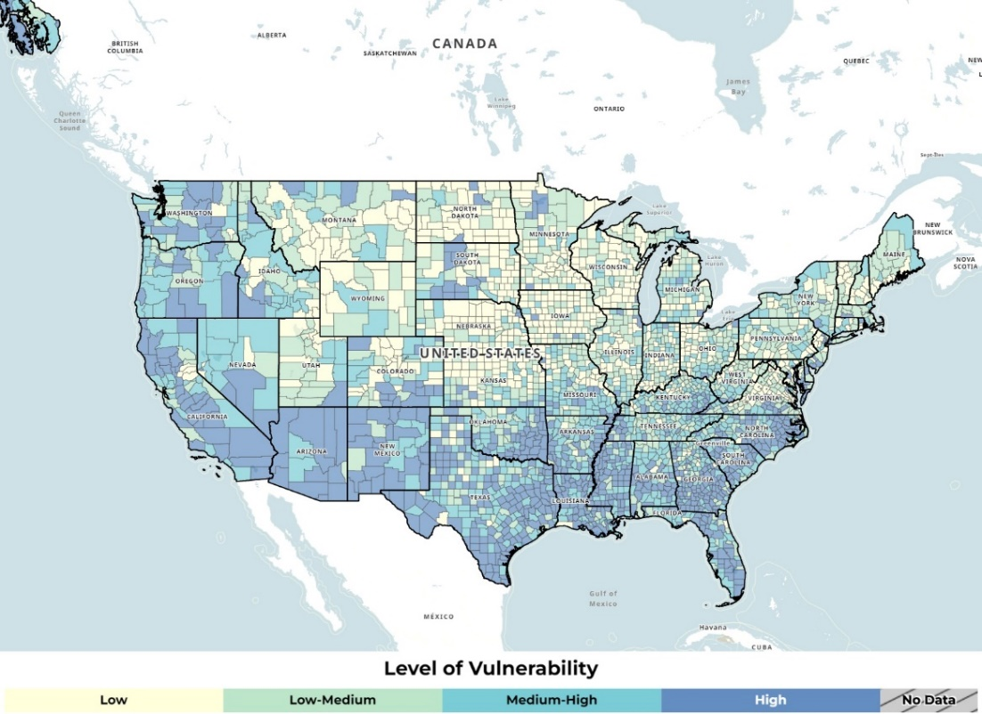
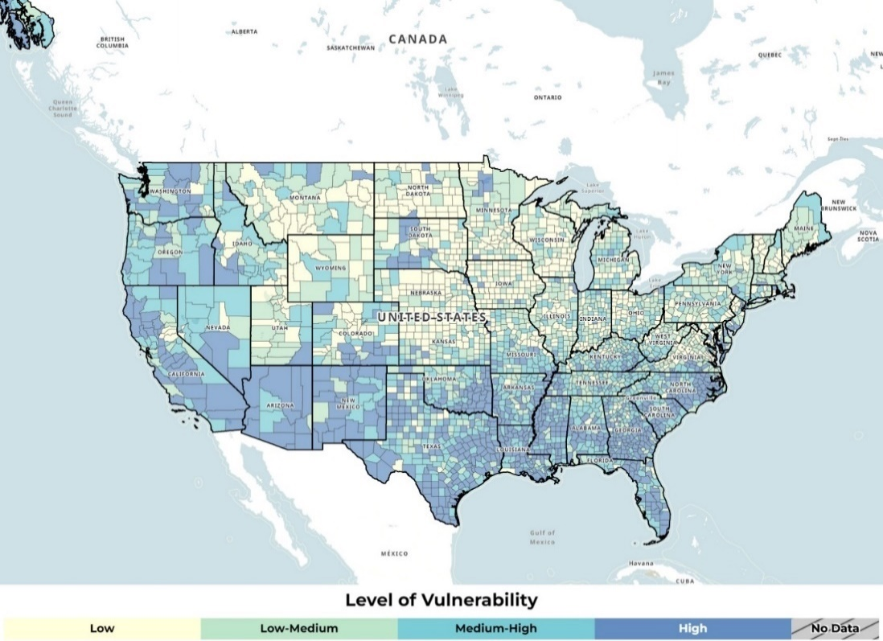
.

The 2022 SVI scores for Cumberland County are shown in Figure 2.9 below. Possible scores range from 0 (lowest vulnerability) to 1 (highest vulnerability), and these scores show a relative comparison with other counties and census tracts in North Carolina. The vulnerability of Cumberland County overall is higher than average compared to the state. Levels of vulnerability are variable across the county with the average being 0.83.
Figure 2.9: Cumberland County SVI , 2022
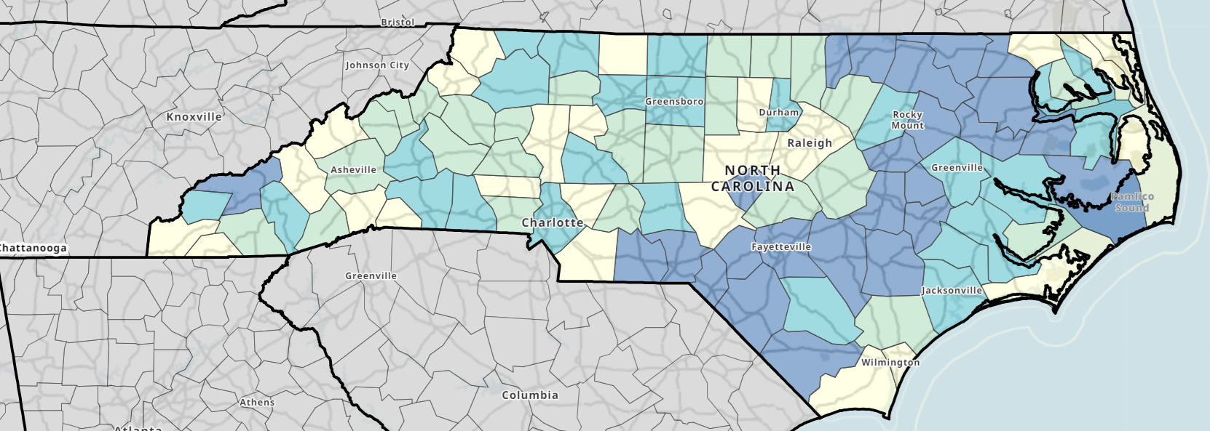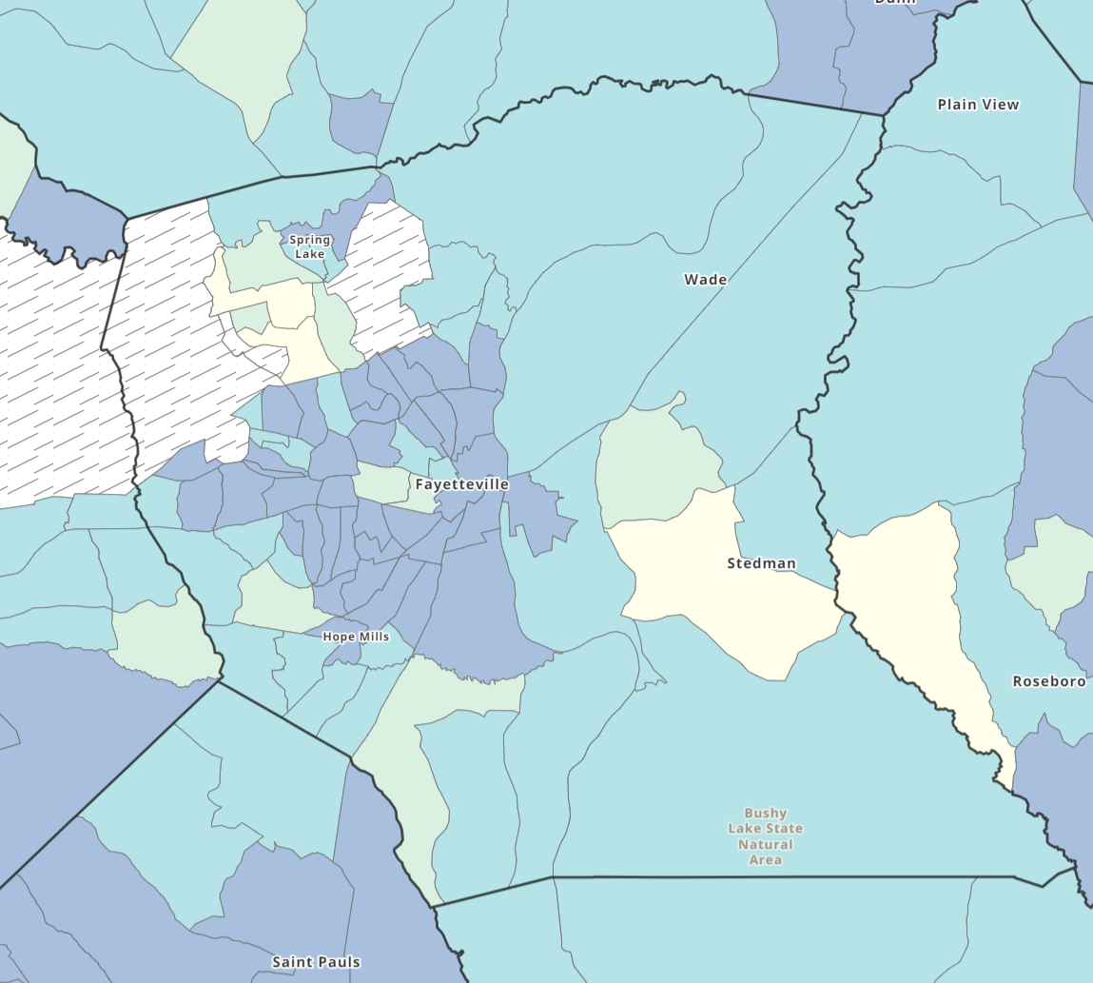

Environmental Justice Index

Environmental justice means the just treatment and meaningful involvement of all people, regardless of income, race, color, national origin, Tribal affiliation, or disability, in agency decision-making and other Federal activities that affect human health and the environment. It aims to protect everyone from disproportionate health and environmental risks, address cumulative impacts and systemic barriers, and provide equitable access to a healthy and sustainable environment for all activities and practices.

The CDC/ATSDR EJI is a database that ranks the impact of environmental injustice on health. It uses data from the U.S. Census Bureau, the U.S. Environmental Protection Agency, the U.S. Mine Safety and Health Administration, and the U.S. Centers for Disease Control and Prevention. The Index scores environmental burden and injustice at the census tract level in the U.S. based on multiple social, environmental, and health factors.

Over time, communities with a higher EJI score are generally shown to experience more severe impacts from environmental burden than communities in other census tracts. Figure 2.10 outlines the variables used to calculate EJI scores.

Figure 2.10: EJI Variables

The United States EJI by county is shown in Figure 2.11 below. As shown, a lot of variation exists across the country, and even within individual states.

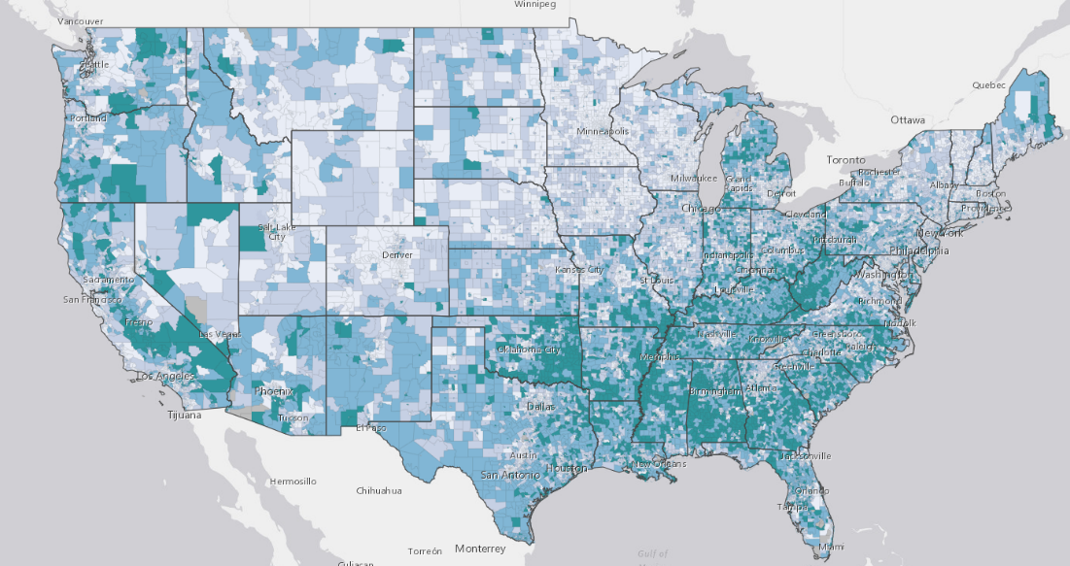
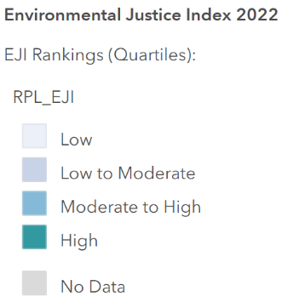
Figure 2.11: United States EJI by Census Tract, 2022

The 2022 EJI scores for Cumberland County are shown in Figure 2.12 below. EJI scores use percentile ranking which represents the proportion of census tracts that experience environmental burden relative to other census tracts in North Carolina. The index ranges from 0-1 with higher scores indicating more environmental burden compared to other census tracts. Levels of environmental burden are variable across the county with the average being 0.57.
Figure 2.12: Cumberland County EJI by Census Tract, 2022
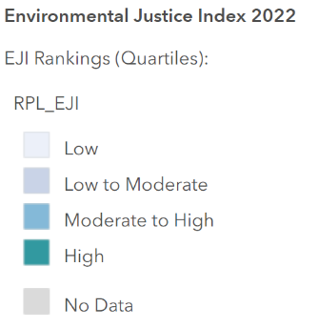
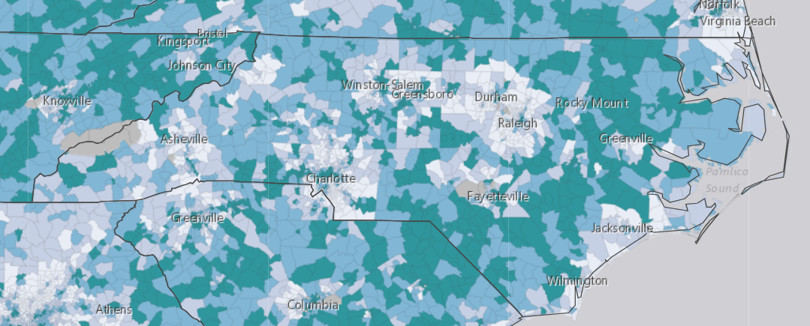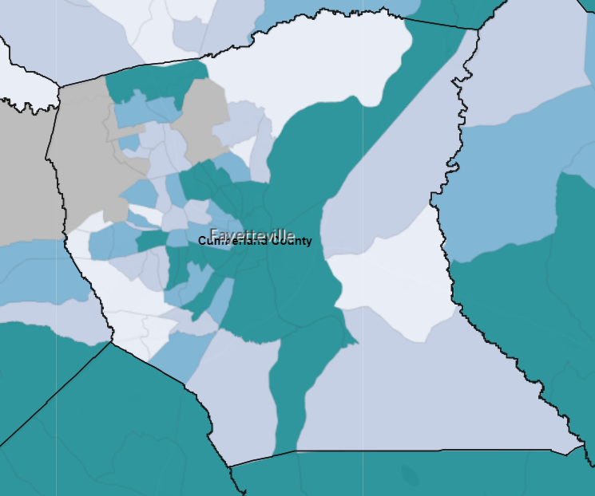

Health Outcome and Health Factor Rankings

County leaders also reviewed and analyzed data from the Robert Wood Johnson Foundation and the University of Wisconsin County Health Rankings for the year 2024. The Health Outcomes measure looks at how long people in a community live and how physically and mentally healthy they are. These categories are discussed further in Appendices 2 and 3. Cumberland County falls behind the national and state averages for health outcomes.

Figure 2.13: State Health Outcomes Rating Map12
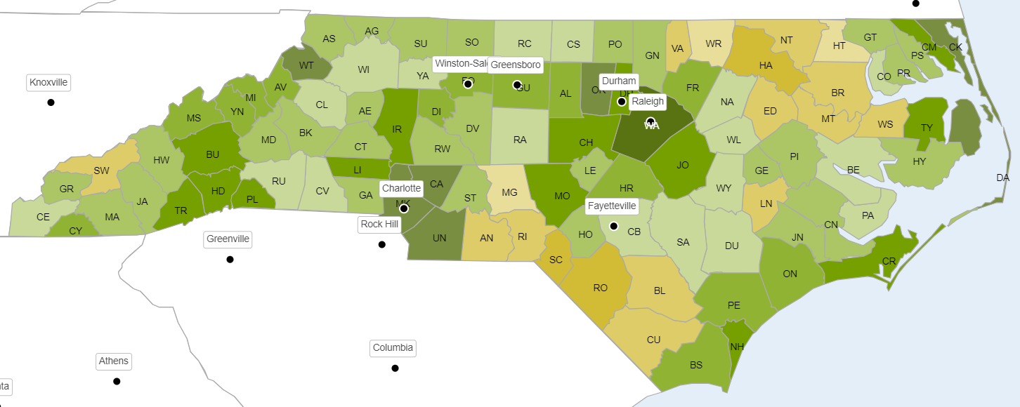
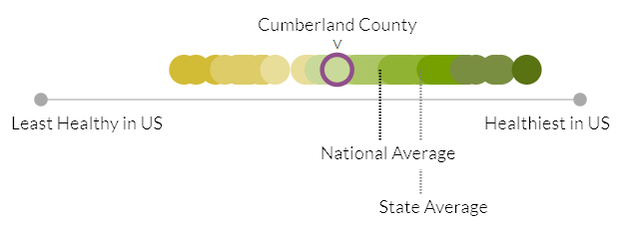

The Health Factors measure looks at variables that affect people's health including health behaviors, clinical care, social & economic factors, and the physical environment they live in. More details about these indicators can be found in Appendices 2 and 3. Similarly to the health outcome measure, Cumberland County falls behind the national and state averages for health factors

Figure 2.14: State Health Factors Rating Map12
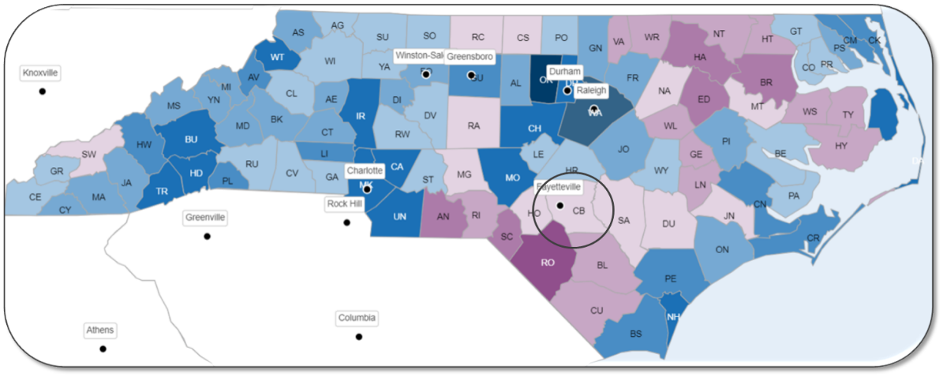

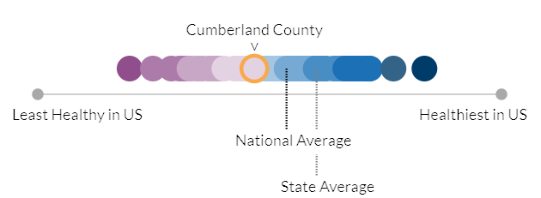

CHAPTER 3 | PRIORITY NEED AREAS

This chapter describes each of the three priority areas in more detail and discusses the data that supports each priority. The information in this section includes context and national perspective, secondary data findings, and primary data findings (including the community member survey and focus groups).

On September 5, 2024, Cumberland County conducted its health prioritization meeting as part of the 2024 Community Health Needs Assessment process. The meeting was held at the Cumberland County Department of Public Health and included diverse representation from key stakeholder groups including local government officials, healthcare system leadership, educational institutions, public health professionals, justice services representatives, and community health organizations. Using a multi-voting technique, participants engaged in two rounds of structured discussion and voting. This method was selected to build commitment to the team's choices, ensure equal representation from all participants regardless of role, and make team consensus visible while creating opportunities for robust discussion. The initial list of priorities was generated from survey results, focus groups, and interview data, with additional priorities added through group discussion. After thorough deliberation and two rounds of voting, the group identified the three final priority areas.

As mentioned previously, these priority needs areas are not listed in any hierarchical order of importance and all will be addressed by the Cumberland County leaders in health improvement plans guided by this CHNA. As noted in Chapter 1, county health leadership considered the following factors when determining the priority needs reported in this assessment:

- Size and scope of the health need;

- Severity and intensity of the health need;

- Estimated feasability and effectiveness of possible interventions;

- Health disparities associated with the need; and

- Importance the community places on addressing the need.

Priority Need: Behavioral Health (Mental Health & Substance Use)

Context and National Perspective

The definition of behavioral health often describes conditions related to both mental health and substance use. Mental health is defined as an emotional, psychological, and social state of well-being. Mental health impacts every stage of life and affects how one is able to handle their relationships, daily stressors, and health behaviors. After evaluating data from a variety of sources including surveys and focus groups conducted throughout the assessment process, the Steering Committee identified mental health, including substance use, to be an area of urgent need within Cumberland County.

Mental illnesses are common in the United States: in 2021, an estimated 57.8 million U.S. adults – nearly one in five – were living with a mental illness. There is risk for developing a mental illness across the lifespan, with over one in five children and adults in the U.S. reported to have a mental illness, and nearly one in twenty-five adults currently coping with a serious mental illness (SMI) such as major depression, schizophrenia or bipolar disorder.

Mental illness can occur due to multiple different factors, such as genetics, drug and/or alcohol usage, isolation, adverse childhood experiences, and chronic health conditions. Additionally, mental illness can act like other chronic health conditions, in that it can worsen or improve depending on the environment. Mental health services have evolved in the past five years, especially during the COVID-19 pandemic. However, accessing mental health care services can be challenging. According to the National Institute of Mental Health, less than half (47.2%) of adults with a common mental illness received any mental health services in 2021. Those who had an SMI were more likely (65.4%) to have received mental health services that same year.17 While access to telehealth mental health services has increased, those living in rural areas may still find it difficult to access care. This is a particular concern among those who are low-income or experiencing homelessness, two groups at high risk for developing an acute or chronic mental health condition. As of 2023, over seven million people in the U.S. who reported having a mental illness lived in a rural area.

Mental illness is a prevalent concern in North Carolina, with nearly 1.5 million adults reported to have a mental health condition in 2023. Additionally, that same year, 1 in 7 individuals who were identified as homeless also were living with an SMI. Access to mental health care in North Carolina is changing, however it is still unavailable to many. Specifically, over 452,000 individuals did not seek care in 2023, with 44.8% citing cost as the main reason. Additionally, those in live in North Carolina are seven times more likely to be pushed out of network of their behavioral health providers, than a primary care provider, furthering cost as a cause for stopping treatment.

Substance use disorders (SUDs) are one of the fastest rising categories of behavioral health disorders. According to the American Psychiatric Association, SUDs are a complex condition in which there is uncontrolled use of a substance (such as alcohol or drugs), despite harmful consequences. SUDs often occur in conjunction with other mental illness. In 2023, 16 million (46.9%) young adults aged 18-25 reported having either a SUD or Acute Mental Illness (AMI) in the past year. In that same year, 17.1% (48.5 million) of all U.S. adults were reported as having an SUD. These trends have been increasing in recent years. According to the National Center for Drug Abuse Statistics, in 2018 (3.7%) of all adults aged 18 and older (9.2 million) had both an AMI and at least one SUD. By 2021, this had increased to 13.5% of U.S. adults, with the highest incidence among Multiracial adults.

There are multiple common forms of SUD, such as alcohol use, cocaine use, cannabis use, opioid use, and methamphetamine use disorders. An individual living with one SUD can also be coping with another at the same time, such as co-occurring use of alcohol and cannabis. Treatment SUDs generally cannot follow a cookie-cutter approach, as each person receiving treatment will have different withdrawal and coping needs. Treatment is typically provided through various therapies, inpatient admissions, and forms of medication-assisted treatment such as methadone. Opioid overdoses are one of the most common types of deaths related to SUDs, and can be preventable and treatable if caught in time. Multiple efforts have been coordinated within the past two years to incorporate the storage of overdose reversing medications such as Naloxone in public facilities such as federal facilities, and over the counter, as was approved in 2023 by the FDA. This is critical, as in 2022, the number of opioid overdoses nationwide surpassed 81,051 – a 63% increase in overdoses since 2019.

Substance use disorders have also had an impact in North Carolina. Over 36,000 overdose deaths occurred in the state between 2000 and 2022 – an average of more than 1,600 deaths each year. Multiple programs have been developed in North Carolina to combat substance use disorder, notably surrounding opioid usage, which has led to an increase in access and usage of Medication Assisted Treatment (MAT) and methadone clinics within the state. Additionally, North Carolina launched the Opioid and Substance use action plan, which involved the development of multiple interventions, dashboards, and educational materials to help support counties and organizations with reducing not only overdose deaths, but the incidence of SUDs as well.

The pandemic impacted public mental health and well-being in many ways. Community members continue to grapple with the pandemic-related effects of isolation and loneliness, financial instability, long-term health impacts and grief, all of which are drivers for developing a substance use disorder. In addition, both drug overdose and suicide deaths have sharply increased over the past several years – often disproportionately impacting younger people and communities of color.

Access to services that address mental health and substance use is an ongoing challenge across the U.S. According to the Substance Abuse and Mental Health Services Administration (SAMHSA), in 2021, less than half (47.2%) of U.S. adults who reported having a mental illness utilized any type of mental health services, including inpatient, outpatient or telehealth services or prescription drug therapies. Demand for mental health services, particularly anxiety and depression treatment, remains high across the nation, while the prevalence of stress- and trauma-related disorders, along with substance use disorders, continues to grow. The American Psychological Association reports that the percentage of psychologists in the U.S. seeing more patients than they did before the pandemic increased from 15% in 2020 to 38% in 2021 to 43% in 2022. Further, 60% of psychologists reported having no openings for new patients and 38% maintained a waitlist for their services.

Secondary Data Findings

Secondary data collected through the CHNA process identified behavioral health as a significant area of concern for residents of Cumberland County. As displayed in the table below, multiple behavioral health indicators for Cumberland County were higher than the state and national averages, including the crude rates of suicide and deaths of despair. The crude mortality rate for deaths of despair in Cumberland County (74.7 per 100,000 population) was significantly higher compared to both North Carolina (58.7) and the United States (55.9). Additionally, Cumberland County residents reported an average of 5.3 poor mental health days per month, higher than both the state (4.6) and national (4.9) averages.

Table 3.1: Behavioral Health Indicators
Indicator | Cumberland County | North Carolina | United States
Deaths of Despair  (Crude Rate per 100,000 Population) | 74.7 | 58.7​ | 55.9​
Suicide  (Crude Rate per 100,000 Population) | 16.9 | 14.0 | 14.5
Average Number of Poor Mental Health Days  (per Month) | 5.3 | 4.6 | 4.9

A notable gender disparity exists for deaths of despair in Cumberland County, with the death rate being significantly higher among men compared to women. The figure below illustrates this disparity.

Figure 3.1: Crude Rate of Deaths of Despair by Gender

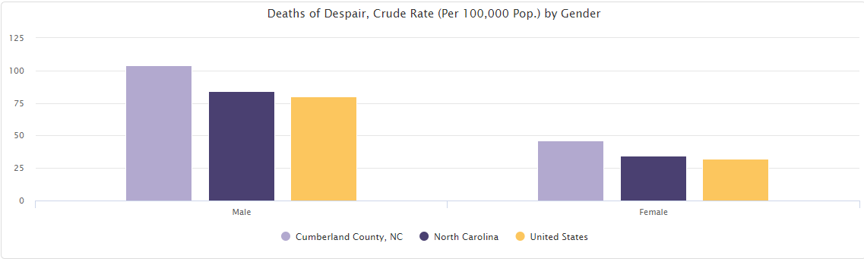
In terms of substance use disorder indicators, Cumberland County presents a mixed picture relative to the state of North Carolina and the U.S. The county has a slightly higher percentage of adults reporting excessive drinking (19%) compared to both state and national averages (18%). While the county has a lower rate of emergency department visits for opioid use disorder (35 per 100,000 beneficiaries) compared to the state (43) and national (41) rates, it has a significantly higher opioid overdose death rate (36.9 per 100,000 population) compared to North Carolina's rate of 25.1.

Table 3.2: Substance Use Disorder Indicators
Indicator | Cumberland County | North Carolina | United States
Percentage of Adults Reporting Excessive Drinking | 19% | 18% | 18%
Opioid Use Disorder Emergency Department Utilization (Rate per 100,000 Beneficiaries) | 35 | 43 | 41
Alcohol-Involved Crash Deaths, Annual  (Rate per 100,000 Population) | 2.9 | 2.9 | 2.3
Opioid Overdose Death Rate ​  (Crude Rate per 100,000 Population)​ | 36.9 | 25.1 | N/A​

Notably, the county has a higher rate of mental health providers (216.0 per 100,000 population) compared to both North Carolina (155.7) and the United States (178.7). It also has higher rates of substance use providers (39.4 per 100,000) and buprenorphine providers (22.7 per 100,000) compared to state (25.0 and 15.2) and national (27.9 and 15.5) averages.

Table 3.3: Providers by Type
Indicator | Cumberland County | North Carolina | United States
Substance Use Providers  (Rate per 100,000 Population) | 39.4 | 25.0 | 27.9
Buprenorphine Providers  (Rate per 100,000 Population) | 22.7 | 15.2 | 15.5
Mental Health Providers  (Rate per 100,000 Population) | 216.0 | 155.7 | 178.7

*Substance Use Providers is a less stigmatizing and inclusive term. However, for consistency with the terminology used in the original secondary data source, we have maintained the term Substance Abuse Providers
For additional detail on secondary data findings, see Appendix 3.

Primary Data Findings – Community Member Web Survey

Cumberland County residents highlighted different aspects of behavioral health as areas of community concern on the web-based survey. When asked to identify the most important community health needs, 64% of respondents identified mental health (depression/anxiety) and 50% identified alcohol/drug addiction. These were the most frequent and second most frequent of all community health needs identified, respectively.

Figure 3.2: What are the three most important health problems that affect the health of your community? Please select up to three.
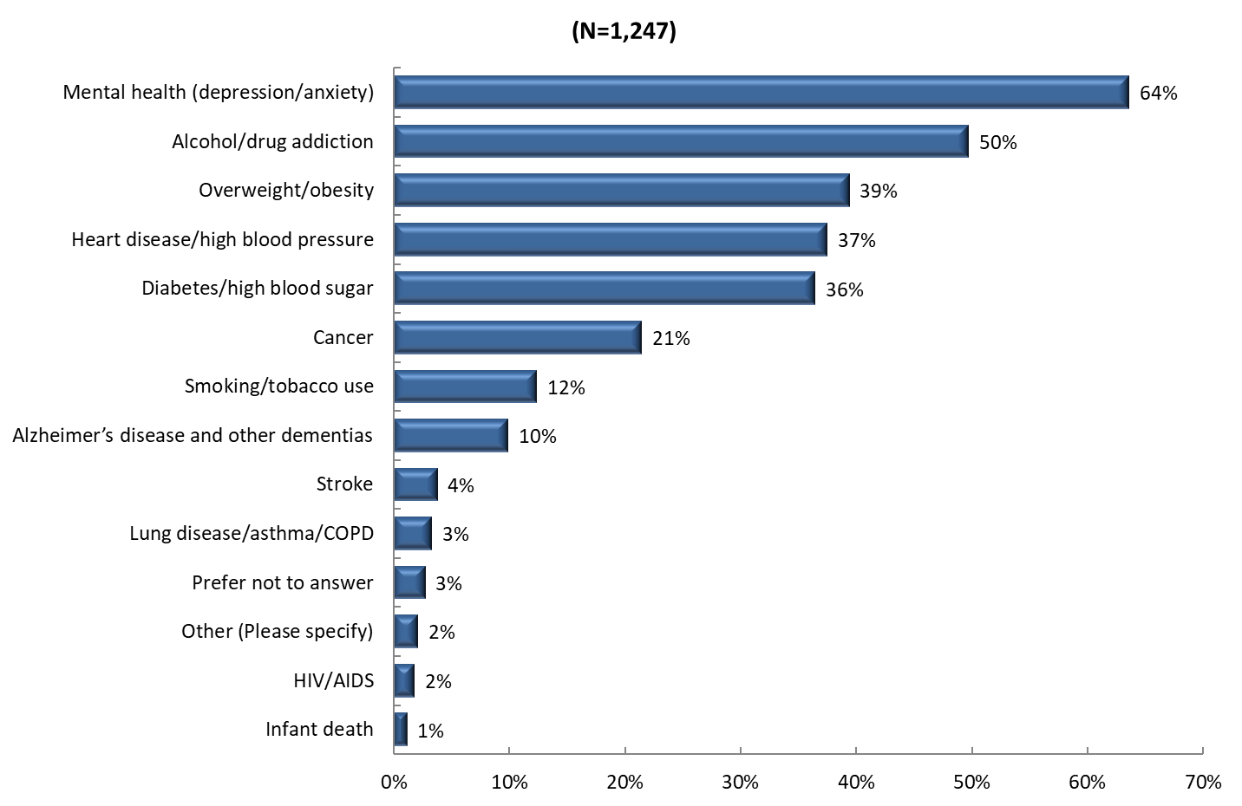
However, when these data were examined by the race of community member respondents, differences emerged. Alcohol/drug addiction had among the most significant variation. Those who identified as White (60%) selected this as an important community health need more frequently than those who identified as Black or African American (39%) and all other races (50%), as displayed in the figure below. Similarly, a higher percentage of respondents identifying as White (68%) selected mental health as a top community health need, while a lower percentage of those identifying as Black or African American (60%) or with another racial identity (58%) selected this as a top need.

Figure 3.3: What are the three most important health problems that affect the health of your community? Please select up to three. (by race)

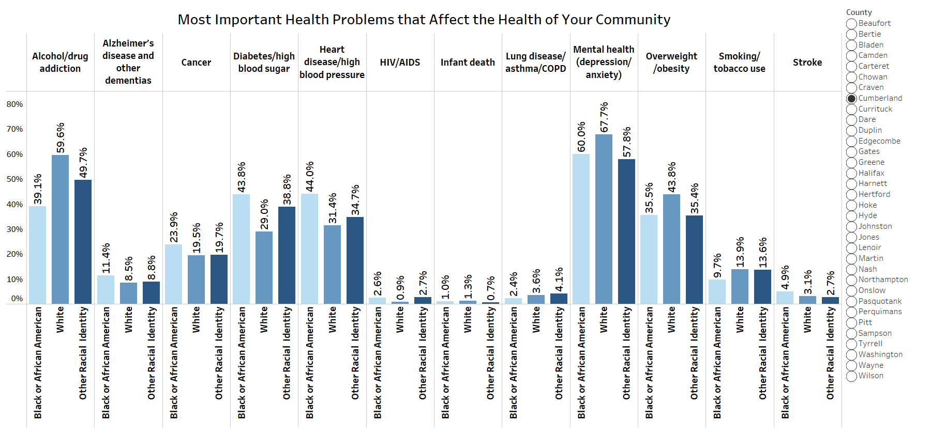

Similarly, there were differences in responses across age groups. Younger people identified alcohol/drug addiction and mental health as more significant than older respondents. These perceived differences by demographic characteristics may be important in planning efforts to address behavioral health in the community.

When respondents were asked about their own mental health, nearly two-thirds of respondents indicated having one or more poor mental health days in the past 30 days, with an average of seven poor mental health days among all respondents.

Figure 3.4:
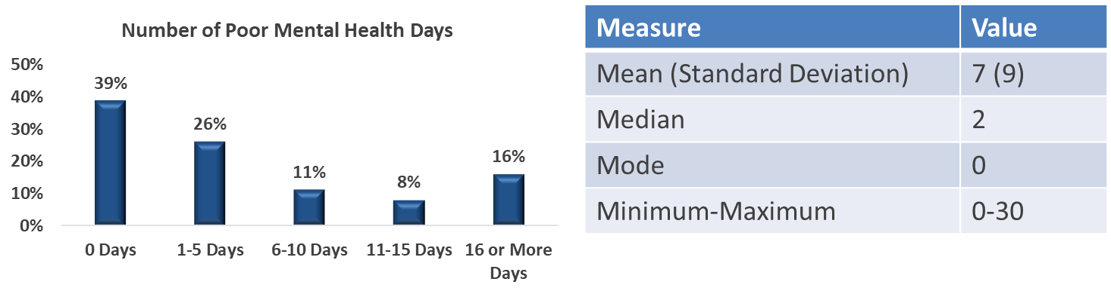
Community member respondents who indicated they experienced at least one poor mental health day a month were asked if there was a time in the past 12 months when they needed mental healthcare or counseling but did not get it at that time. Nearly 40% of these respondents answered yes.

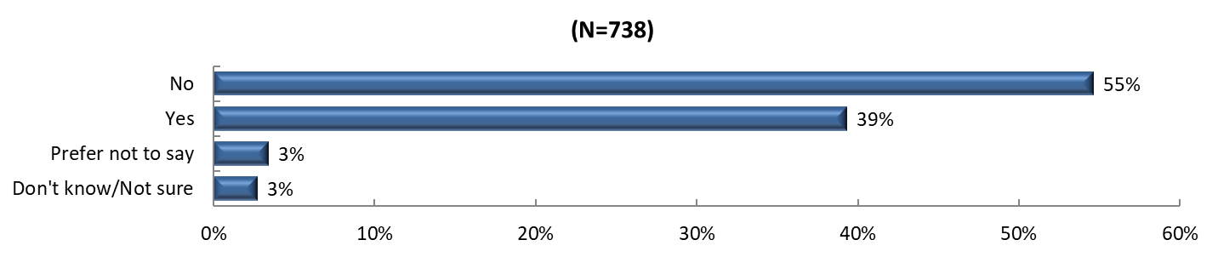
Figure 3.5: Was there a time in the past 12 months when you needed mental healthcare or counseling, but did not get it at that time?

The top responses for why care was not received for this group, included cost/no insurance (18%), being too busy to go to an appointment (14%), and not knowing where to go (11%), suggesting accessibility and resource awareness issues exist in the community that impact access to needed mental healthcare.

For additional detail on survey findings, see Appendix 5.

Primary Data Findings – Focus Groups

Mental health and substance use concerns emerged as significant themes across all four focus groups conducted in Cumberland County. The student focus group at Fayetteville State University highlighted a critical need for more mental health resources and providers in the community. Healthcare workers at Cape Fear Valley Medical Center noted that mental health stigma affects everyone across the county, regardless of demographic background. Military veterans offered unique perspectives on behavioral health challenges, particularly relating to the intersection of military culture and mental well-being. They emphasized the significant health disparities faced by marginalized groups, especially racial minority communities, in accessing mental health support.

In terms of substance use, participants from Fayetteville State University emphasized the need for substance use education classes to teach people about the impacts of drugs and alcohol. Healthcare workers suggested practical health classes focused on mental health, addiction, and violence prevention, emphasizing the importance of preventative approaches rather than just responding to acute concerns.
To address these behavioral health challenges, focus group participants suggested implementing substance use classes in schools, offering parenting classes to support child nurturing, and improving access to mental health resources in underserved areas of the county.

For a more detailed description of focus group findings, see Appendix 5.

Priority Need: Maternal & Infant Health

Context and National Perspective

Maternal health refers to the overall health of pregnant and postpartum women and can be affected by health prior to a pregnancy. Efforts surrounding maternal health are often concentrated towards reducing maternal mortality, premature births, and other pregnancy-related conditions such as gestational diabetes and post-birth infections. Additionally, access to prenatal care among minority groups and increasing equity in maternal health has become a larger focus post-pandemic, with attempts to increase access to providers and mental health services. Most pregnant women (76.7%) do receive enough prenatal care, however those who do not are at least three times more likely to die from a pregnancy-related complication. Maternal mortality is largely preventable, with estimates suggesting that at least 60% of deaths could be avoided. These concerns become compounded in rural areas, due to a potential lack of access to a physical OB/GYN in the community, and patients may have to drive several miles to see a healthcare provider. While telehealth services are becoming more common, prenatal care requires physically seeing a provider to identify any complications. Health outcomes can be improved with mobile ultrasound services, over-the-counter methods like portable vital sign devices like oximeters, and education, such as learning to monitor blood pressure at home.

Maternal mortality has increased in North Carolina, to 76 deaths in 2019, 26% higher than the prior reporting period of 2016. Over one-quarter (26%) of those deaths were due to a drug overdose, and 85% of deaths were considered to be preventable. Additionally, the North Carolina Division of Public Health found that discrimination was a probable factor in nearly 70% of all the deaths, and was the most common factor recorded. This statistic highlights the need for culturally-competent prenatal and postpartum care for all mothers across the state. Improving maternal health can have a positive impact on fetal health by preventing pre-term births, and complications to the fetus related to maternal health conditions such as gestational diabetes and high blood pressure.

Infant health encompasses the health of a child prior to their first birthday. Mortality among infants can be the result of multiple complications, such as congenital defects, low birthweight, maternal health complications, short gestation, and sudden infant death syndrome. In 2022, the rate of infant mortality in the U.S. was 5.6 deaths per 1,000 live births, roughly equal to 20,927 infants. Health disparities also exist within infant health, with Non-Hispanic African American and indigenous infants twice as likely to die before their first birthday than non-Hispanic white infants. While infant health has improved significantly in recent decades, it is still a vital sign highlighting the overall health of a community and state and is also an indicator for the availability of maternal health care. Low maternal and infant mortality rates generally suggest a community is healthy and are also often a sign of high access to healthcare, especially in diverse communities.

Secondary Data Findings

Secondary data analysis revealed concerning trends in maternal and infant health outcomes in Cumberland County. The county's infant mortality rate of 9.0 deaths per 1,000 live births is significantly higher than both North Carolina (7.0) and the United States (5.7). Additionally, the percentage of low birthweight babies in Cumberland County (10.1%) exceeds the North Carolina average (9.4%). Cumberland County performs slightly better than the state average in terms of births with late or no prenatal care, with 5.7% of births falling into this category compared to 6.9% for North Carolina and 6.1% for the United States.

Table 3.4: Maternal and Infant Health Indicators
Report Area | Number of Infant Deaths | Deaths per 1,000 Live Births | % of Births with Late/No Care | % Low Birthweight
Cumberland County | 322 | 9.0 | 5.7 | 10.1%
North Carolina | 5,820 | 7.0 | 6.9 | 9.4%
United States | 150,841 | 5.7 | 6.1 | --

For additional detail on secondary data findings, see Appendix 3.

Primary Data Findings – Community Member Web Survey

While a small percentage of respondents (1%) explicitly identified infant health as an important problem affecting the community, key components of positive maternal health outcomes are access to care, cost of care, and access to providers. Therefore, the following figures and narrative discuss access to care results.

Nearly 1,250 Cumberland residents responded to the web-based survey. Respondents identified several access to care needs in Cumberland County. In the survey, community members were asked to identify the top barriers to receiving healthcare. Cost (85%), no insurance (66%), and wait times (38%) were the top three identified reasons why people in the community are not getting care when they need it. Another one-third of responses (34%) identified lack of transportation, while an additional quarter of responses indicated insurance not being accepted as the top barriers to care.

Figure 3.6: What are the three most important reasons people in your community do not get health care when they need it? Please select up to three.

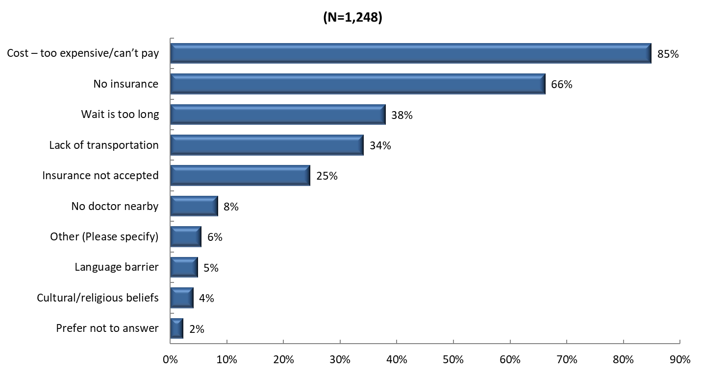
When these data were examined by age group, there was not a wide range of disparity, and all groups indicated the top two barriers to care nearly equally. It is important to note that regarding wait times, those in the 25 to 44 age group were most likely to identify it as a top barrier to care (44%). With respect to gender, women were more likely to identify cost (86% vs. 77%) and lack of insurance (67% vs. 59%) as barriers to care than men.

Figure 3.7: What are the three most important reasons people in your community do not get health care when they need it? Please select up to three. (by age group)

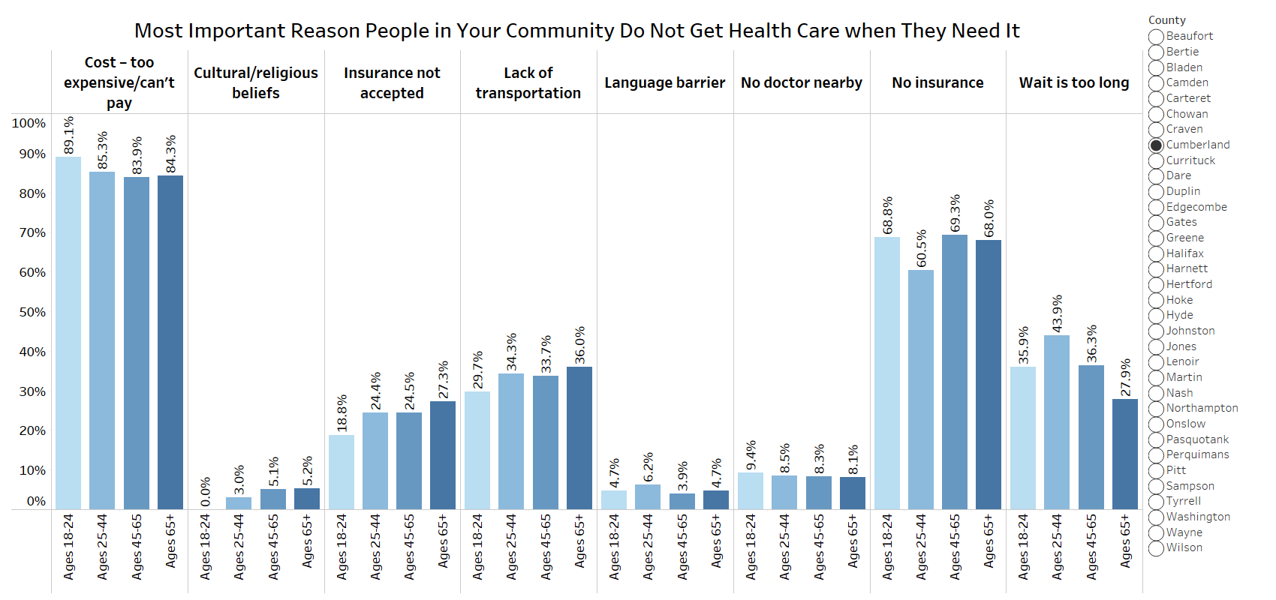

Similar patterns followed with reviewing ethnicity. However, those who identified as Hispanic/Latino were less likely to identify cost (80% versus 85%) and lack of insurance (62% vs. 66%) as barriers to care than non-Hispanic/Latino respondents. Responses also differed by race. Notably, a higher percentage of respondents who identified as Black/African American noted no insurance as a top barrier to healthcare (69%), compared to 65% identifying as White and 62% identifying as “Other”. However, nearly all respondents within each identified race cited cost of care as the top barrier to receiving healthcare.

Figure 3.8: What are the three most important reasons people in your community do not get health care when they need it? Please select up to three. (by race)

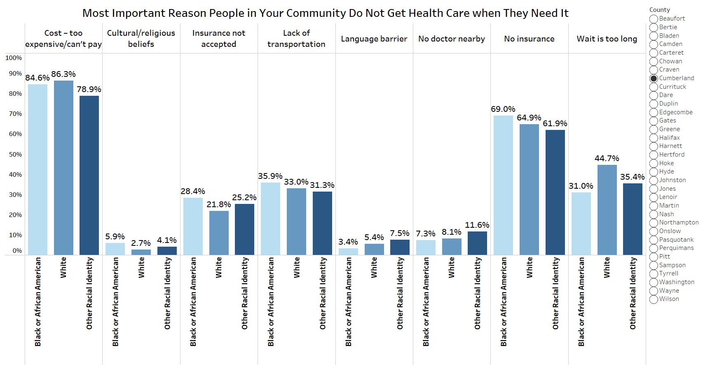

For additional detail on survey findings, see Appendix 5.

Primary Data Findings – Focus Groups

Focus group participants across Cumberland County highlighted several challenges related to healthcare access that could affect maternal and infant health. Participants discussed the high cost of care and challenges with insurance coverage, noting that many people get turned away from healthcare facilities because they lack insurance. The costs of medication and co-pays were specifically noted as barriers to accessing care. Focus group participants indicated that while resources are available in the community, many residents lack knowledge about these resources, including recent changes like Medicaid expansion.

Regarding social and economic factors impacting maternal and infant health, the lack of affordable childcare was identified as a significant issue. Participants particularly highlighted the inadequacy of public transportation and suggested that subsidizing bus fees could help marginalized residents access health services. Concerns were also raised over healthcare facility staffing shortages, long wait times, and a lack of access to urgent care or after-hours clinics.

Some participants suggested that mobile clinics in neighborhoods and community outreach events could help address healthcare access issues. They also emphasized the need for better promotion of existing programs to reach those who need them most, suggesting the use of high-traffic areas to disseminate information about health services.

For a more detailed description of focus group findings, see Appendix 5.

Priority Need: Physical Health

Context and National Perspective

Physical health is the monitoring and maintenance of the human body. There are many factors involved in an individual’s overall physical health status such as disease prevention, timely access to primary and preventive healthcare, exercising, and maintaining a healthy diet. Living a healthy lifestyle is not a one size fits all approach. Many individuals choose to incorporate different healthy behaviors at different times, gradually building healthier habits. The CDC recommends multiple healthy behaviors that can be integrated for healthier living such as getting at least 6-8 hours of sleep every night, moving more and sitting less, limiting alcohol intake, and incorporating healthier food choices. Another healthy behavior that can be incorporated is movement, starting at least 20 minutes a day with some light activity, such as walking or dancing.

Another form of healthy living and disease prevention is taking a proactive role in preventative health care, which can often start with one’s diet. According to experts, losing just 5-10 % of one’s current weight can lower the risk for multiple chronic conditions such as Diabetes, Arthritis, Cancer, and High Blood Pressure. When speaking with a primary care doctor or Nutritionist about creating a healthy diet plan, it is important to have some information prepared, such as food allergies, health goals, the types of medication taken, and any other health concerns that one may have. When considering a diet for weight loss, ensure that the diet is key in both filling and matching a daily activity level of your choice. When implementing a new diet, there are a few recommendations for success. First, eating when hungry and stopping when full is key, and choosing to eat filling foods that one might enjoy, such as one’s favorite vegetables, fruit, or lean protein. Secondly, seasoning the food with different herbs and spices, and reducing the amount of salt and sugar in a recipe. Finally, drinking enough water throughout the day helps with digestion and other bodily functions.

When considering healthy living in rural communities, research has shown that just one in four adults in rural areas are consistently performing at least four healthy behaviors. Rural areas often have fewer or less diverse grocery stores, with many relying on smaller general stores, which may not always have fresh produce and meat. Additionally, these areas also may not have safe places to walk or exercise, such as sidewalks, recreation centers, or parks.

In North Carolina, over half (52%) of adults do not get at least two and a half hours of moderate exercise per week, and over 70% don’t meet weekly muscle strengthening recommendations. However, 84% of adults eat at least one vegetable a day, and over 60% eat fruit at least once a day. North Carolina’s Department of Health and Human Services has implemented several workshops and classes that individuals can take to learn healthy habits, such as Living Healthy workshops. Additionally, several nonprofits have implemented programs to help individuals learn healthy behaviors. North Carolina also has an extensive WIC program, as well as the NCCARE360 program, which seeks to connect individuals with all necessary resources for living a healthier life.

Secondary Data Findings

Secondary data analysis identified multiple physical health concerns in Cumberland County, with the county performing worse than state and national averages across several chronic disease indicators. As displayed in the table below, Cumberland County has notably higher rates of various chronic conditions, including Obesity (37.1% compared to state average of 29.7%), Hypertension (37.1% compared to 32.1% state average), and Diabetes (12.2% compared to 9.0% state average).

Table 3.5: Chronic Disease Related Indicators
Indicator | Cumberland County | North Carolina | United States
Adults (Age 18+) with Asthma | 10.5% | 9.8% | 9.7%
Adults (Age 20+) with Diagnosed Diabetes | 12.2% | 9.0% | 8.9%
Adults (Age 18+) Ever Diagnosed with Coronary Heart Disease | 5.8% | 5.5% | 5.2%
Adults (Age 18+) with Hypertension | 37.1% | 32.1% | 29.6%
Adults (Age 18+) with High Cholesterol | 31.8% | 31.4% | 31.0%
Adults (Age 18+) with Kidney Disease | 3.3% | 2.9% | 2.7%
Adults (Age 18+) Ever Having a Stroke | 3.5% | 3.1% | 2.8%
Adults with BMI > 30.0 (Obese) | 37.1% | 29.7% | 30.1%
Adults (Age 18+) with Poor Dental Health | 13.5% | 12.0% | 13.9%
Percent Reporting Poor or Fair Health | 17.6% | 14.4% | -

The emergency room visit rate in Cumberland County (608 per 1,000 population) significantly exceeds both state (563) and national (535) averages, suggesting potential challenges in managing chronic conditions through preventive care. The county has comparable rates to the state for Cardiovascular Disease hospitalizations (11.7 per 1,000 population) and Stroke hospitalizations (9.7 per 1,000 population), though both exceed national averages.

Table 3.6: Emergency Room Visits and Hospitalizations
Indicator | Cumberland County | North Carolina | United States
Emergency Room Visits  (Rate per 1,000 Population) | 608 | 563 | 535
Cardiovascular Disease Hospitalizations  (Rate per 1,000 Medicare Beneficiaries) | 11.7 | 11.7 | 10.4
Ischemic Stroke Hospitalizations  (Rate per 1,000 Medicare Beneficiaries) | 9.7 | 9.5 | 8.0

Several health behavior indicators that influence physical health outcomes show room for improvement in Cumberland County. The county has fewer recreational facilities (8.4 per 100,000 population) compared to state (13.1) and national (14.7) averages, and a higher percentage of physically inactive adults (24.5%) compared to the state average (21.6%). Additionally, just 73% of the population has access to exercise opportunities, lower than the national average of 84%.

Table 3.7: Health Behavior and Environmental Indicators
Indicator | Cumberland County | North Carolina | United States
Recreation and Fitness Facility Establishments, (Rate per 100,000 Population) | 8.4 | 13.1 | 14.7
Walkability Index Score | 7 | 7 | 10
% Physically Inactive | 24.5 | 21.6 | -
Percentage of Population with Access to Exercise Opportunities | 73% | 73% | 84%

Healthcare access metrics suggest potential barriers to managing physical health conditions as well. While Cumberland County has a higher rate of primary care providers (107.0 per 100,000 population) compared to the state average (101.1), it has a higher rate of preventable hospitalizations and a 30-day hospital readmission rate of 22%, exceeding both state and national averages of 18%. Despite having provider availability, residents may face challenges in accessing or maintaining consistent care for chronic conditions.
Figure 3.9: Preventable Hospitalization Rate by Year 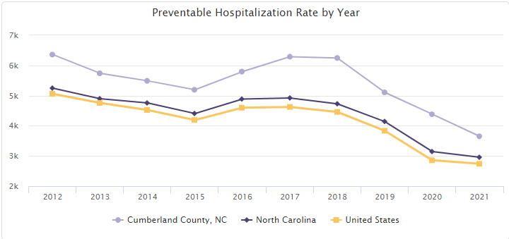

For additional detail on secondary data findings, see Appendix 3.

Primary Data Findings – Community Member Web Survey

Cumberland County residents identified several physical health concerns in the community in the web survey. In fact, seven out of the top ten most frequently identified community health needs were chronic health conditions with the top being Overweight/Obesity (39% of respondents), followed by Heart Disease/High Blood Pressure (37%). A third of respondents also identified Diabetes/High Blood Sugar as an important community health problem.

Figure 3.10: What are the three most important health problems that affect the health of your community? Please select up to three.

When these results were examined by various demographics of the respondents, responses varied. Older adults viewed diabetes and heart disease as more significant problems than younger respondents, as displayed in Figure 3.11 below. Respondents identifying as all other races and Black or African American identified diabetes/high blood sugar and heart disease/high blood pressure more frequently than respondents identifying as White. Women were also more likely to identify these as important community health problems than men. Considering these differences in targeted efforts to address specific community health indicators may be important.

Figure 3.11: What are the three most important health problems that affect the health of your community? Please select up to three. (by age group)

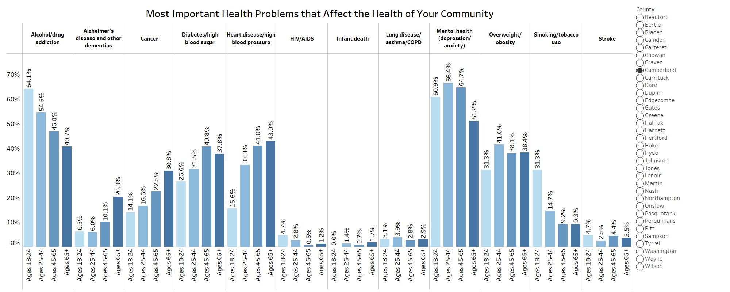

In terms of community perspectives on health behaviors and food security, 14% of Cumberland County respondents viewed limited access to healthy foods as an important social or environmental problem in the community, while 6% selected limited places to exercise. Women were more likely to view limited access to healthy food (14% vs. 11% for men) and limited places to exercise (6% vs. 5% for men) as top concerns in the community. Similarly, Hispanic/Latino respondents identified limited to healthy foods (23%) as a top concern nearly twice as frequently as non-Hispanic/Latino respondents (13%).

For additional detail on survey findings, see Appendix 5.

Primary Data Findings – Focus Groups

Physical health concerns were discussed extensively across all four focus groups, with each population highlighting unique challenges. Healthcare workers at Cape Fear Valley Medical Center identified several prevalent conditions including high blood sugar, obesity, asthma, and sickle cell disease. They noted that these conditions particularly impact communities with limited access to preventive care.

The migrant farmworker focus group at Jeff Simpson Farm described specific physical health challenges related to their work conditions, including dehydration, body aches, cramps, headaches, colds, nausea, and hallucinations. Environmental factors, particularly extreme heat, were noted to significantly impact their physical health and working conditions.

Military veterans highlighted unique physical health concerns specific to their population as well, particularly noting a high prevalence of gut issues, including Crohn's disease, which they attributed to military diet and culture. They also expressed concerns about environmental factors affecting physical health, specifically regarding water quality and air pollution from local factories and plants.

Built environment challenges were identified as barriers to maintaining physical health. Healthcare workers noted the lack of sidewalks, absence of bike-friendly roads, and limited places to exercise as significant impediments to physical activity. The military veterans group suggested tightening regulations on local plants to improve environmental health conditions that affect physical well-being.

To address these physical health challenges, participants suggested increasing targeted health education for younger audiences and focusing on preventative care rather than just responding to acute health concerns. The healthcare worker group emphasized the need for practical health education and improved access to exercise opportunities.

For a more detailed description of focus group findings, see Appendix 5.

CHAPTER 4 | HEALTH RESOURCE INVENTORY

NCLHDA requirements for local health departments and IRS requirements for nonprofit hospitals require the CHNA report to include a description of the resources available in a county to address the significant health needs identified in the assessment. This section includes information about local organizations in Cumberland County that provide resources to address general community health needs, as well as the county’s 2024 priority need areas: Behavioral Health, Physical Health and Maternal and Infant Health.
Category | Organization Name
County Resource Directories | - NC 211: Information and referral service provided by United Way of North Carolina. Call 2-1-1 or 1-888-892-1162 for assistance.  - Community Resource Guide  - Cumberland County Department of Public Health Resource Booklet
Healthcare Facilities | - Cumberland County Department of Public Health: Offers various health services including immunizations, maternal health, child health, and STD clinics. (1235 Ramsey St., Fayetteville, NC 28301, (910) 433-3600)  - Better Health of Cumberland County: Provides assistance for chronic conditions such as diabetes and hypertension, a free medication program, and a clinic for the uninsured. (1422 Bragg Blvd., Fayetteville, NC 28301, (910) 483-7534)  - The CARE Clinic: Free medical and dental care for uninsured, low-income adults. (239 Robeson St., Fayetteville, NC 28301, (910) 485-0555)  - Community Mental Health Center at Cape Fear Valley: Mental health services for children, adolescents, and adults. (1724 Roxie Ave., Fayetteville, NC 28304, (910) 615-3333)  - Alliance Behavioral Healthcare: Mental health, developmental disability, and substance abuse services. (711 Executive Pl., Fayetteville, NC 28305, (800) 510-9132)  - Goshen Medical Center - Cape Fear: Primary care services with a sliding fee scale. (3613 Cape Center Dr., Fayetteville, NC 28304, (910) 354-1720)  - Cape Fear Regional Bureau for Community Action, Inc.: Provides various health and social services. (2008 Murchison Rd., Fayetteville, NC 28301, (910) 483-9177)
Other Healthcare Services | Substance Use and Recovery Services  - Myrover Reese Fellowship Homes Inc.: Recovery services for substance use users. (1418 Clinton Rd., Fayetteville, NC 28301, (910) 223-1148)  - Operation Blessing: Emergency food, clothing, and assistance with utility and rent bills. (1337 Ramsey St., Fayetteville, NC 28301, (910) 483-1119)  - Oxford Houses: Recovery housing for substance use. (5307 Cypress Rd. for Women, 5214 Cypress Rd. for Men, Fayetteville, NC, (910)  433-9123 for women, (910) 425-8221 for men)  Services for the Disabled  - North Carolina Department of Health & Human Services - Division of Services for the Blind: Vocational rehabilitation and social work services. (225 Green St., Suite 500, Fayetteville, NC 28301, (910) 486-1582)  - Vision Resource Center: Rehabilitation, educational, and social programs for the blind and visually impaired. (1600 Purdie Dr., Fayetteville, NC 28301, (910) 483-2719)
Community Services | Emergency and Crisis Services  - Rape Crisis Center: Support and resources for individuals affected by sexual violence. (515 Ramsey St., Fayetteville, NC 28301, (910) 485-7273)  Other Community Services  - Fayetteville Economic Development Corporation  - Fayetteville Murchinson Road Choice Neighborhood  - Fayetteville Technical Community College  - Fayetteville Urban Ministries  - Region 6 Tobacco Prevention Collaborative Stedman-Wade Health Services
Additional Resources | - Assurance Wireless and SafeLink Wireless: Provides cell phones for low-income and homeless individuals. (Assurance: (888) 321-5880, SafeLink: (800) 977-3768)  - Greater Image Healthcare: Mental health services. (401 Robeson St., Fayetteville, NC 28301, (910) 321-0069)  - PATH (Projects for Assistance in Transition from Homelessness): Assistance for the homeless with mental health issues. (711 Executive Pl., Fayetteville, NC 28305, (910) 491-4800)
Priority Need: Behavioral Health (Mental Health and Substance Use) | - Cape Fear Valley Health System: Provides services in southeastern North Carolina with a range of medical services and facilities. (1638 Owen Dr, Fayetteville, NC 28301, (910) 615-4000)  - Cumberland HealthNet: Provides care for the uninsured residents. (225 Green St, Suite 410 Fayetteville, NC 28301, (910) 483-6869)  - First Health Moore Regional Hospital: Provides quality healthcare for the entire community. (155 Memorial Dr, Pinehurst, NC 28374, (910) 715-1000)  - Womack Army Medical Center: Provides comprehensive medical services to soldiers, retirees, and their families. (2817 Rock Merritt Ave, Fort Liberty, NC 28310, (910) 907-6000)  - Cumberland County Emergency Management: Coordinates community emergency planning with key stakeholders to define roles during major emergencies. (500 Executive Place, Fayetteville, NC 28305, (910) 438-4069  - Alliance Health: Mental Health Services (711 Executive Place, Fayetteville, NC 28305, (910) 651-8401)  - Cumberland County Department of Public Health: Provides an array of services to Cumberland County residents (1235 Ramsey St., Fayetteville, NC 28301, (910) 433-3600)  - RI International Recovery Response Center: Mental health Services (1724 Roxie Ave, Fayetteville, NC 28304, (910) 778-5900.)  - Lifenet Services  - Cumberland County Recovery Resource Center: Provides support and resources for individuals at any stage of recovery from substance use. (707 Executive Place, Fayetteville, NC 28305, (910) 321-6485).  - Cumberland County Department of Social Services: Collaborates with community partners to provide programs and services that improve quality of life. (1225 Ramsey St, Fayetteville, NC 28301. (910)323-1540)  - Cumberland Community Collaborative: Health consultant (351 Wagoner Dr, Suite 309, Fayetteville, NC 28303. (910) 485-1250.)
Priority Need: Physical Health | - Cape Fear Valley Health System  - Cumberland County Department of Public Health  - Cumberland County Department of Social Services  - Cumberland Community Collaborative
Priority Need: Maternal and Infant Health | - Cape Fear Valley Health System  - Womack Army Medical Center  - Fayetteville Women’s Care  - Jones Center for Womens Health  - A Women’s Place  - Women’s Wellness Center  - All American Obstetrics & Gynecology  - Cumberland County Department of Public Health  - LATCH Breastfeeding and Postpartum Wellness Center  - Momma’s Village-Fayetteville  - Mother’s Helper  - Central Carolina Doulas  - Dandelion Legacy Doula Services  - Divine Doula Goddess  - The Fayetteville Doulas  - Cumberland County Department of Social Services  - Cumberland Community Collaborative

CHAPTER 5 | NEXT STEPS

The CHNA findings are used to develop effective community health improvement strategies to address the priority needs identified throughout the process. The next and final step in the CHNA process is to develop community-based health improvement strategies and action plans to address the priorities identified in this assessment. Health leaders in Cumberland County will leverage information from this CHNA to develop implementation and action plans for their local community, while also working together with other community partners to ensure the priority need areas are being addressed in the most efficient and effective way. Cumberland County leaders recognize that the most effective strategies will be those that have the collaborative support of community organizations and residents. The strategies developed will include measurable objectives through which progress can be measured.

APPENDIX 1 | STATE OF THE COUNTY HEALTH REPORT

Results-Based Accountability Framework

To meet North Carolina accreditation requirements, LHDs are required to track progress on their implementation plans by publishing an annual State of the County Health Report (SOTCH). The SOTCH is guided by the Results-Based Accountability (RBA) Framework, and demonstrates that the LHD is tracking priority issues identified in the community health (needs) assessment process, identifying emerging issues, and implementing any relevant new initiatives to address community concerns.

Figure A1.1: Population vs. Performance Accountability
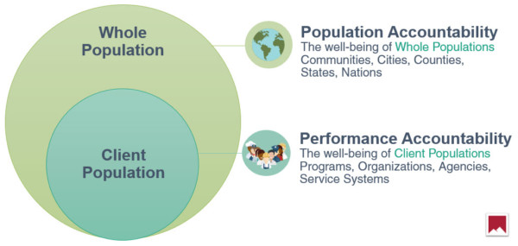
RBA provides a disciplined way of thinking about – and acting upon – complex social issues, with the goal of improving the lives of all members of the community. The framework is organized to recognize two distinct types of accountability: population and performance. Population accountability refers to the well-being of entire populations, and RBA recognizes that it is challenging, if not impossible, to hold individual organizations accountable for solving systemic problems. Conversely, performance accountability recognizes that individual organizations are accountable for the outcomes and impact of their programs, policies and practices as they relate to their client populations. Figure A1.1 illustrates the way population and performance accountability interact.

In the CHIP process, RBA asks three key questions: how much did we do, how well did we do it, and is anyone better off? To more effectively answer these questions, and develop measurable strategies to address community health concerns, North Carolina LHDs use a software called Clear Impact Scorecard to develop their SOTCH and track progress against their goals. Clear Impact Scorecard is performance management and reporting software used by non-profit and government agencies to efficiently and effectively explain the impact of their work. The scorecard mirrors RBA and links results with indicators and programs with performance measures. Cumberland County’s most recent SOTCH is presented on the following pages.

State of the County Health Report
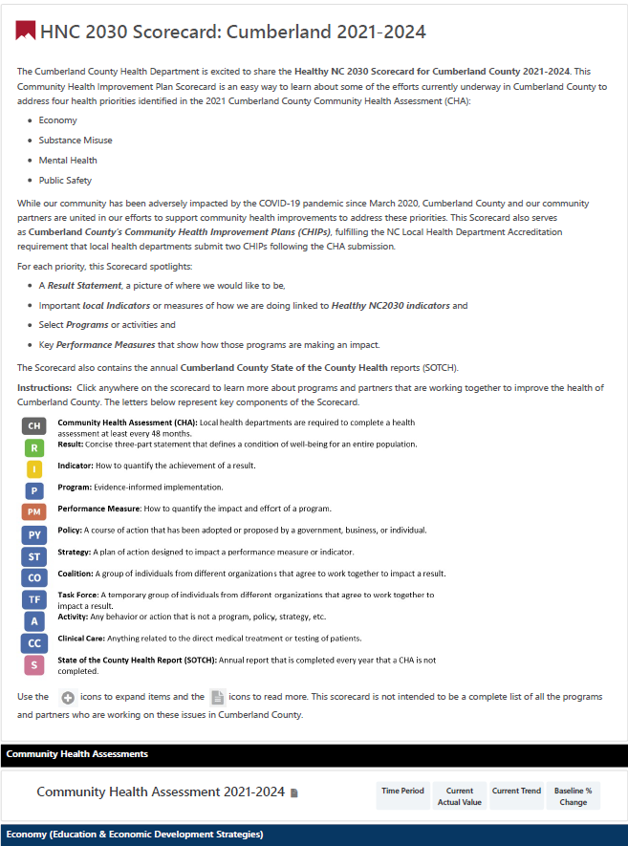
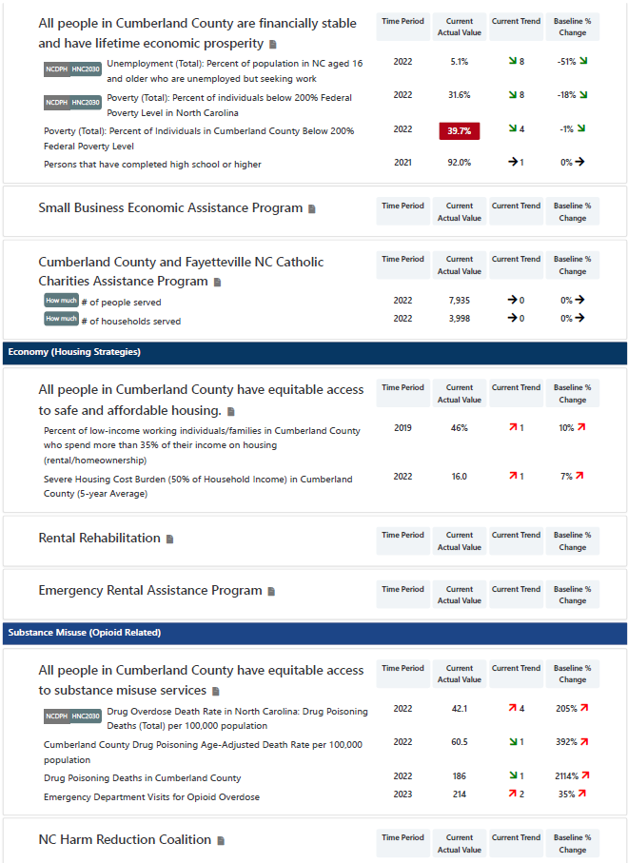
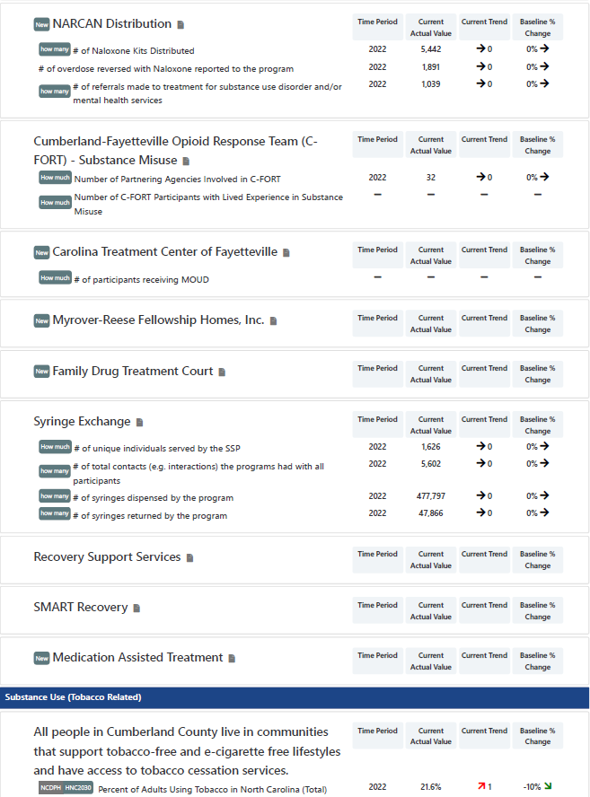
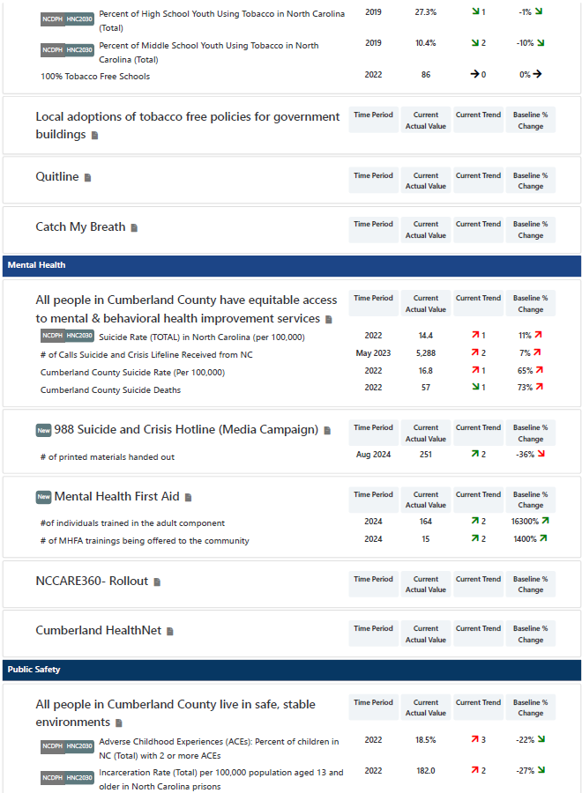
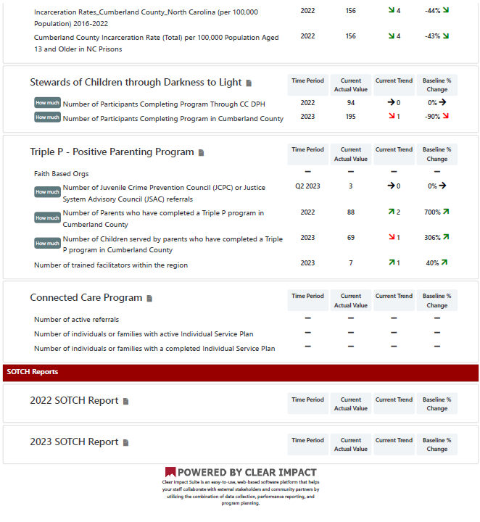

APPENDIX 2 | SECONDARY DATA METHODOLOGY AND SOURCES

Many individual secondary data measures were analyzed as part of the CHNA process. These data provide detailed insight into the health status and health-related behavior of residents in the county. These secondary data are based on statistics of actual occurrences, such as the incidence of certain diseases, as well as statistics related to SDoH.

Methodology

All individual secondary data measures were grouped into six categories and 20 corresponding focus areas based on “common themes.” In order to draw conclusions about the secondary data for Cumberland County, its performance on each data measure was compared to targets/benchmarks. If Cumberland County’s performance was more than five percent worse than the comparative benchmark, it was concluded that improvements could be needed to better the health of the community. Conversely, if an area performed more than five percent better than the benchmark, it was concluded that while a need is still present, the significance of that need relative to others is likely less acute. The most recently available data were compared to these targets/benchmarks in the following order (as applicable):

- For all available data sources, state and national averages were compared.

The following methodology was used to assign a priority level to each individual secondary data measure:
- If the data were more than 5 percent worse = High need
- If the data were within or equal to 5 percent (better or worse) = Medium need
- If the data were more than 5 percent better = Low need

These measures are noted with an asterisk.

Additionally, data measures were also viewed with regard to performance over time and whether the measure has improved or worsened compared to the prior CHNA timeframe.

Data Sources

The following tables are organized by each of the twenty focus areas and contain information related to the secondary data measures analyzed including a description of each measure, the data source, and most recent data time periods.
Table A2.1: Access to Care
Measure | Description | Data Source | Most Recent Data Year(s)
Primary Care Providers (per 100,000 population) | Number of providers with a CMS National Provider Identifier (NPI) that specialize in primary care. Primary health providers include practicing physicians specializing in general practice medicine, family medicine, internal medicine, and pediatrics. | Centers for Medicare and Medicaid Services (CMS) – National Plan and Provider Enumeration System (NPPES). Data accessed via the North Carolina Data Portal, June 2024. | 2024
Mental Health Providers (per 100,000 population) | Number of providers with a CMS National Provider Identifier (NPI) that specialize in mental health. Mental health providers include licensed clinical social workers and other credentialed professionals specializing in psychiatry, psychology, counseling, or child, adolescent, or adult mental health. | CMS –NPPES. Data accessed via the North Carolina Data Portal, June 2024. | 2024
Addiction/Substance Use Providers (per 100,000 population) | Number of providers who specialize in addiction or substance use treatment, rehabilitation, addiction medicine, or providing methadone. The providers include Doctors of Medicine (MDs), Doctors of Osteopathic Medicine (DOs), and other credentialed professionals with a Center for Medicare and Medicaid Services and a valid National Provider Identifier (NPI). | CMS –NPPES. Data accessed via the North Carolina Data Portal, June 2024. | 2024
Buprenorphine Providers (per 100,000 population) | Number of providers authorized to treat opioid dependency with buprenorphine. Buprenorphine is the first medication to treat opioid dependency that is permitted to be prescribed or dispensed in physician offices, significantly increasing treatment access. Qualified physicians are required to acquire and maintain certifications to legally dispense or prescribe opioid dependency medications. | US Department of Health and Human Services (DHHS), Substance Abuse and Mental Health Services Administration. Data accessed via the North Carolina Data Portal, June 2024. | 2023
Dental Health Providers (per 100,000) | Number of oral health providers with a CMS National Provider Identifier (NPI). Providers included are those who list “dentist”, “general practice dentist”, or “pediatric dentistry” as their primary practice classification, regardless of sub-specialty. | CMS – NPPES. Data accessed via the North Carolina Data Portal, June 2024. | 2024
Health Professional Shortage Areas - Dental Care | Percentage of the population that is living in a geographic area designated as a “Health Professional Shortage Area” (HSPA), defined as having a shortage of dental health professionals. This indicator is relevant because a shortage of health professionals contributes to access and health status issues. | U.S. Census Bureau, American Community Survey (ACS). Data accessed via the North Carolina Data Portal, June 2024. | 2018-2022
Federally Qualified Health Centers (FQHCs) | Number of Federally Qualified Health Centers (FQHCs) in the community. This indicator is relevant because FQHCs are community assets that provide health care to vulnerable populations; they receive extra funding from the federal government to promote access to ambulatory care in areas designated as medically underserved. | U.S. DHHS, CMS, Provider of Services File. Data accessed via the North Carolina Data Portal, June 2024. | 2023
Population Receiving Medicaid | Percentage of the population with insurance enrolled in Medicaid (or other means-tested public health insurance). This indicator is relevant because it assesses vulnerable populations which are more likely to have multiple health access, health status, and social support needs; when combined with poverty data, providers can use this measure to identify gaps in eligibility and enrollment. | U.S. Census Bureau, ACS. Data accessed via the North Carolina Data Portal, June 2024. | 2018-2022
Uninsured Population (SAHIE) | Percentage of adults under age 65 without health insurance coverage. This indicator is relevant because lack of health insurance is a primary barrier to healthcare access including regular primary care, specialty care, and other health services that contribute to poor health status. The lack of health insurance is considered a key driver of health status. | U.S. Census Bureau, Small Area Health Insurance Estimates (SAHIE). Data accessed via the North Carolina Data Portal, June 2024. | 2022

Table A2.2: Built Environment
Measure | Description | Data Source | Most Recent Data Year(s)
Broadband Access (Access to DL Speeds >= 25MBPS and UL Speeds >= 3 MBPS) | Percentage of population with access to high-speed internet. Data are based on the reported service area of providers offering download speeds of 25 MBPS or more and upload speeds of 3 MBPS or more. These data represent both wireline and fixed/terrestrial wireless internet providers. Cellular internet providers are not included. | Federal Communications Commission (FCC) FABRIC Data. Additional data analysis by CARES. Data accessed via the North Carolina Data Portal, June 2024. | 2023
Broadband Access (Access to DL Speeds >= 100MBPS and UL Speeds >= 20 MBPS) | Percentage of population with access to high-speed internet. Data are based on the reported service area of providers offering download speeds of 100 MBPS or more and upload speeds of 20 MBPS or more. These data represent both wireline and fixed/terrestrial wireless internet providers. Cellular internet providers are not included. | FCC FABRIC Data. Additional data analysis by CARES. Data accessed via the North Carolina Data Portal, June 2024. | 2023
Households with No Computer | Percentage of households who don’t own or use any types of computers, including desktop or laptop, smartphone, tablet, or other portable wireless computer, and some other type of computer, based on the 2018-2022 American Community Survey estimates. | U.S. Census Bureau, ACS. Data accessed via the North Carolina Data Portal, June 2024. | 2018-2022
Households with No or Slow Internet | Percentage of households who either use dial-up as their only way of internet connection or have internet access but don’t pay for the service, or have no internet access in their home, based on the 2018-2022 American Community Survey estimates. | U.S. Census Bureau, ACS. Data accessed via the North Carolina Data Portal, June 2024. | 2018-2022
Liquor Stores | Number of liquor stores per 100,000 population provides a measure of environmental influences on dietary behaviors and the accessibility of healthy foods. Note this data excludes establishments preparing and serving alcohol for consumption on premises (including bars and restaurants) or which sell alcohol as a secondary retail product (including gas stations and grocery stores). | U.S. Census Bureau, County Business Patterns. Additional data analysis by CARES. Data accessed via the North Carolina Data Portal, June 2024. | 2022
Adverse Childhood Experiences (ACEs) | Percentage of children in North Carolina (total) with two or more ACEs. ACEs are potentially traumatic events that occur in childhood (0-17 years), including experiencing violence, abuse, or neglect; witnessing violence in the home or community; and having a family member attempt or die by suicide. Also included are aspects of the child’s environment that can undermine their sense of safety, stability, and bonding, such as substance use problems, mental health problems, instability due to parental separation, and instability due to household members being in jail or prison. Other traumatic experiences that impact health and well-being may include not having enough food to eat, experiencing homelessness or unstable housing, or experiencing discrimination. ACEs can have lasting effects on health and well-being in childhood and life opportunities well into adulthood, for example, education and job potential. These experiences can increase the risks of injury, sexually transmitted infections, teen pregnancy, suicide, and a range of chronic diseases including cancer, diabetes, and heart disease. | Clear Impact Healthy North Carolina (HNC) 2030 Scorecard, 2021-2024. Data accessed June 2024. | 2022

Table A2.4: Diet and Exercise
Measure | Description | Data Source | Most Recent Data Year(s)
Physical inactivity (percent of adults that report no leisure time physical activity) | Percentage of adults ages 20 and over reporting no leisure-time physical activity in the past month. Examples of physical activities include running, calisthenics, golf, gardening, or walking for exercise.  The method for calculating Physical Inactivity changed. Data for Physical Inactivity are provided by the CDC Interactive Diabetes Atlas which combines 3 years of survey data to provide county-level estimates. In 2011, BRFSS changed their methodology to include cell phone and landline participants. Previously only landlines were used to collect data. Physical Inactivity is created using statistical modeling. | Behavioral Risk Factor Surveillance System. Data accessed via Robert Wood Johnson Foundation & University of Wisconsin Population Health Institute County Health Rankings & Roadmaps, June 2024. | 2021
Community Design - Walkability Index Score | The National Walkability Index (2021) is a nationwide index score developed by the Environmental Protection Agency (EPA) that ranks block groups according to their relative walkability using selected variables on density, diversity of land uses, and proximity to transit from the Smart Location Database. The block groups are assigned their final National Walkability Index scores on a scale of 1 to 20 where the higher a score, the more walkable the community is. | EPA – Smart Location Database. Data accessed via the North Carolina Data Portal, June 2024. | 2021
Access to Exercise Opportunities | Percentage of individuals in the county who live reasonably close to a location for physical activity. Locations for physical activity are defined as parks or recreational facilities. The numerator is the 2020 total population living in census blocks with adequate access to at least one location for physical activity (adequate access is defined as census blocks where the border is a half-mile or less from a park, 1 mile or less from a recreational facility in an urban area, or 3 miles or less from a recreational facility in a rural area) and the denominator is the 2020 resident county population. This indicator is used in the 2024 County Health Rankings. | ArcGIS Business Analyst and Living Atlas of the World, YMCA & U.S. Census Tigerline Files. Data accessed via the North Carolina Data Portal, June 2024. | 2023
Recreation and Fitness Facility Access (per 100,000 population) | Number of establishments primarily engaged in operating fitness and recreational sports facilities featuring exercise and other active physical fitness conditioning or recreational sports activities, such as swimming, skating, or racquet sports. Access to recreation and fitness facilities encourages physical activity and other healthy behaviors. | U.S. Census Bureau, County Business Patterns. Additional data analysis by CARES. Data accessed via the North Carolina Data Portal, June 2024. | 2022
Sugar-Sweetened Beverage (SSB) Consumption Among Adults | Percentage of total adults reporting consumption of one or more SSBs per day. | Clear Impact. HNC2030 Scorecard, 2021-2024. Data accessed June 2024. | 2022

Table A2.5: Education
Measure | Description | Data Source | Most Recent Data Year(s)
Population with Limited English Proficiency | Percentage of the population aged 5 and older who speak a language other than English at home and speak English less than "very well". This indicator is relevant because an inability to speak English well creates barriers to healthcare access, provider communications, and health literacy/education. | U.S. Census Bureau, ACS. Data accessed via the North Carolina Data Portal, June 2024. | 2018-2022
High School Graduation Rate | Percentage of high school students who graduate within four years. The adjusted cohort graduation rate (ACGR) is a graduation metric that follows a “cohort” of first-time 9th graders in a particular school year, and adjusts this number by adding any students who transfer into the cohort after 9th grade and subtracting any students who transfer out, emigrate to another county, or pass away. | U.S. Department of Education, EDFacts. Additional data analysis by CARES. Data accessed via the North Carolina Data Portal, June 2024. | 2020-2021
No High School Diploma | Percentage of the population aged 25 and older without a high school diploma (or equivalency) or higher. This indicator is relevant because educational attainment is linked to positive health outcomes. | U.S. Census Bureau, ACS. Data accessed via the North Carolina Data Portal, June 2024. | 2018-2022
Student Math Proficiency (4th Grade) | Percentage of 4th grade students testing below the “proficient” level on the Math portion of state-specific standardized tests. | U.S. Department of Education, EDFacts. Additional data analysis by CARES. Data accessed via the North Carolina Data Portal, June 2024. | 2020-2021
Student Reading Proficiency (4th Grade) | Percentage of 4th grade students testing below the “proficient” level on the English Language Arts portion of state-specific standardized tests. | US Department of Education, EDFacts. Additional data analysis by CARES. Data accessed via the North Carolina Data Portal, June 2024. | 2020-2021
School Funding Adequacy | The average gap in dollars between actual and required spending per pupil among public school districts. Required spending is an estimate of dollars needed to achieve U.S. average test scores in each district. | School Finance Indicators Database. Data accessed via RWJF & UWPHI County Health Rankings & Roadmaps, June 2024. | 2021
School Funding Adequacy – Spending per Pupil | Actual spending per pupil among public school districts. | School Finance Indicators Database. Data accessed via RWJF & UWPHI County Health Rankings & Roadmaps, June 2024. | 2021

Table A2.6: Employment
Measure | Description | Data Source | Most Recent Data Year(s)
Unemployment Rate (percent of population age 16+ but unemployed) | Percentage of the civilian non-institutionalized population age 16 and older (non-seasonally adjusted) that is unemployed but seeking work. This indicator is relevant because unemployment creates financial instability and barriers to access including insurance coverage, health services, healthy food, and other necessities that contribute to poor health status. | U.S. Department of Labor, Bureau of Labor Statistics. Data accessed via the North Carolina Data Portal, June 2024. | 2024
Average Annual Unemployment Rate, 2013-2023 | Average yearly percentage across the given time period of the civilian non-institutionalized population age 16 and older (non-seasonally adjusted) that is unemployed but seeking work. This indicator is relevant because unemployment creates financial instability and barriers to access including insurance coverage, health services, healthy food, and other necessities that contribute to poor health status. | U.S. Census Bureau, ACS. Data accessed via the North Carolina Data Portal, June 2024. | 2024

Table A2.7: Environmental Quality
Measure | Description | Data Source | Most Recent Data Year(s)
Climate and Health – Flood Vulnerability | Estimated number of housing units within the special flood hazard area (SFHA) per county. The SFHAs have 1% annual chance of coastal or riverine flooding. | Federal Emergency Management Agency (FEMA), National Flood Hazard Layer. Data accessed via the North Carolina Data Portal, June 2024. | 2011
Air and Water Quality – Drinking Water Safety | Number of drinking water violations recorded in a two-year period. Health-based violations include incidents where either the amount of contaminant exceeded the maximum contaminant level (MCL) safety standard, or where water was not treated properly. In cases where a water system serves multiple counties and has a violation, each county served by the system is given a violation. | EPA. Data accessed via the North Carolina Data Portal, June 2024. | 2023

Table A2.8: Family, Community, and Social Support
Measure | Description | Data Source | Most Recent Data Year(s)
Childcare Cost Burden | Childcare costs for a median-income household with two children as a percentage of household income. Data are included as part of the 2024 County Health Rankings. | The Living Wage Calculator, Small Area Income and Poverty Estimates. Data accessed via the North Carolina Data Portal, June 2024. | 2023
Young People Not in School and Not Working | Percentage of youth ages 16-19 who are not currently enrolled in school and who are not employed. | U.S. Census Bureau, ACS. Data accessed via the North Carolina Data Portal, June 2024. | 2018-2022

Table A2.9: Food Security
Measure | Description | Data Source | Most Recent Data Year(s)
Food Insecurity Rate | Estimated percentage of the population that experienced food insecurity at some point during the report year. Food insecurity is the household-level economic and social condition of limited or uncertain access to adequate food. | Feeding America. Data accessed via the North Carolina Data Portal, June 2024. | 2021
Food Insecure Children | Estimated percentage of the population under age 18 that experienced food insecurity at some point during the report year. Food insecurity is the household-level economic and social condition of limited or uncertain access to adequate food. | Feeding America. Data accessed via the North Carolina Data Portal, June 2024. | 2021
Low-Income and Low Food Access | Percentage of the low-income population with low food access. Low food access is defined as living more than 1 mile (urban) or 10 miles (rural) from the nearest supermarket, supercenter, or large grocery store. Data are from the April 2021 Food Access Research Atlas dataset. This indicator is relevant because it highlights populations and geographies facing food insecurity. | U.S. Department of Agriculture (USDA), Economic Research Service, USDA – Food Access Research Atlas. 2019. Data accessed via the North Carolina Data Portal, June 2024. | 2019
Limited access to healthy foods | Percentage of population who are low-income and do not live close to a grocery store. | USDA Food Environment Atlas. Data accessed via RWJF & UWPHI County Health Rankings & Roadmaps, June 2024. | 2019
Food Environment - Fast Food Restaurants (per 100,000 population) | Number of fast food restaurants per 100,000 population. The prevalence of fast food restaurants provides a measure of both access to healthy food and environmental influences on dietary behaviors. Fast food restaurants are defined as limited-service establishments primarily engaged in providing food services (except snack and nonalcoholic beverage bars) where patrons generally order or select items and pay before eating. | US Census Bureau, County Business Patterns. Additional data analysis by CARES. 2022. Data accessed via the North Carolina Data Portal, June 2024. | 2022
Food Environment - Grocery Stores (per 100,000 population) | Number of grocery establishments per 100,000 population. Grocery stores are defined as supermarkets and smaller grocery stores primarily engaged in retailing a general line of food, such as canned and frozen foods; fresh fruits and vegetables; and fresh and prepared meats, fish, and poultry. Delicatessen-type establishments are also included. Convenience stores and large general merchandise stores that also retail food, such as supercenters and warehouse club stores, are excluded. Healthy dietary behaviors are supported by access to healthy foods, and grocery stores are a major provider of these foods. | US Census Bureau, County Business Patterns. Additional data analysis by CARES. 2022. Data accessed via the North Carolina Data Portal, June 2024. | 2022

Table A2.10: Housing and Homelessness
Measure | Description | Data Source | Most Recent Data Year(s)
Renter Costs – Average Gross Rent | Average gross rent is the contract rent plus the estimated average monthly cost of utilities (electricity, gas, and water and sewer) and fuels (oil, coal, kerosene, wood, etc.) if these are paid by the renter (or paid for the renter by someone else). Gross rent provides information on the monthly housing cost expenses for renters. When the data is used in conjunction with income data, the information offers an excellent measure of housing affordability and excessive shelter costs. The data also serve to aid in the development of housing programs to meet the needs of people at different economic levels, and to provide assistance to agencies in determining policies on fair rent. | U.S. Census Bureau, ACS. Data accessed via the North Carolina Data Portal, June 2024. | 2018-2022
Housing Cost Burden, Severe (50%) | Percentage of the households where housing costs are 50% or more total household income. This indicator provides information on the cost of monthly housing expenses for owners and renters. The information offers a measure of housing affordability and excessive shelter costs. The data also serve to aid in the development of housing programs to meet the needs of people at different economic levels. | U.S. Census Bureau, ACS. Data accessed via the North Carolina Data Portal, June 2024. | 2018-2022
Housing & Urban Development (HUD)-Assisted Housing Units (per 10,000 households) | Number of HUD-funded assisted housing units available to eligible renters as well as the unit rate (per 10,000 total households). | U.S. Department of HUD. Data accessed via the North Carolina Data Portal, June 2024. | 2017-2021
Substandard Housing, Severe | Percentage of owner- and renter-occupied housing units having at least one of the following conditions: 1) lacking complete plumbing facilities, 2) lacking complete kitchen facilities, 3) with 1.51 or more occupants per room, 4) selected monthly owner costs as a percentage of household income greater than 50%, and 5) gross rent as a percentage of household income greater than 50%. Selected conditions provide information in assessing the quality of the housing inventory and its occupants. This data is used to easily identify homes where the quality of living and housing can be considered substandard. | U.S. Census Bureau, ACS. Data accessed via the North Carolina Data Portal, June 2024. | 2011-2015
Homeless Children and Youth | Number of homeless children and youth enrolled in the public school system during the school year 2019-2020. According to the data source definitions, homelessness is defined as lacking a fixed, regular, and adequate nighttime residence. Those who are homeless may be sharing the housing of other persons, living in motels, hotels, or camping grounds, in emergency transitional shelters, or unsheltered. Data are aggregated to the report-area level based on school-district summaries where three or more homeless children are counted. | US Department of Education, EDFacts. Additional data analysis by CARES. 2019-2020. Data accessed via the North Carolina Data Portal, June 2024. | 2019-2020

Table A2.11: Income
Measure | Description | Data Source | Most Recent Data Year(s)
Median Family Income | Median family income based on the latest 5-year American Community Survey estimates. A family household is any housing unit in which the householder is living with one or more individuals related to him or her by birth, marriage, or adoption. Family income includes the incomes of all family members ages 15 and older. | U.S. Census Bureau, ACS. Data accessed via the North Carolina Data Portal, June 2024. | 2018-2022
Gender Pay Gap | Ratio of women's median earnings to men's median earnings for all full-time, year-round workers, presented as "cents on the dollar." Data are acquired from the 2018-2022 ACS and are used in the 2024 County Health Rankings. | U.S. Census Bureau, ACS. Data accessed via the North Carolina Data Portal, June 2024. | 2018-2022
Population Below 100% Federal Poverty Level (FPL) | Percentage of population living in households with income below the FPL. This indicator is relevant because poverty creates barriers to access including health services, healthy food, and other necessities that contribute to poor health status. | U.S. Census Bureau, ACS. Data accessed via the North Carolina Data Portal, June 2024. | 2022
Population Below 200% FPL | Percentage of population living in households with income below 200% of the FPL. This indicator is relevant because poverty creates barriers to access including health services, healthy food, and other necessities that contribute to poor health status. | U.S. Census Bureau, ACS. Data accessed via the North Carolina Data Portal, June 2024. | 2018-2022
Children Below 200% FPL | Percentage of children living in households with income below 200% of the FPL. This indicator is relevant because poverty creates barriers to access including health services, healthy food, and other necessities that contribute to poor health status. | U.S. Census Bureau, ACS. Data accessed via the North Carolina Data Portal, June 2024. | 2018-2022
Population Receiving SNAP (SAIPE) | Average percentage of the population receiving SNAP benefits during the month of June during the most recent report year. The Supplemental Nutrition Assistance Program, or SNAP, is a federal program that provides nutrition benefits to low-income individuals and families that are used at stores to purchase food. | U.S. Census Bureau, Small Area Income and Poverty Estimates. Data accessed via the North Carolina Data Portal, June 2024. | 2021
Children Eligible for Free/Reduced Price Lunch | Percentage of public school students eligible for the free or reduced price lunch program in the latest report year. Free or reduced price lunches are served to qualifying students in families with income between 185 percent (free lunch) and or 130 percent (reduced price) of the US federal poverty threshold as part of the federal National School Lunch Program (NSLP). | National Center for Education Statistics (NCES) – Common Core of Data. Data accessed via the North Carolina Data Portal, June 2024. | 2022-2023

Table A2.12: Length of Life
Measure | Description | Data Source | Most Recent Data Year(s)
Premature Death (years of potential life lost before age 75 per 100,000 population age-adjusted) | Number of events (i.e., deaths, births, etc.) in a given time period (three-year period) divided by the average number of people at risk during that period. Years of potential life lost measures mortality by giving more weight to deaths at earlier ages than deaths at later ages. Premature deaths are deaths before age 75. All of the years of potential life lost in a county during a three-year period are summed and divided by the total population of the county during that same time period-this value is then multiplied by 100,000 to calculate the years of potential life lost under age 75 per 100,000 people. These are age-adjusted. | National Center for Health Statistics – Natality and Mortality Files; Census Population Estimates Program. Data accessed via RWJF & UWPHI County Health Rankings & Roadmaps, June 2024. | 2019-2021
Premature Age-Adjusted Mortality | Number of deaths among residents under age 75 per 100,000 population (age-adjusted). | National Center for Health Statistics – Natality and Mortality Files; Census Population Estimates Program. Data accessed via RWJF & UWPHI County Health Rankings & Roadmaps, June 2024. | 2019-2021
Life expectancy | Average life expectancy at birth (age-adjusted to 2000 standard). Data were from the National Center for Health Statistics - Mortality Files (2019-2021) and are used for the 2024 County Health Rankings. | National Center for Health Statistics – Natality and Mortality Files; Census Population Estimates Program. Data accessed via RWJF & UWPHI County Health Rankings & Roadmaps, June 2024. | 2019-2021

Table A2.13: Maternal and Infant Health
Measure | Description | Data Source | Most Recent Data Year(s)
Births with no or late prenatal care | Percentage of women who did not obtain prenatal care until the 7th month (or later) of pregnancy or who didn't have any prenatal care, as of all who gave birth during the three-year period from 2017 to 2019. This indicator is relevant because engaging in prenatal care decreases the likelihood of maternal and infant health risks. This indicator can also highlight a lack of access to preventive care, a lack of health knowledge, insufficient provider outreach, and/or social barriers preventing utilization of services. | CDC – National Vital Statistics System (NVSS). CDC WONDER. CDC, Wide-Ranging Online Data for Epidemiologic Research. Data accessed via the North Carolina Data Portal, June 2024. | 2017-2019
Low birthweight (percent of live births with birthweight < 2500 grams) | Percentage of live births where the infant weighed less than 2,500 grams (approximately 5 lbs., 8 oz.). The numerator is the number of low birthweight infants born over a 7-year time span, while the denominator is the total number of births in a county during the same time. | National Center for Health Statistics – Natality Files. Data accessed via RWJF & UWPHI County Health Rankings & Roadmaps, June 2024. | 2016-2022
Infant Mortality | Number of all infant deaths (within 1 year) per 1,000 live births. Data were from the National Center for Health Statistics - Mortality Files (2015-2021) and are used for the 2024 County Health Rankings. | National Center for Health Statistics – Natality and Mortality Files. Data accessed via RWJF & UWPHI County Health Rankings & Roadmaps, June 2024. | 2015-2021

Table A2.14: Mental Health
Measure | Description | Data Source | Most Recent Data Year(s)
Poor Mental Health Days | Average number of self-reported mentally unhealthy days in past 30 days among adults (age-adjusted to the 2000 standard). Data are included as part of the 2024 County Health Rankings. | CDC, Behavioral Risk Factor Surveillance System (BRFSS). Data accessed via the North Carolina Data Portal, June 2024. | 2021
Deaths of Despair (Suicide and Drug/Alcohol Poisoning) (per 100,000 population) | Average rate of death due to intentional self-harm (suicide), alcohol-related disease, and drug overdose, also known as "deaths of despair", per 100,000 population. Figures are reported as crude rates. Rates are re-summarized for report areas from county level data, only where data is available. This indicator is relevant because death of despair is an indicator of poor mental health. | CDC – NVSS. Data accessed via the North Carolina Data Portal, June 2024. | 2018-2022
Suicide (per 100,000 population) | Five-year average rate of death due to intentional self-harm (suicide) per 100,000 population from 2018 to 2022. Figures are reported as crude rates. Rates are re-summarized for report areas from county level data, only where data is available. This indicator is relevant because suicide is an indicator of poor mental health. | CDC – NVSS. Data accessed via the North Carolina Data Portal, June 2024. | 2018-2022

Table A2.15: Physical Health
Measure | Description | Data Source | Most Recent Data Year(s)
Poor or fair health (percent of adults reporting fair or poor health age-adjusted) | Percentage of adults in a county who consider themselves to be in poor or fair health. This measure is based on responses to the BRFSS question: “In general, would you say that your health is excellent, very good, good, fair, or poor?” The value reported in the County Health Rankings is the percentage of respondents who rated their health “fair” or “poor.” Poor or Fair Health is age-adjusted. Poor or Fair Health estimates are created using statistical modeling. | Behavioral Risk Factor Surveillance System. Data accessed via RWJF & UWPHI County Health Rankings & Roadmaps, June 2024. | 2021
Asthma Prevalence (Adult) | Percentage of adults ages 18 and older who answer “yes” to both of the following questions: “Have you ever been told by a doctor, nurse, or other health professional that you have asthma?” and the question “Do you still have asthma?” | CDC, BRFSS. Data accessed via the North Carolina Data Portal, June 2024. | 2022
Heart Disease (Adult) | Percentage of adults ages 18 and older who report ever having been told by a doctor, nurse, or other health professional that they had angina or coronary heart disease. | CDC, BRFSS. Data accessed via the North Carolina Data Portal, June 2024. | 2022
High Blood Pressure (Adult) | Percentage of adults ages 18 and older who report ever having been told by a doctor, nurse, or other health professional that they have high blood pressure (HTN). Women who were told high blood pressure only during pregnancy and those who were told they had borderline hypertension were not included. | CDC, BRFSS. Data accessed via the North Carolina Data Portal, June 2024. | 2021
High Cholesterol (Adult) | Percentage of adults ages 18 and older who report having been told by a doctor, nurse, or other health professional that they had high cholesterol. | CDC, BRFSS. Data accessed via the North Carolina Data Portal, June 2024. | 2021
Diabetes Prevalence (Adult) | Percentage of adults ages 20 and older who have ever been told by a doctor that they have diabetes. This indicator is relevant because diabetes is a prevalent problem in the U.S.; it may indicate an unhealthy lifestyle and puts individuals at risk for further health issues. | CDC, National Center for Chronic Disease Prevention and Health Promotion. Data accessed via the North Carolina Data Portal, June 2024. | 2021
Kidney Disease (Adult) | Percentage of adults ages 18 and older who report ever having been told by a doctor, nurse, or other health professional that they have kidney disease. | CDC, BRFSS. Data accessed via the North Carolina Data Portal, June 2024. | 2021
Stroke (Adult) | Percentage of adults ages 18 and older who report ever having been told by a doctor, nurse, or other health professional that they have had a stroke. | CDC, BRFSS. Data accessed via the North Carolina Data Portal, June 2024. | 2022
Obesity | Percentage of adults ages 20 and older self-report having a Body Mass Index (BMI) greater than 30.0 (obese). Respondents were considered obese if their BMI was 30 or greater. BMI (weight [kg]/height [m]2) was derived from self-report of height and weight. Excess weight may indicate an unhealthy lifestyle and puts individuals at risk for further health issues. | CDC, National Center for Chronic Disease Prevention and Health Promotion. Data accessed via the North Carolina Data Portal, June 2024. | 2021
Poor Dental Health – Teeth Loss | Percentage of adults ages 18 and older who report having lost all of their natural teeth because of tooth decay or gum disease. | CDC, BRFSS. Data accessed via the North Carolina Data Portal, June 2024. | 2022
Cancer Incidence – All Sites (per 100,000 population) | Age-adjusted incidence rate (cases per 100,000 population per year) of cancer (all sites) adjusted to 2000 U.S. standard population age groups (Under age 1, 1-4, 5-9, ..., 80-84, 85 and older). | State Cancer Profiles. Data accessed via the North Carolina Data Portal, June 2024. | 2016-2020
Emergency Room (ER) Visits (per 100,000 Medicare beneficiaries) | Rate of ER visits among Medicare beneficiaries age 65 and older (per 100,000 beneficiaries). This indicator is relevant because ER visits are "high intensity" services that can burden on both health care systems and patients. High rates of ER visits "may indicate poor care management, inadequate access to care or poor patient choices, resulting in ER visits that could be prevented". | CMS – Geographic Variation Public Use File. Data accessed via the North Carolina Data Portal, June 2024. | 2022
Hospitalizations – Heart Disease (per 1,000 Medicare beneficiaries) | Hospitalization rate for coronary heart disease among Medicare beneficiaries ages 65 and older for hospital stays occurring between 2018 and 2020. | CDC – Atlas of Heart Disease and Stroke. Data accessed via the North Carolina Data Portal, June 2024. | 2018-2020
Hospitalizations – Stroke (per 1,000 Medicare beneficiaries) | Hospitalization rate for Ischemic stroke among Medicare beneficiaries ages 65 and older for hospital stays occurring between 2018 and 2020. | CDC – Atlas of Heart Disease and Stroke. Data accessed via the North Carolina Data Portal, June 2024. | 2018-2020

Table A2.16: Quality of Care
Measure | Description | Data Source | Most Recent Data Year(s)
Seasonal Influenza Vaccine | Percentage of adults ages 18 and older who reported receiving an influenza vaccination in the past 12 months. These data are derived from responses to the 2019 BRFSS. | CDC – FluVaxView. Data accessed via the North Carolina Data Portal, June 2024. | 2019
Hospitalizations – Preventable Conditions (per 100,000 Medicare beneficiaries) | Preventable hospitalization rate among Medicare beneficiaries for the latest reporting period. Preventable hospitalizations include hospital admissions for one or more of the following conditions: diabetes with short-term complications, diabetes with long-term complications, uncontrolled diabetes without complications, diabetes with lower-extremity amputation, chronic obstructive pulmonary disease, asthma, hypertension, heart failure, bacterial pneumonia, or urinary tract infection. Rate is presented per 100,000 beneficiaries. | CMS, Mapping Medicare Disparities Tool. Data accessed via the North Carolina Data Portal, June 2024. | 2021
Readmissions – All Cause (Medicare Population) | Rate of 30-day hospital readmissions among Medicare beneficiaries ages 65 and older. Hospital readmissions are unplanned visits to an acute care hospital within 30 days after discharge from a hospitalization. Patients may have unplanned readmissions for any reason, however readmissions within 30 days are often related to the care received in the hospital, whereas readmissions over a longer time period have more to do with other complicating illnesses, patients’ own behavior, or care provided to patients after hospital discharge. | CMS – Geographic Variation Public Use File. Data accessed via the North Carolina Data Portal, June 2024. | 2022

Table A2.17: Safety
Measure | Description | Data Source | Most Recent Data Year(s)
Incarceration Rate | Percentage of individuals born in each census tract who were incarcerated at the time of the 2010 Census as estimated by Opportunity Atlas data. | Opportunity Insights. Data accessed via the North Carolina Data Portal, June 2024. | 2018
Juvenile Arrest Rate (per 1,000 juveniles) | Rate of delinquency cases per 1,000 juveniles. Data are acquired from the 2021 Easy Access to State and County Juvenile Court Case Counts (EZACO) and are used in the 2024 County Health Rankings. | Office of Juvenile Justice and Delinquency Department, Easy Access to State and County Juvenile Court Case Counts (EZACO). Data accessed via the North Carolina Data Portal, June 2024. | 2021
Violent Crime (per 100,000 people) | Annual rate of reported violent crimes per 100,000 people during the three-year period of 2015-2017. Violent crime includes homicide, rape, robbery, and aggravated assault. | Federal Bureau of Investigation (FBI), FBI Uniform Crime Reports. Additional analysis by the National Archive of Criminal Justice Data. Data accessed via the North Carolina Data Portal, June 2024. | 2015-2017
Mortality – Firearm (per 100,000 population) | Five-year average rate of death due to firearm wounds per 100,000 population, which includes gunshot wounds from powder-charged handguns, shotguns, and rifles. Figures are reported as crude rates for the time period of 2018 to 2022. This indicator is relevant because firearm deaths are preventable, and are a cause of premature death. | CDC – National Vital Statistics System. Data accessed via the North Carolina Data Portal, June 2024. | 2018-2022
Mortality – Poisoning (per 100,000 population) | Five-year average rate of death due to poisoning (including drug overdose) per 100,000 population. Figures are reported as crude rates for the time period of 2018 to 2022. Rates are re-summarized for report areas from county level data, only where data is available. This indicator is relevant because poisoning deaths, especially from drug overdose, are a national public health emergency. | CDC – National Vital Statistics System. Data accessed via the North Carolina Data Portal, June 2024. | 2018-2022

Table A2.18 Sexual Health
Measure | Description | Data Source | Most Recent Data Year(s)
Sexually transmitted infections (chlamydia rate per 100,000 population) | Number of newly diagnosed chlamydia cases per 100,000 population | National Center for HIV/AIDS, Viral Hepatitis, STD, and TB Prevention. Data accessed via RWJF & UWPHI County Health Rankings & Roadmaps, June 2024. | 2021
HIV Incidence (rate per 100,000 population) | Incidence rate of HIV infection or infection classified as state 3 (AIDS) per 100,000 population. Incidence refers to the number of confirmed diagnoses during a given time period, in this case is January 1st and December 31st of the latest reporting year. | CDC, National Center for HIV/AIDS, Viral Hepatitis, STD, and TB Prevention. Data accessed via the North Carolina Data Portal, June 2024. | 2022
Teen Births (per 1,000 female population age 15-19) | Seven-year average number of births per 1,000 female population age 15-19. Data were from the National Center for Health Statistics - Natality files (2016-2022) and are used for the 2024 County Health Rankings. | CDC – National Vital Statistics System. Data accessed via the North Carolina Data Portal, June 2024. | 2016-2022

Table A2.19: Substance Use Disorders
Measure | Description | Data Source | Most Recent Data Year(s)
Excessive Drinking – Heavy Alcohol Consumption | Percentage of adults that self-report excessive drinking in the last 30 days. Data for this indicator were based on survey responses to the 2021 Behavioral Risk Factor Surveillance System (BRFSS) annual survey and are used for the 2024 County Health Rankings.  Excessive drinking is defined as the percentage of the population who report at least one binge drinking episode involving five or more drinks for men and four or more for women over the past 30 days, or heavy drinking involving more than two drinks per day for men and more than one per day for women, over the same time period. Alcohol use is a behavioral health issue that is also a risk factor for a number of negative health outcomes, including: physical injuries related to motor vehicle accidents, stroke, chronic diseases such as heart disease and cancer, and mental health conditions such as depression and suicide. There are a number of evidence-based interventions that may reduce excessive/binge drinking; examples include raising taxes on alcoholic beverages, restricting access to alcohol by limiting days and hours of retail sales, and screening and counseling for alcohol abuse. | CDC, BRFSS. Data accessed via the North Carolina Data Portal, June 2024. | 2021
Mortality - Motor Vehicle Crash – Alcohol-Involved (annual rate per 100,000 population) | Crude rate of persons killed in motor vehicle crashes involving alcohol as an annual rate per 100,000 population. Fatality counts are based on the location of the crash and not the decedent's residence. Motor vehicle crash deaths are preventable and are a leading cause of death among young persons. | U.S. Department of Transportation, National Highway Traffic Safety Administration, Fatality Analysis Reporting System. Data accessed via the North Carolina Data Portal, June 2024. | 2018-2022
Opioid Use Disorder (per 100,000 Medicare beneficiaries) | Rate of emergency department utilization for opioid use and opioid use disorder among the Medicare population. Figures are reported as age-adjusted to year 2000 standard. Rates are re-summarized for report areas from county level data, only where data is available. This indicator is relevant because mental health and substance use is an indicator of poor health. | CMS, Mapping Medicare Disparities Tool. Data accessed via the North Carolina Data Portal, June 2024. | 2021
Mortality – Opioid Overdose (per 100,000 population) | Five-year average rate of death due to opioid drug overdose per 100,000 population. Figures are reported as crude rates for the time period of 2018 to 2022. Rates are re-summarized for report areas from county level data, only where data is available. This indicator is relevant because opioid drug overdose is the leading cause of injury deaths in the United States, and they have increased dramatically in recent years. | CDC – NVSS. Data accessed via the North Carolina Data Portal, June 2024. | 2018-2022

Table A2.20: Tobacco Use

Measure | Description | Data Source | Most Recent Data Year(s)
Adult smoking | Percentage of the adult population that currently smokes every day or most days and has smoked at least 100 cigarettes in their lifetime. Adult Smoking estimates are created using statistical modeling. | Behavioral Risk Factor Surveillance System. Data accessed via RWJF & UWPHI County Health Rankings & Roadmaps, June 2024. | 2021

Table A2.21: Transportation Options and Transit
Measure | Description | Data Source | Most Recent Data Year(s)
Households with No Motor Vehicle | Percentage of households with no motor vehicle based on the latest 5-year American Community Survey estimates. | U.S. Census Bureau, ACS. Data accessed via the North Carolina Data Portal, June 2024. | 2018-2022
Commuter Travel Patterns - Public Transportation | Percentage of population using public transportation as their primary means of commuting to work. Public transportation includes buses or trolley buses, streetcars or trolley cars, subway or elevated rails, and ferryboats. | U.S. Census Bureau, ACS. Data accessed via the North Carolina Data Portal, June 2024. | 2018-2022
Community Design – Distance to Public Transit | Proportion of the population living within 0.5 miles of a GTFS (General Transit Feed Specification) or fixed-guideway transit stop. Transit data is available from over 200 transit agencies across the United States, as well as all existing fixed-guideway transit service in the U.S. This includes rail, streetcars, ferries, trolleys, and some bus rapid transit systems. | EPA – Smart Location Database. Data accessed via the North Carolina Data Portal, June 2024. | 2021

APPENDIX 3 | SECONDARY DATA COMPARISONS

Description of Focus Area Comparisons

When viewing the secondary data summary tables, please note that the following color shadings have been included to identify how Cumberland County compares to North Carolina and the national benchmark. If both statewide North Carolina and national data was available, North Carolina data was preferentially used as the target/benchmark value.

Secondary Data Summary Table Color Comparisons
Color Shading | Priority Level | Cumberland County Description
 | Low | Represents measures in which Cumberland County scores are more than five percent better than the most applicable target/benchmark and for which a low priority level was assigned.
 | Medium | Represents measures in which Cumberland County scores are comparable to the most applicable target/benchmark scoring within or equal to five percent, and for which a medium priority level was assigned.
 | High | Represents measures in which Cumberland County scores are more than five percent worse than the most applicable target/benchmark and for which a high priority level was assigned.
Note: Please see the methodology section of this report for more information on assigning need levels to the secondary data.

Please note that to categorize each metric in this manner and identify the priority level, the Cumberland County value was compared to the benchmark by calculating the percentage difference between the values, relative to the benchmark value:

(Cumberland Co Value – Benchmark Value)/(Benchmark) x 100 = % Difference Used to Identify Priority Level

For example, for the % Limited Access to Healthy Foods metric, the following calculation was completed:

(13.6-7.5)/(7.5) x 100% = 81.3% = Displayed as High Priority Level, Shaded in Red

This metric indicates that the percentage of the population with limited access to healthy foods in Cumberland County is 81.3 percent worse (or, in this case, higher) than the percentage of the population with limited access to healthy foods in the state of North Carolina.

Detailed Focus Area Benchmarks

Table A3.1: Access to Care
Measure | National Benchmark | North Carolina Benchmark | Cumberland County Data | Most Recent Data Year | Cumberland County Need
Primary Care Providers Ratio | 112.4 | 101.1 | 107.0 | 2024 | Low
Mental Health Providers Ratio | 178.7 | 155.7 | 216.0 | 2024 | Low
Addiction/Substance Use Providers Ratio | 27.9 | 25.0 | 39.4 | 2024 | Low
Buprenorphine Providers Ratio | 15.5 | 15.2 | 22.7 | 2023 | Low
Dental Health Providers Ratio | 39.1 | 31.5 | 62.1 | 2024 | Low
% Living in Health Professional Shortage Areas (HPSAs) – Dental Care | 17.8% | 34.0% | 38.0% | 2018-2022 | High
Federally Qualified Health Centers (FQHCs) | 3.5 | 4.1 | 1.5 | 2023 | High
% Receiving Medicaid | 22.3% | 20.2% | 27.8% | 2018-2022 | High
% Uninsured | 10.2% | 12.5% | 11.3% | 2022 | Low

Table A3.2: Built Environment
Measure | National Benchmark | North Carolina Benchmark | Cumberland County Data | Most Recent Data Year | Cumberland County Need
Broadband Access (Access to DL Speeds >= 25MBPS and UL Speeds >= 3 MBPS) | 93.8% | 93.6% | 98.2% | 2023 | Medium
Broadband Access (Access to DL Speeds >= 100MBPS and UL Speeds >= 20 MBPS) | 91.2% | 90.4% | 97.7% | 2023 | Low
Households with No Computer | 6.1% | 6.9% | 7.1% | 2018-2022 | Medium
Households with No or Slow Internet | 11.7% | 13.0% | 11.5% | 2018-2022 | Low
Liquor Stores | 13.3 | 6.2 | 4.5 | 2022 | Low
Adverse Childhood Experiences (ACEs) | N/A | N/A | 18.5% | 2022 | N/A

Table A3.3: Diet and Exercise
Measure | National Benchmark | North Carolina Benchmark | Cumberland County Data | Most Recent Data Year | Cumberland County Need
% Physically Inactive | N/A | 21.6% | 24.5% | 2021 | High
Walkability Index Score | 10 | 7 | 7 | 2021 | Medium
% with Access to Exercise Opportunities | 84.1% | 73.0% | 73.0% | 2023 | Medium
Recreation and Fitness Facility Access | 14.8 | 13.1 | 8.4 | 2022 | High
Sugar-Sweetened Beverage (SSB) Consumption | N/A | N/A | Suppressed | 2022 | N/A

Table A3.4: Education
Measure | National Benchmark | North Carolina Benchmark | Cumberland County Data | Most Recent Data Year | Cumberland County Need
% Limited English Proficiency | 8.2% | 4.6% | 3.6% | 2018-2022 | Low
High School Graduation Rate | 81.1% | 87.6% | 84.0% | 2020-2021 | Medium
% with No High School Diploma | 10.9% | 10.6% | 7.7% | 2018-2022 | Low
Student Math Proficiency | 63.9% | 65.8% | 75.6% | 2020-2021 | High
Student Reading Proficiency | 60.1% | 59.5% | 65.2% | 2020-2021 | High
School Funding Adequacy | N/A | -$4,742 | -$7,819 | 2021 | High
School Funding Adequacy – Spending per pupil | N/A | $10,655 | $10,286 | 2021 | Medium

Table A3.5: Employment
Measure | National Benchmark | North Carolina Benchmark | Cumberland County Data | Most Recent Data Year | Cumberland County Need
Unemployment Rate | 3.9% | 3.7% | 4.4% | 2024 | High
Average Annual Unemployment Rate, 2013-2023 | 3.6% | 3.5% | 4.7% | 2024 | High

Table A3.6: Environmental Quality
Measure | National Benchmark | North Carolina Benchmark | Cumberland County Data | Most Recent Data Year | Cumberland County Need
Flood Vulnerability | 6.5% | 4.9% | 1.7% | 2011 | Low
Drinking Water Safety | 16,107 | 194 | 0 | 2023 | Low

Table A3.7: Family, Community and Social Support
Measure | National Benchmark | North Carolina Benchmark | Cumberland County Data | Most Recent Data Year | Cumberland County Need
Childcare Cost Burden | 28.8% | 27.0% | 29.0% | 2023 | High
% Young People Not in School or Working | 6.9% | 7.5% | 8.7% | 2018-2022 | High

Table A3.8: Food Security
Measure | National Benchmark | North Carolina Benchmark | Cumberland County Data | Most Recent Data Year | Cumberland County Need
% Food Insecure | 10.3% | 11.4% | 14.1% | 2021 | High
% Food Insecure Children | 13.3% | 15.3% | 23.0% | 2021 | High
% Low-Income and with Low Food Access | 19.4% | 21.3% | 32.4% | 2019 | High
% Limited Access to Healthy Foods | N/A | 7.5% | 13.6% | 2019 | High
Fast Food Restaurants | 96.2 | 77.4 | 92.6 | 2022 | High
Grocery Stores | 23.4 | 18.7 | 17.0 | 2022 | High

Table A3.9: Housing and Homelessness
Measure | National Benchmark | North Carolina Benchmark | Cumberland County Data | Most Recent Data Year | Cumberland County Need
Renter Costs – Average Gross Rent | $1,366 | $1,090 | $1,065 | 2018-2022 | Medium
% Severe Housing Cost Burden | 14.1% | 12.2% | 16.3% | 2018-2022 | High
Assisted Housing Units | 413.9 | 319.2 | 324.7 | 2017-2021 | Medium
% Severe Substandard Housing | 18.5% | 16.1% | 16.5% | 2011-2015 | Medium
% Homeless Children | 2.8% | 1.9% | 1.6% | 2019-2020 | Low

Table A3.10: Income
Measure | National Benchmark | North Carolina Benchmark | Cumberland County Data | Most Recent Data Year | Cumberland County Need
Median Family Income | $92,646 | $82,890 | $66,288 | 2018-2022 | High
Gender Pay Gap | 81.0% | 83.0% | 90.0% | 2018-2022 | Low
% Living Below 100% FPL | 12.5% | 13.3% | 17.6% | 2022 | High
% Living Below 200% FPL | 28.8% | 31.6% | 39.6% | 2018-2022 | High
% Children Living Below 200% FPL | 37.2% | 41.1% | 51.1% | 2018-2022 | High
% Receiving SNAP | 12.4% | 15.7% | 24.3% | 2021 | High
Children Eligible for Free/Reduced Price Lunch | 51.7% | 50.8% | 74.1% | 2022-2023 | High

Table A3.11: Length of Life
Measure | National Benchmark | North Carolina Benchmark | Cumberland County Data | Most Recent Data Year | Cumberland County Need
Years of Potential Life Lost Rate | N/A | 8,853 | 11,619 | 2019-2021 | High
Premature Age-Adjusted Mortality | N/A | 420 | 545 | 2019-2021 | High
Life Expectancy | 77.6 | 76.6 | 73.9 | 2019-2021 | Medium
Table A3.12: Maternal and Infant Health
Measure | National Benchmark | North Carolina Benchmark | Cumberland County Data | Most Recent Data Year | Cumberland County Need
Births with Late or No Prenatal Care | 6.1% | 6.9% | 5.7% | 2019 | Low
Low Birthweight | N/A | 9.4% | 10.1% | 2016-2022 | High
Infant Mortality Rate | 5.7 | 7.0 | 9.0 | 2015-2021 | High

Table A3.13: Mental Health
Measure | National Benchmark | North Carolina Benchmark | Cumberland County Data | Most Recent Data Year | Cumberland County Need
Poor Mental Health Days | 4.9 | 4.6 | 5.3 | 2021 | High
Deaths of Despair Rate | 55.9 | 58.7 | 74.7 | 2018-2022 | High
Suicide Death Rate | 14.5 | 14.0 | 16.9 | 2018-2022 | High

Table A3.14: Physical Health
Measure | National Benchmark | North Carolina Benchmark | Cumberland County Data | Most Recent Data Year | Cumberland County Need
% Poor or Fair Health | N/A | 14.4% | 17.6% | 2021 | High
% Adults with Asthma | 9.7% | 9.8% | 10.5% | 2022 | High
% Adults with Heart Disease | 5.2% | 5.5% | 5.8% | 2022 | High
% Adults with High Blood Pressure | 29.6% | 32.1% | 37.1% | 2021 | High
% Adults with High Cholesterol | 31.0% | 31.4% | 31.8% | 2021 | Medium
Diabetes Prevalence | 8.9% | 9.0% | 12.2% | 2021 | High
% Adults with Kidney Disease | 2.7% | 2.9% | 3.3% | 2021 | High
% Stroke | 2.8% | 3.1% | 3.5% | 2022 | High
Obesity | 30.1% | 29.7% | 37.1% | 2021 | High
% Teeth Loss | 13.9% | 12.0% | 13.5% | 2022 | High
Cancer Incidence Rate | 442.3 | 464.4 | 464.1 | 2016-2020 | Medium
Emergency Room Visits | 535 | 563 | 608 | 2022 | High
Heart Disease Hospitalization Rate | 10.4 | 11.7 | 11.7 | 2018-2020 | Medium
Stroke Hospitalization Rate | 8.0 | 9.5 | 9.7 | 2018-2020 | Medium

Table A3.15: Quality of Care
Measure | National Benchmark | North Carolina Benchmark | Cumberland County Data | Most Recent Data Year | Cumberland County Need
Children/adults vaccinated annually against seasonal influenza | 44.5% | 45.6% | 47.3% | 2021 | Medium
Preventable Hospital Rate | 2,752 | 2,957 | 3,653 | 2021 | High
Readmissions Rate | 18.1% | 17.6% | 22.2% | 2022 | High

Table A3.16: Safety
Measure | National Benchmark | North Carolina Benchmark | Cumberland County Data | Most Recent Data Year | Cumberland County Need
Incarceration Rate | 1.3% | 1.5% | 1.9% | 2018 | High
Juvenile Arrest Rate | 13.8 | 16.0 | 19.0 | 2021 | High
Violent Crime | 416.0 | 365.7 | 535.5 | 2015-2017 | High
Firearm Death Rate | 13.4 | 15.5 | 22.7 | 2018-2022 | High
Poisoning Death Rate | 28.5 | 31.5 | 44.8 | 2018-2022 | High

Table A3.17: Sexual Health
Measure | National Benchmark | North Carolina Benchmark | Cumberland County Data | Most Recent Data Year | Cumberland County Need
Chlamydia Rate | 495.0 | 603.3 | 1,260.2 | 2021 | High
HIV Incidence Rate | 12.7 | 15.5 | 30.3 | 2022 | High
Teen Births | 16.6 | 18.2 | N/A | 2016-2022 | N/A

Table A3.18: Substance Use Disorders
Measure | National Benchmark | North Carolina Benchmark | Cumberland County Data | Most Recent Data Year | Cumberland County Need
% Excessive Drinking | 18.1% | 18.2% | 18.7% | 2021 | Medium
% Driving Deaths with Alcohol | 2.3 | 2.9 | 2.9 | 2018-2022 | Medium
Opioid Use Disorder Rate | 41.0 | 43.0 | 35.0 | 2021 | Low
Opioid Drug Overdose Deaths | N/A | 25.1 | 36.9 | 2018-2022 | High

Table A3.19: Tobacco Use
Measure | National Benchmark | North Carolina Benchmark | Cumberland County Data | Most Recent Data Year | Cumberland County Need
% Smokers | 14.5% | 15.0% | 17.0% | 2021 | High

Table A3.20: Transportation Options and Transit
Measure | National Benchmark | North Carolina Benchmark | Cumberland County Data | Most Recent Data Year | Cumberland County Need
% Households with No Motor Vehicle | 8.3% | 5.4% | 6.9% | 2018-2022 | High
% Public Transit | 3.8% | 0.8% | 0.5% | 2018-2022 | High
% Living Near Public Transit | 34.8% | 10.9% | 0.0% | 2021 | High

APPENDIX 4 | PRIMARY DATA METHODOLOGY AND SOURCES

Primary data were collected through focus groups, which were conducted in-person or in a virtual format and a web-based Community Member Survey.

Methodologies

The methodologies varied based on the type of primary data being analyzed. The following section describes the various methodologies used to analyze the primary data, along with key findings.

Focus Groups

The following four focus groups were conducted virtually or in person between May 8th and May 29th, 2024. These groups included representation from key community members, migrant farmworkers, students, and healthcare workers with over 20 participants providing responses on their experiences living, working, or receiving healthcare in Cumberland County.

- Virtual (Fayetteville State University)
- Jeff Simpson Farm
- Cape Fear Valley Medical Center
- Virtual (Military Veterans)

Input was gathered on the following topics:

- Community health concerns
- Social and environmental concerns that may impact health
- Access to care
- Other topics of concern for Cumberland County

The majority (91.3%) of participants identified as male, and the group was predominantly Black or African American (21.7%) and Hispanic/Latino (78.3%). Participants represented a wide range of ages with nearly a third (30.4%) of the group between the ages of 18-29 and 40-49.

The focus group discussion guide questions are below:

FACILITATOR INTRODUCTION:
“Thank you for being a part of today’s focus group! My name is [NAME] and I’m here on behalf of [ORGANIZATION]. We are conducting a community health needs assessment to find out more about some of the health and social issues facing residents in [COUNTY NAME]. The results of this focus group will be used to help health leaders throughout [COUNTY NAME] develop programs and services to address some of the issues we’ll be talking about today. We may record today’s discussion to assist with notetaking, but we will not be using any identifying information, like participant names, in our results. We would also like to ask you to fill out this demographic form, so we can understand a little bit more about who is participating in this focus group.”
PARTICIPANT INTRODUCTIONS
- Please tell us your first name, how long you’ve lived in [COUNTY NAME] and something you like about living here.
HEALTH AND WELLNESS
- What are some of the issues that keep residents in [COUNTY NAME] from living healthy lives?
- What are the most serious health problems facing people who live in [COUNTY NAME]?
  - Are there particular groups of people (i.e. race, ethnicity, age, LGBTQ+, etc.) who are more affected by these problems than others?
  - Are there particular areas in the county that are more affected by these problems than others?
- Thinking about the health problems you described, what do you think could be done to address these issues?
SOCIAL DETERMINANTS OF HEALTH
- What are some of the environmental and/or social conditions that affect quality of life for people living in [COUNTY NAME]?
  - Examples of social and environmental issues that negatively impact health: availability or access to health insurance, domestic violence, housing problems, homelessness, lack of job opportunities, lack of affordable childcare, limited access to healthy food, neighborhood safety/ street violence, poverty, racial/ethnic discrimination, limited/poor educational opportunities.
- Thinking about the social and environmental issues you described, how do you think these issues could be addressed?
ACCESS TO CARE
- What are some reasons people in [COUNTY NAME] do not get health care when they need it? How can these issues be addressed?
- What do you think about the health-related services that are available in your community, including medical care, dental care and behavioral health care?
  - Are there enough locations providing these types of care for people who need it?
  - Can you find medical, dental or behavioral health care within a reasonable timeframe when you need it?
  - Are your experiences with providers (doctors, dentists, nurses, therapists, emergency personnel, etc.) more positive or negative, and why?
SUGGESTIONS

- What are some of the strengths or community assets in [COUNTY NAME] that can help residents live healthier lives?
- What do you think local health leaders should do to improve health and quality of life in [COUNTY NAME]? What do you want local health leaders to know?
- What actions can local residents take to help improve the health of the community?

Community Member Web Survey

A total of 1,256 surveys were completed by individuals living, working or receiving healthcare in the Cumberland County community. The survey was available in both English and Spanish, and approximately 2% were completed in Spanish. Consistent with one of the survey process goals, survey community member respondents were representative of a broad geographic area encompassing areas throughout the county. The map below provides additional information on survey respondents’ ZIP Code of residence.

Figure A4.1: Respondent Zip Code of Residence
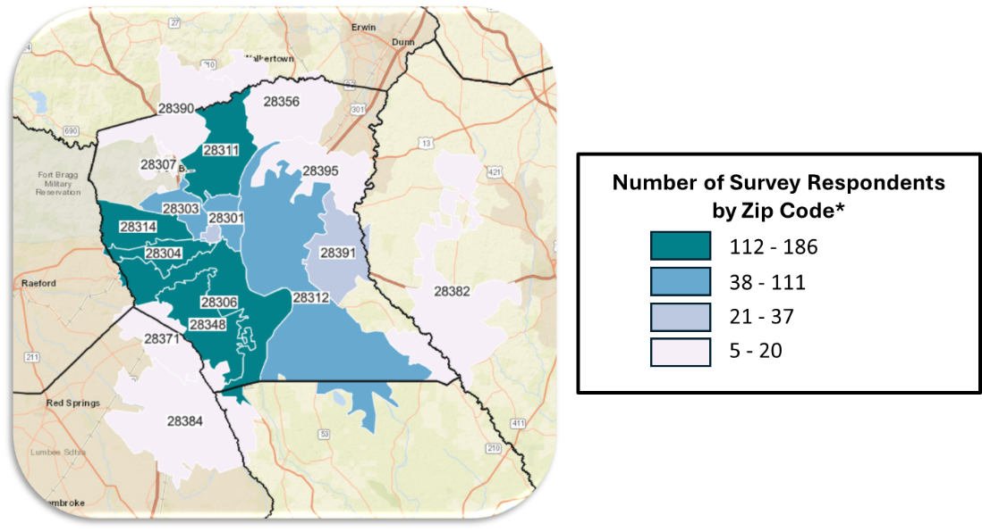
In general, survey questions focused on:

- Community health problems and concerns
- Community social/environmental problems and concerns
- Specific topics of interest to Cumberland County:
  - Income
  - Mental health
  - Safety
  - Substance use disorders

The key findings from the Community Member Survey are detailed below:

- Mental health (e.g., depression and anxiety), alcohol/drug addiction, and weight/obesity were identified as the top three health problems affecting the community. About one third of respondents also identified heart disease/high blood pressure and diabetes/high blood sugar as important health problems.
- Cost, not having insurance, and long wait times were the top three barriers to receiving health care identified by the community.
- Housing, poverty, and availability and access to doctor's offices were identified as the top three most important social or environmental problems that affect the health of the community. Insurance, neighborhood safety, and affordable child care were also identified by almost one in four respondents.

Information describing the respondents to the Community Member Survey are displayed below:
Figure A4.3: Respondents by Ethnicity
Figure A4.2: Respondents by Race

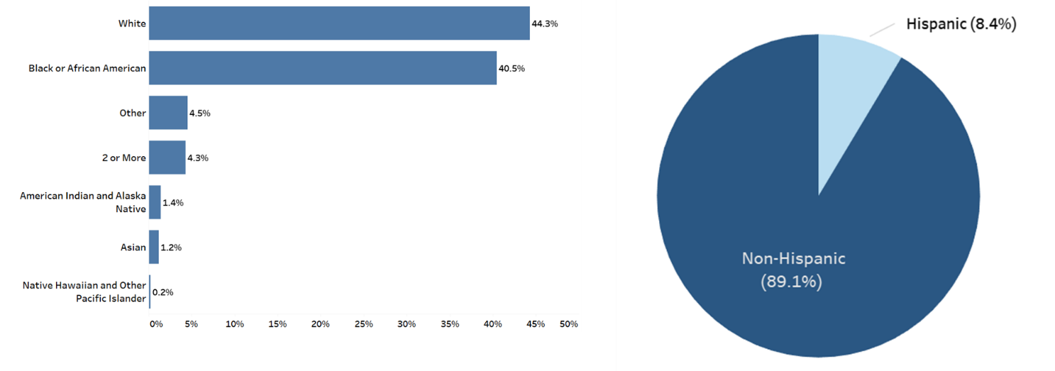

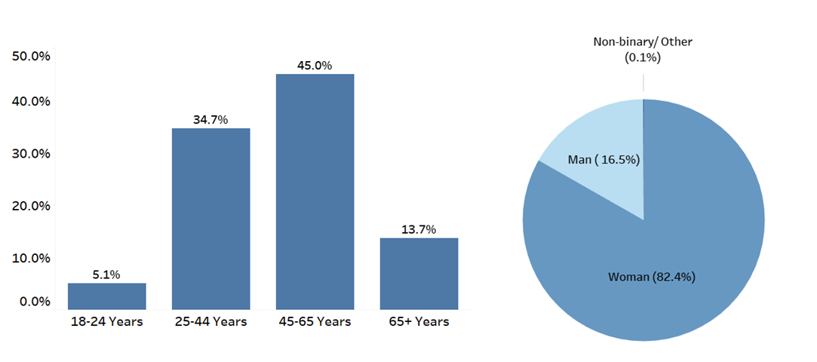
Figure A4.4: Respondents by Age Group
Figure A4.5: Respondents by Gender

The questions administered via the Community Member Survey instrument are below. The survey instrument was also available in Spanish, and a copy of the Spanish language survey instrument is available on request.

Dear Community Member,
We invite you to participate in your county's Community Health Needs Survey.
Your responses to this optional survey are anonymous and will inform how hospitals and agencies work to improve health in your county. This is not a research survey. It will take less than 10 minutes to complete.
Instructions: You must be 18 years or older to complete this survey. Please answer all questions and return the survey as indicated.
For questions about this survey, contact Ascendient Healthcare Advisors: emilymccallum@ascendient.com
Thank you for your time and participation!

Topic: Demographics
- What is the zip code where you currently live?

- What is your age group?

□ 18-24
□ 25-44
□ 45-65
□ 65+
- Don't know/ Not sure
- Prefer not to say

- Which of the following best describes your gender? Select all that apply:

  - Man
  - Woman
  - Non-binary, genderqueer, or gender nonconforming
  - Additional gender category:
  - Prefer not to say

- How would you describe your race? Select all that apply:

  - American Indian and Alaska Native
  - Asian
  - Black or African American
  - Native Hawaiian and Other Pacific Islander
  - White
  - Other race:
  - Don't know/Not sure
  - Prefer not to say

- Are you of Hispanic or Latino origin, or is your family originally from a Spanish speaking country?

  - Yes
  - No
  - Don't know/Not sure
  - Prefer not to say

- What is the highest grade or year of school you completed?

  - Less than 9th grade
  - 9-12th grade, no diploma
  - High school graduate (or GED/equivalent)
  - Some college (no degree)
  - Associate's degree or vocational training
  - Bachelor's degree
  - Graduate or professional degree
  - Don't know/Not sure
  - Prefer not to say

- Which language is most often spoken in your home? Select one:

  - English
  - Spanish
  - Other, please specify:
  - Don't know/Not sure
  - Prefer not to say

- For employment, are you currently...Select all that apply:

- Employed full-time (40+ hours per week) | - Homemaker
- Employed part-time (under 40 hours per  week) | - Temporarily unable to work due to illness  or injury
- Retired | - Unemployed for less than one year
- Student | - Unemployed for more than one year
- Armed forces/military | - Permanently unable to work
- Self-employed | - Prefer not to answer

- Which category best describes your yearly household income before taxes? Do not give the dollar amount, just give the category. Include all income received from employment, social security, support from family, welfare, Aid to Families with Dependent Children (AFDC), bank interest, retirement accounts, rental property, investments, etc.

  - Less than $15,000
  - $15,000 - $24,999
  - $25,000 - $34,999
  - $35,000 - $49,999
  - $50,000 - $74,999
  - $75,000 - $99,999
  - $100,000 - $149,999
  - $150,000 - $199,999
  - $200,000 or more
  - Prefer not to say

Topic: Community Health Opinion Questions
- What are the three most important health problems that affect the health of your community? Please select up to three:

- Alcohol/drug addiction  - Alzheimer’s disease and other dementias  - Mental health (depression/anxiety)  - Cancer  - Diabetes/high blood sugar  - Heart disease/high blood pressure  - HIV/AIDS | - Infant death  - Lung disease/asthma/COPD  - Stroke  - Smoking/tobacco use  - Overweight/obesity  - Other (please specify):  - Prefer not to answer

- What are the three most important social or environmental problems that affect the health of your community? Please select up to three:

- Availability/access to doctor’s office  - Availability/access to insurance  - Child abuse/neglect  - Age Discrimination  - Ability Discrimination  - Gender Discrimination  - Racial Discrimination  - Domestic violence  - Housing/homelessness  - Lack of affordable childcare  - Lack of job opportunities | - Limited access to healthy foods  - Limited places to exercise  - Neighborhood safety/violence  - Limited opportunities for social connection  - Poverty  - Limited/poor educational opportunities  - Transportation problems  - Environmental injustice  - Other (please specify):  - Prefer not to answer

- What are the three most important reasons people in your community do not get health care? Please select up to three:

  - Cost – too expensive/can’t pay
  - Wait is too long
  - No health insurance
  - No doctor nearby
  - Lack of transportation
  - Insurance not accepted
  - Language barriers
  - Cultural/religious beliefs
  - Other (please specify): ________
  - Prefer not to answer

Topic: Income
- How often do you have someone you can rely on to help with the following items, as needed?
1 = Always; 2 = Usually; 3 = Sometimes; 4 = Rarely; 5 = Never
 | 1 | 2 | 3 | 4 | 5 | Prefer not to  say
a. Food | □ | □ | □ | □ | □ | □
b. Transportation | □ | □ | □ | □ | □ | □
c. Childcare | □ | □ | □ | □ | □ | □
d. Other support | □ | □ | □ | □ | □ | □

- In the past year, did you have any of the following assistance needs NOT met? Select all that apply.

  - Access and safety modifications to your home (ex. ramp, handrail)
  - Clothing for yourself and your family
  - Critical house repairs
  - Food for yourself and your family
  - Household goods (furniture, a stove or refrigerator)
  - Medical or adaptive equipment not covered by Medicaid or private insurance
  - None of the above
  - Don’t know/Not sure
  - Prefer not to say

Topic: Mental Health
- Now thinking about your MENTAL health, which includes stress, depression, and problems with emotions, for how many days during the past 30 days was your mental health NOT
good?

  - Number of days:

- Was there a time in the past 12 months when you needed mental health care or counseling, but did not get it at that time?

  - Yes
  - No
  - Don’t know
  - Prefer not to say

- If you answered ‘Yes’ to the previous question, what was the MAIN reason you did not get mental health care or counseling?

  - Cost/No insurance coverage
  - Distance
  - Don't know where to go
  - Concerns about confidentiality
  - Inconvenient office hours
  - Lack of childcare
  - Lack of providers
  - Lack of transportation
  - Previous negative experiences/Distrust of mental health providers
  - Stigma
  - Too busy to go to an appointment
  - Too long of wait for an appointment
  - Trouble getting an appointment
  - Other (please specify):
  - None of the above
  - Don't know/Not sure
  - Prefer not to say

- Are you currently taking medication or receiving treatment, therapy, or counseling from a health professional for any type of MENTAL or EMOTIONAL HEALTH NEED?

  - Yes
  - No
  - Prefer not to say

Topic: Safety
- The following statements describe what your neighborhood might be like. Tell us how much you agree or disagree.
1 = Strongly disagree; 2 = somewhat disagree; 3 = neither agree nor disagree; 4 = somewhat agree; 5 = strongly agree

 | 1 | 2 | 3 | 4 | 5 | Don’t know | Prefer not to  say
a. There is a lot of graffiti in my neighborhood. | □ | □ | □ | □ | □ | □ | □
b. Vandalism is common in my neighborhood. | □ | □ | □ | □ | □ | □ | □
c. There are lot of abandoned buildings in my neighborhood. | □ | □ | □ | □ | □ | □ | □
d. There are too many people hanging around on the streets near my home. | □ | □ | □ | □ | □ | □ | □
e. There is a lot of crime in my neighborhood. | □ | □ | □ | □ | □ | □ | □
f. There is too much drug use in my neighborhood. | □ | □ | □ | □ | □ | □ | □
g. There is too much alcohol use in my neighborhood. | □ | □ | □ | □ | □ | □ | □
h. I’m always having trouble with my neighbors. | □ | □ | □ | □ | □ | □ | □

- The following questions ask about safety. Tell us how much you agree or disagree. 1 = Not at all; 2 = A little; 3 = Somewhat; 4 = A lot; 5 = To a great extent
 | 1 | 2 | 3 | 4 | 5 | Prefer not to  say
a. To what extent do you feel safe in your community when you are outside alone during the day? | □ | □ | □ | □ | □ | □
b. To what extent do you feel safe in your community when you are outside alone at night? | □ | □ | □ | □ | □ | □

- How much do you trust your local law enforcement agency?

  - Not at all
  - A little
  - Somewhat
  - A lot
  - To a great extent
  - Prefer not to say

Topic: Substance Use Disorders
- Considering all types of alcoholic beverages, how many times during the past 30 days did you have 4 (females)/ 5 (males) or more drinks on an occasion?

  - Number of drinks:

- How often do you consume any kind of alcohol product, including beer, wine or hard liquor?

  - Every Day
  - Some Days
  - Not at all
  - Don’t know/not sure
  - Prefer not to say

- In the past year, have you or a member of your household intentionally misused any form of prescription drugs (e.g. used without a prescription, used more than prescribed, used more often than prescribed, or used for any reason other than a doctor’s instructions)?

  - Yes
  - No
  - Don’t know/not sure
  - Prefer not to say

- To what degree has your life been negatively affected by YOUR OWN or SOMEONE ELSE's substance abuse issues, including alcohol, prescription, and other drugs? Would you say:

  - A Great Deal
  - Somewhat
  - A Little
  - Not at All
  - Don't know/Not sure
  - Prefer not to say

APPENDIX 5 | DETAILED PRIMARY DATA FINDINGS

Focus Groups

Key findings from the focus groups are summarized below.

Focus Group General Findings
Four focus groups were conducted in Cumberland County, involving over 20 community members. These groups consistently identified healthcare access and quality as a major concern. Specific issues included high healthcare costs, long emergency care wait times, difficulties navigating the health insurance system, lack of transportation to medical facilities, and staffing shortages in healthcare settings.
Focus Group 1 Unique Insights: Fayetteville State University Students
The student focus group highlighted several key health and social concerns. Community safety, particularly domestic violence, was identified as an issue. They noted the need for more community education on physical and mental health, as well as increased awareness of available resources. Employment and income were concerns, with participants citing low-paying jobs and the perception that most opportunities are focused on the military population. Mental health was another significant issue, with participants noting a lack of resources and providers. Sexual health was also discussed, with high rates of sexually transmitted infections reported in Fayetteville and concerns about inadequate STI testing among students. Transportation and transit issues were raised, as many resources are not within walking distance and are inaccessible to those without cars or means to use rideshares or cabs.
To address these issues, participants suggested implementing substance use classes to educate people about the impacts of drugs and alcohol, offering parenting classes to support child nurturing, and locating healthcare facilities and services in more accessible areas.
Focus Group 2 Unique Insights: Migrant Farmworkers
The migrant farmworker focus group at Jeff Simpson Farm identified unique challenges. Those challenges consisted of environmental quality, and particularly extreme heat. These conditions were noted as impacting working conditions, quality of life, and overall health. Participants discussed issues with family, community members, and social support, mentioning hostility from some local residents and a need for resources to help migrant groups learn English and integrate into the community. Physical health concerns included dehydration, body aches, cramps, headaches, colds, nausea, and hallucinations. Tobacco use was a significant concern, with farmworkers constantly being exposed to very high levels of nicotine due to their working conditions.
Suggestions for improvement included establishing a health department or offering services closer to Roseboro. Participants suggested providing free or reduced-cost services for farmworkers due to their financial and location challenges, and engaging in community education to reduce racial discrimination and improve social support.

Focus Group 3 Unique Insights: Healthcare Workers
Healthcare workers at Cape Fear Valley Medical Center identified several barriers to health. The built environment was a concern, with a lack of sidewalks, bike-friendly roads, and places to exercise. Education issues included limited support for students, particularly after high school. Employment and income concerns centered on a lack of job opportunities, often requiring people to leave the county for work. Housing and homelessness were noted as community issues. Mental health stigma was identified as affecting everyone across the county. Physical health concerns included high blood sugar, obesity, asthma, and sickle cell disease.
To address these issues, participants suggested increasing targeted health education for younger audiences, offering practical health classes focused on mental health, addiction, and violence prevention, and emphasizing preventative care rather than just acute health concerns.
Focus Group 4 Unique Insights: Military Veterans
The Military Veterans focus group highlighted unique perspectives on health and social issues. Employment and income concerns included job insecurity, poor job opportunities, and economic challenges related to the cost of living. Environmental quality was a significant concern, particularly regarding water quality and air pollution from local factories and plants. Health equity issues were raised, with participants noting significant health disparities for marginalized groups, especially black and brown communities. Physical health concerns specific to veterans included a high prevalence of gut issues, such as Crohn's disease, attributed to diet and military culture. Transportation and transit were identified as major issues, with a need for subsidized bus fees for low-income community members.
Suggestions for improvement included tightening regulations on local plants to improve environmental health, improving access to healthcare and resources in underserved areas of the county, investing in mobile clinics and free screenings, and collaborating with organizations like the Veterans of Foreign Wars of the US (VFW) and motorcycle clubs for community events.

Community Member Web Survey

Charts detailing key findings from the Community Member Survey are displayed below:

Topic: Additional Demographic Information

Figure A5.1: What is the highest grade or year of school you completed?
(N=1255)
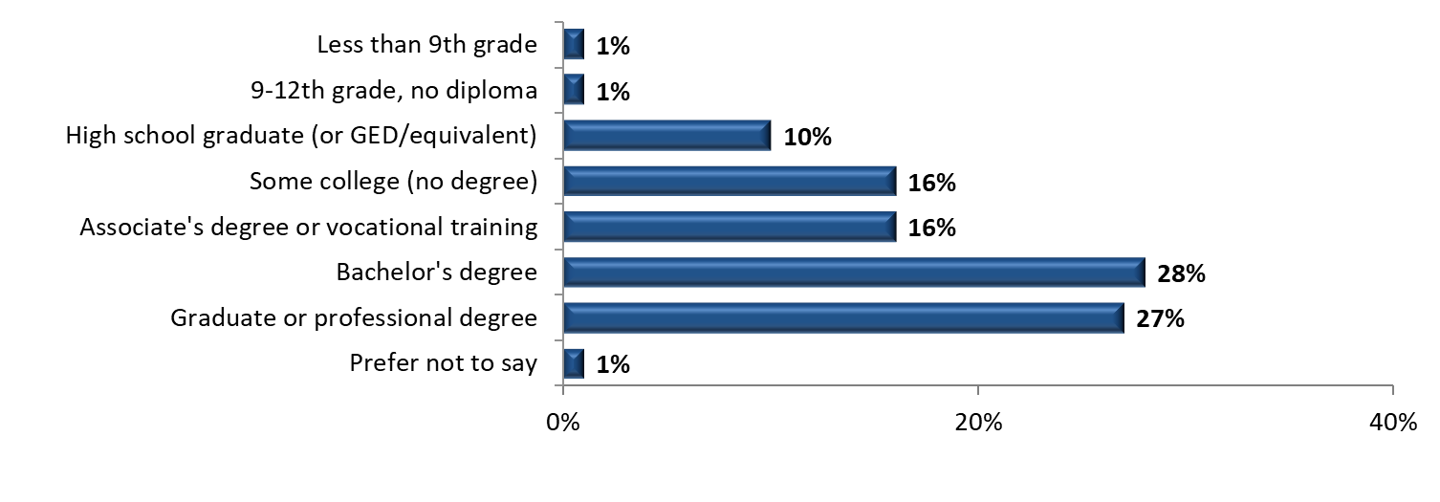

Figure A5.2: Which language is most often spoken in your home? (choose one)
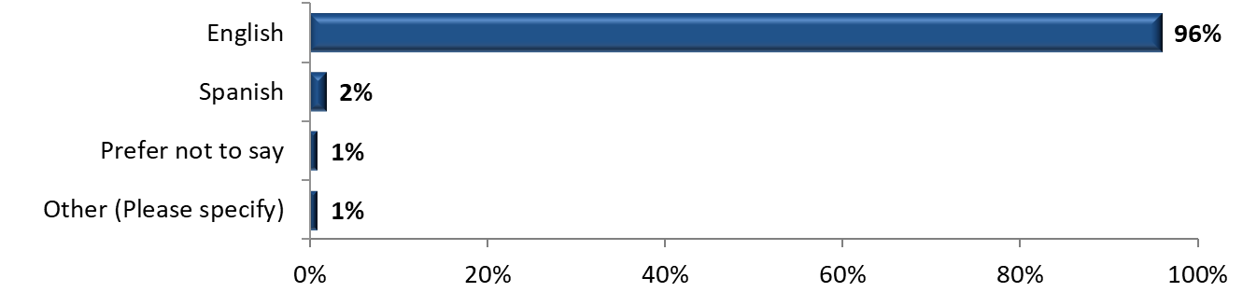
Other (please specify):
- “German” (2 responses)
- “Hindi”
- “Creole Haitian” (2 responses)
- “Vietnamese”

Figure A5.3: For employment, are you currently... (Select all that apply.)
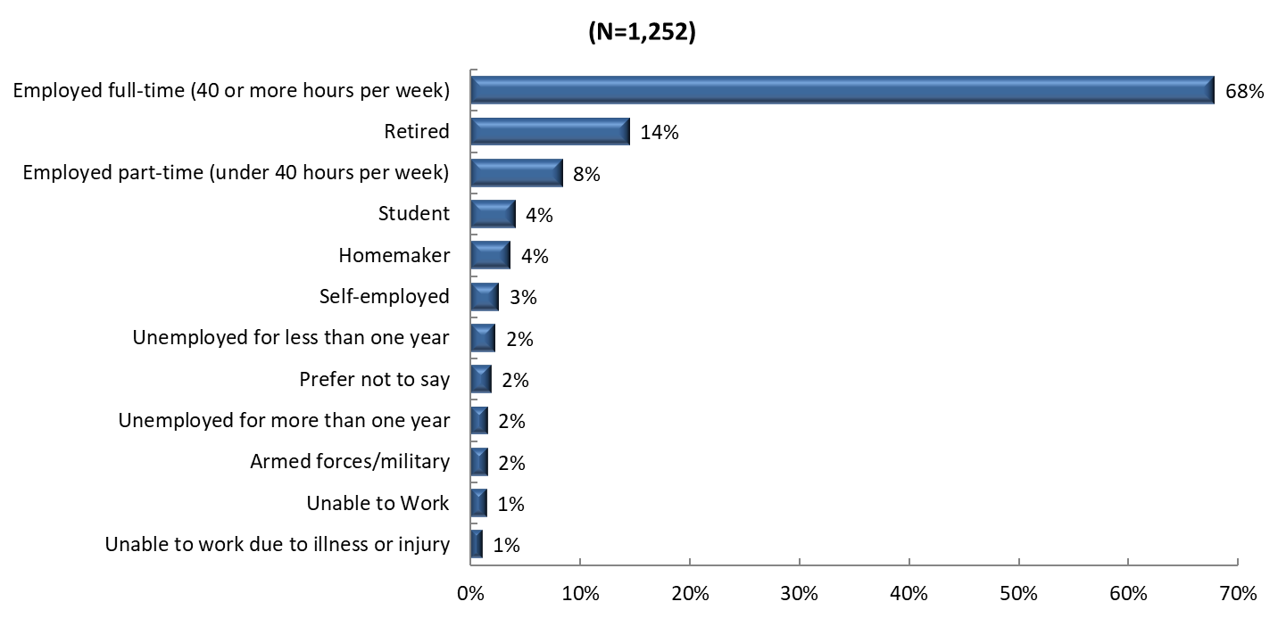

Figure A5.4: Which category best describes your yearly household income before taxes?
Respondents were asked to include all income received from employment, social security, support from children or other family, welfare, Aid to Families with Dependent Children (AFDC), bank interest, retirement accounts, rental property, investments, etc.
(N = 1,251)
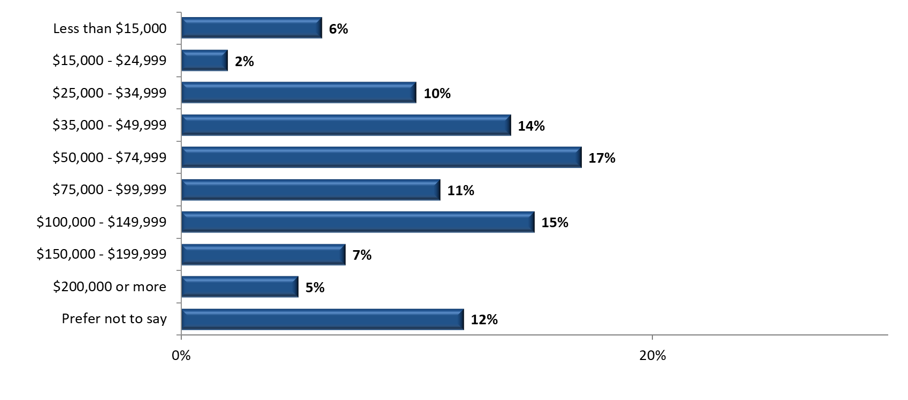

Topic: Health Conditions, Barriers to Care, and Social Determinants of Health
Figure A5.5: What are the three most important health problems that affect the health of your community? Please select up to three.
Other (please specify):

- "Autoimmune diseases (e.g. rheumatoid arthritis)"
- "Breast cancer"
- "Cumberland co Detention center is passing used razors out. My husband contracted hepatitis C. I spoke to the major Adams the head nurse and deputy Lopez. It was caught on camera and dealt with internally they said. The lady still has her job and they are not treating my husband"
- "Environmental air pollution" (2x)
- "Getting up in age"
- "Gun violence" (2x)
- "homelessness" / “vagrancy”
- "Inflation"
- "kidney failure"
- "Lack of Inpatient Mental Health Options for Children and Adolescents"
- "Lack of proper education and tools needed for education such as teachers who actually want to teach, homework, books, an education system that doesn’t just pass children along regardless of their actual test level"
- "Preventive health; health care access; education"
- "Sexually transmitted infections/diseases"
- "Shootings"
- "Sickle cell"
- "Violence" / "violence, gun and other"/ "Violence/Crime"
- "Vision /hearing loss"

Figure A5.6: What are the three most important health problems that affect the health of your community (By age)? Please select up to three.

Figure A5.7: What are the three most important health problems that affect the health of your community (By gender)? Please select up to three.
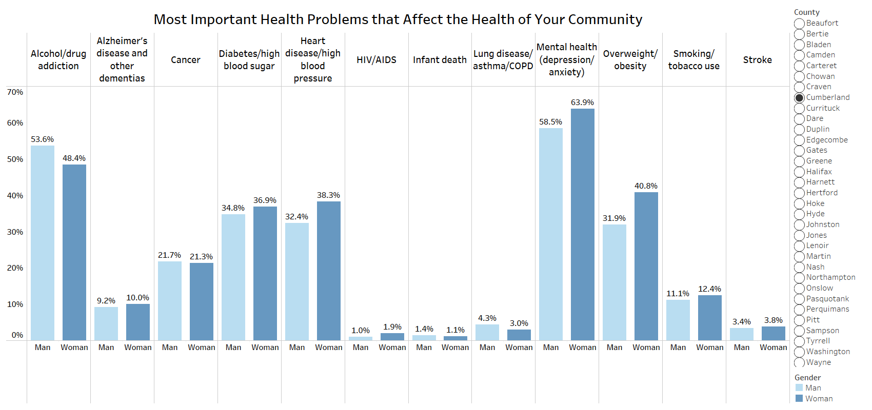

Figure A5.8: What are the three most important health problems that affect the health of your community (By race)? Please select up to three.

Figure A5.9: What are the three most important health problems that affect the health of your community (By ethnicity)? Please select up to three.
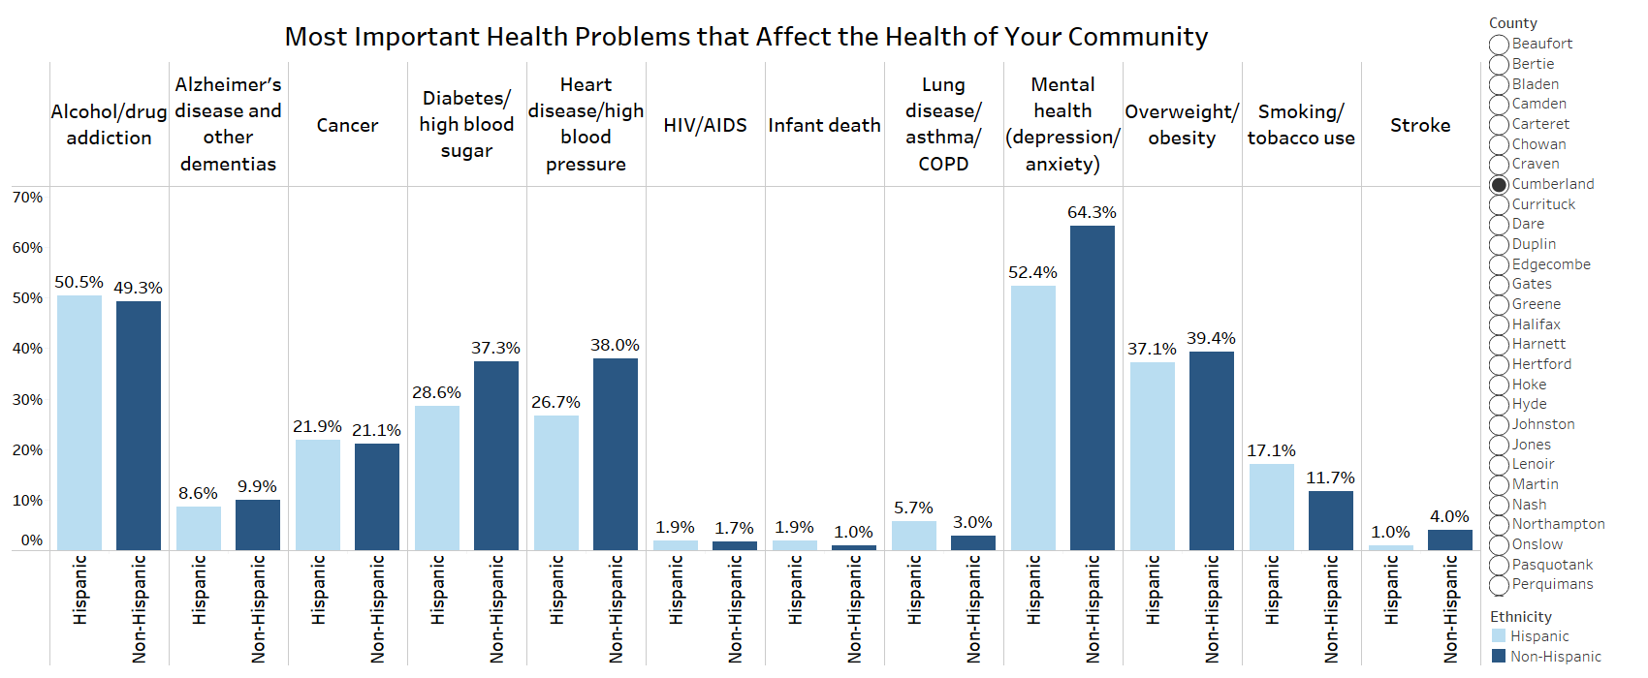

Figure A5.10: What are the three most important social or environmental problems that affect the health of your community? Please select up to three.
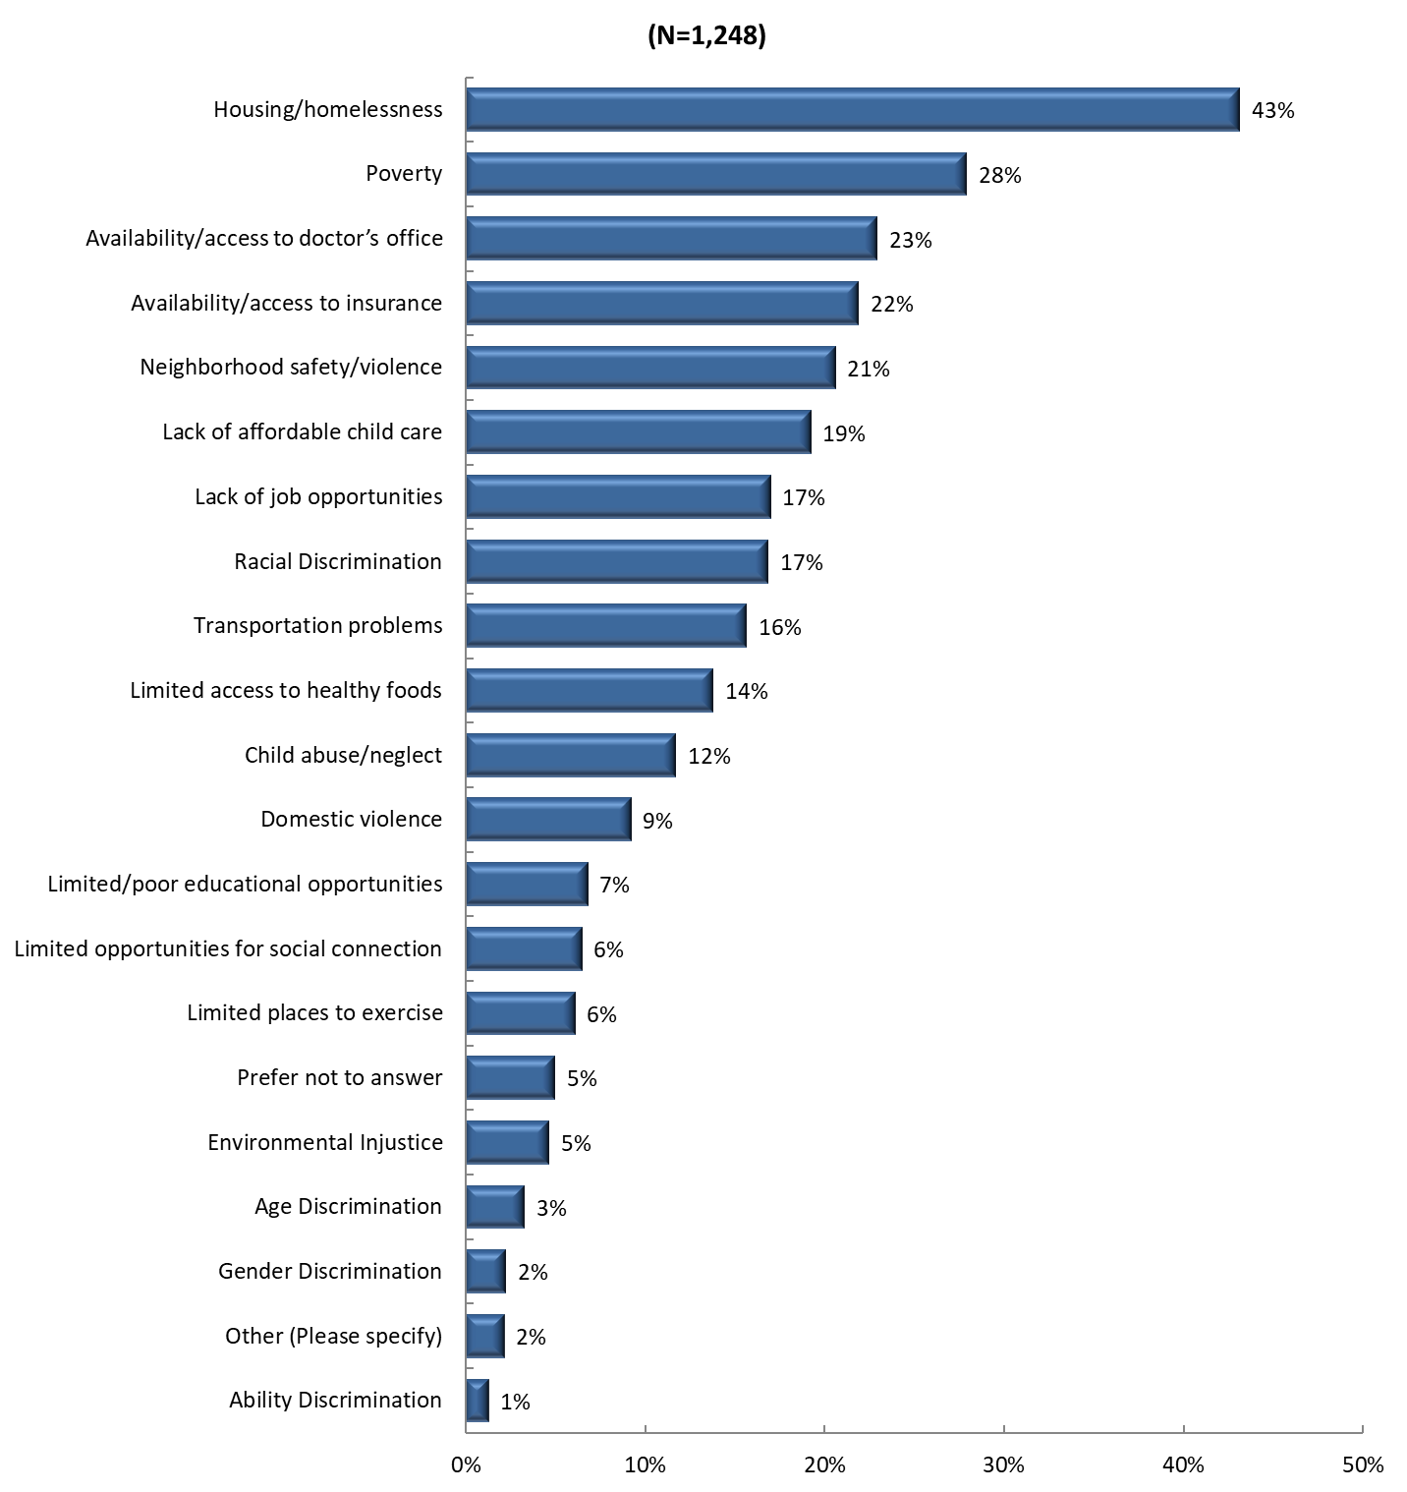
Other (please specify):
- "1-Lack of countywide water and PWC charges too much for hook when it is available; the resident will have to pay a monthly fee anyway so why charge so high for just the hook up, when they added the water lines to my community we tried to hook up as they were laying the lines but we were refused because had to wait. That made no common sense! 2-Lack of tolerance for differing opinions esp. political. I do not feel safe to be registered as anything other than Democrat."
- "Affordable prescription drugs"
- "Appropriate Services for Adults with Disabilities"
- "As a prior employee the detox/mental health facility does not serve the community whatsoever. It does not help anyone dealing with recovery. I quit because of how awful it was to the people that come for help."
- "Cost of healthy food"
- "Disingenuous people that are able to work but choose not to as well as a victims mentality"
- "Elder Abuse"
- "Government efforts at population control by way of fake ”vaccines”, fluoride and ammonia in the water supply, and persistent air ground pollution by way of central spraying recently banned in Tennessee."
- "Jobs for example CFV jobs compensation is $15? working fulltime 40hr week. mentally drains us then it reflects on poverty, food, and transportation. how can we afford any of that."
- "Lack of public transportation/sidewalks"
- "Limited drug/alcohol rehabs"
- "Low health care literacy"
- "Medical provider discrimination"
- "Not enough of coming together"
- "People not willing to work!"
- "Poisoning of water from Chemours"
- "Religious Discrimination"
- "Reverse Discrimination"
- "Senior services esp with disabilities"
- "So many willing to live off government funds"
- "Socioeconomic status"
- "Substance Abuse"
- "Upfront medical cost that keep working people from getting the care they need"

Figure A5.11: What are the three most important social or environmental problems that affect the health of your community (By age)? Please select up to three.
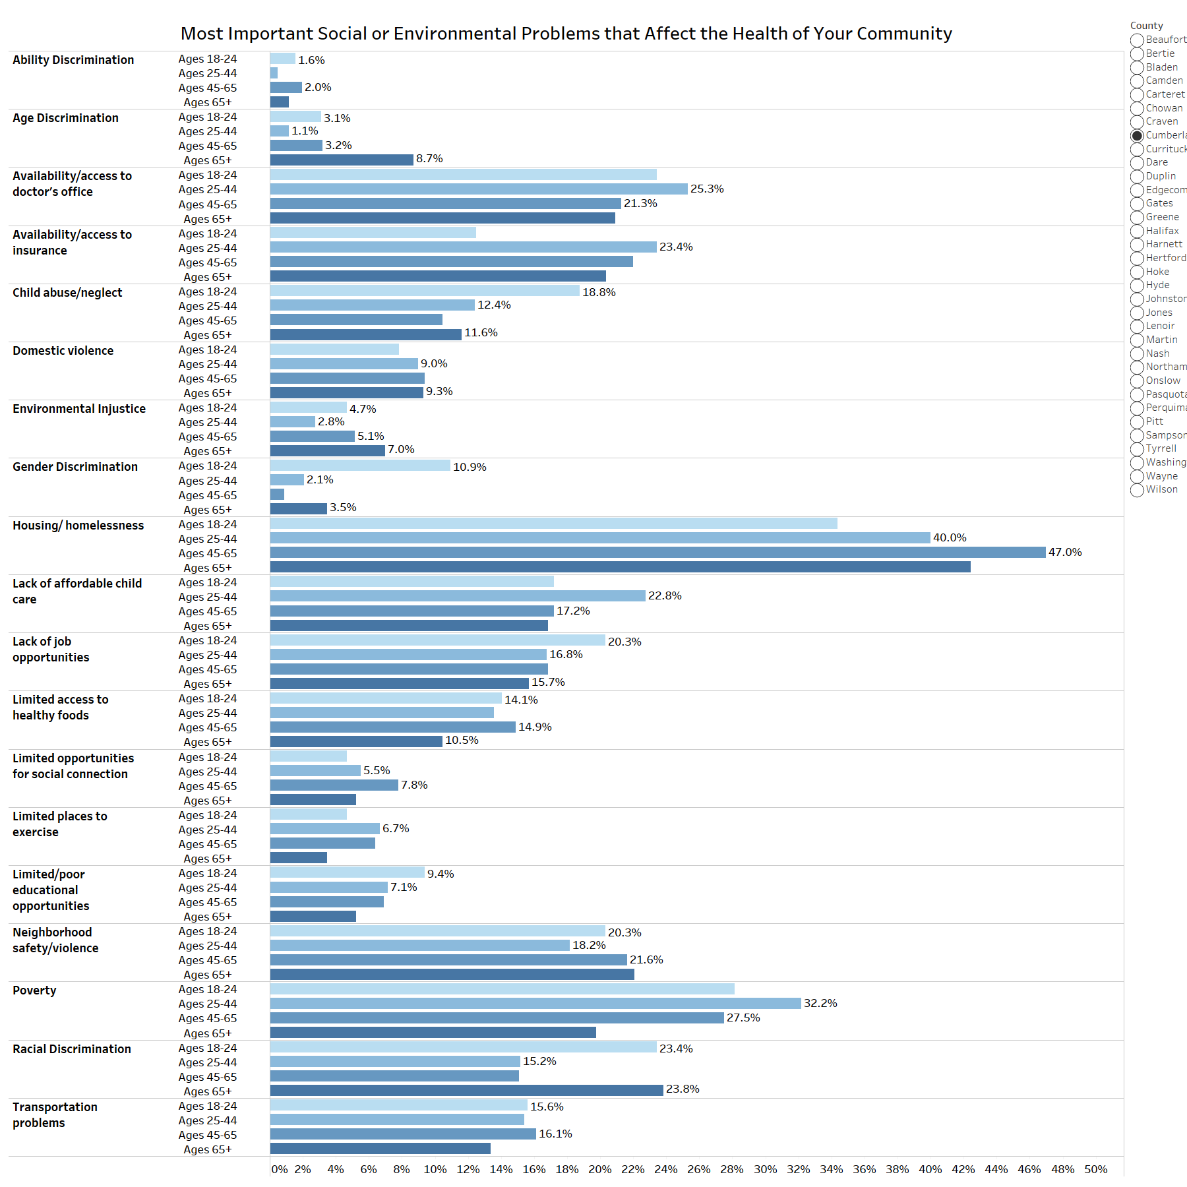

Figure A5.12: What are the three most important social or environmental problems that affect the health of your community (By gender)? Please select up to three.

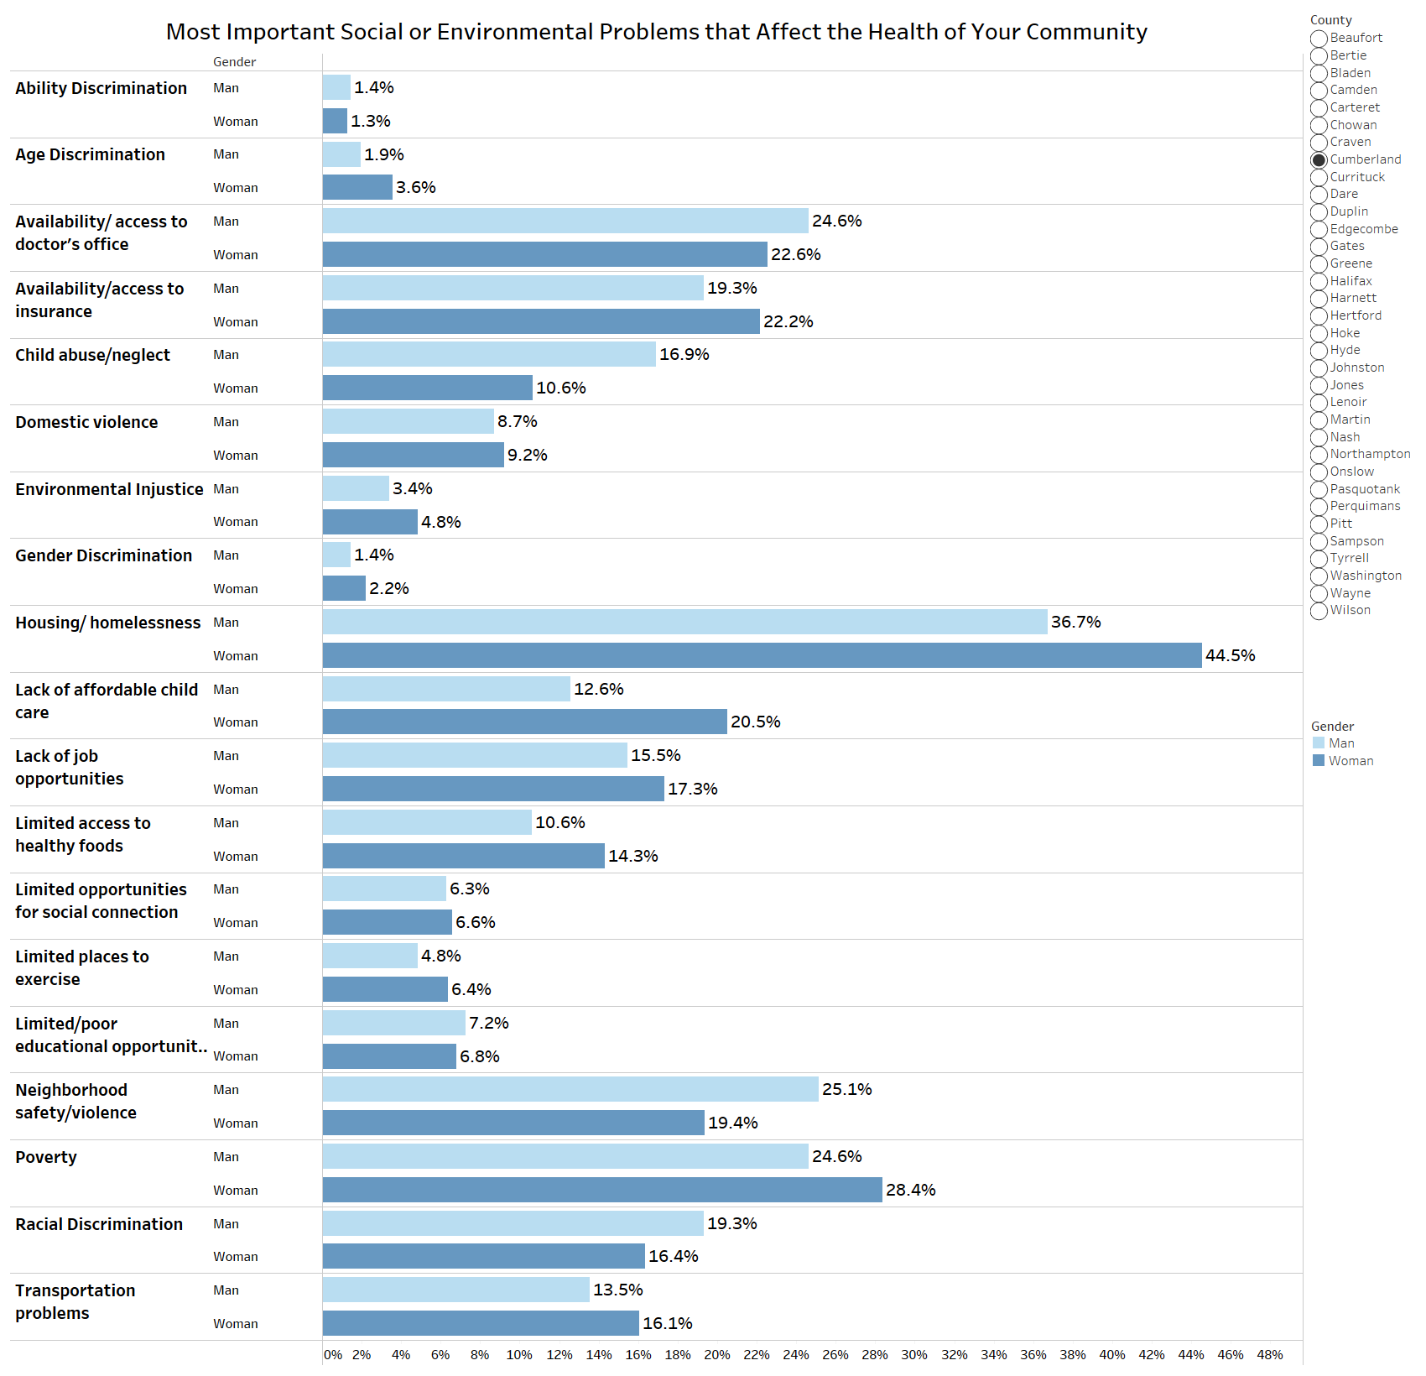

Figure A5.13: What are the three most important social or environmental problems that affect the health of your community (By race)? Please select up to three.

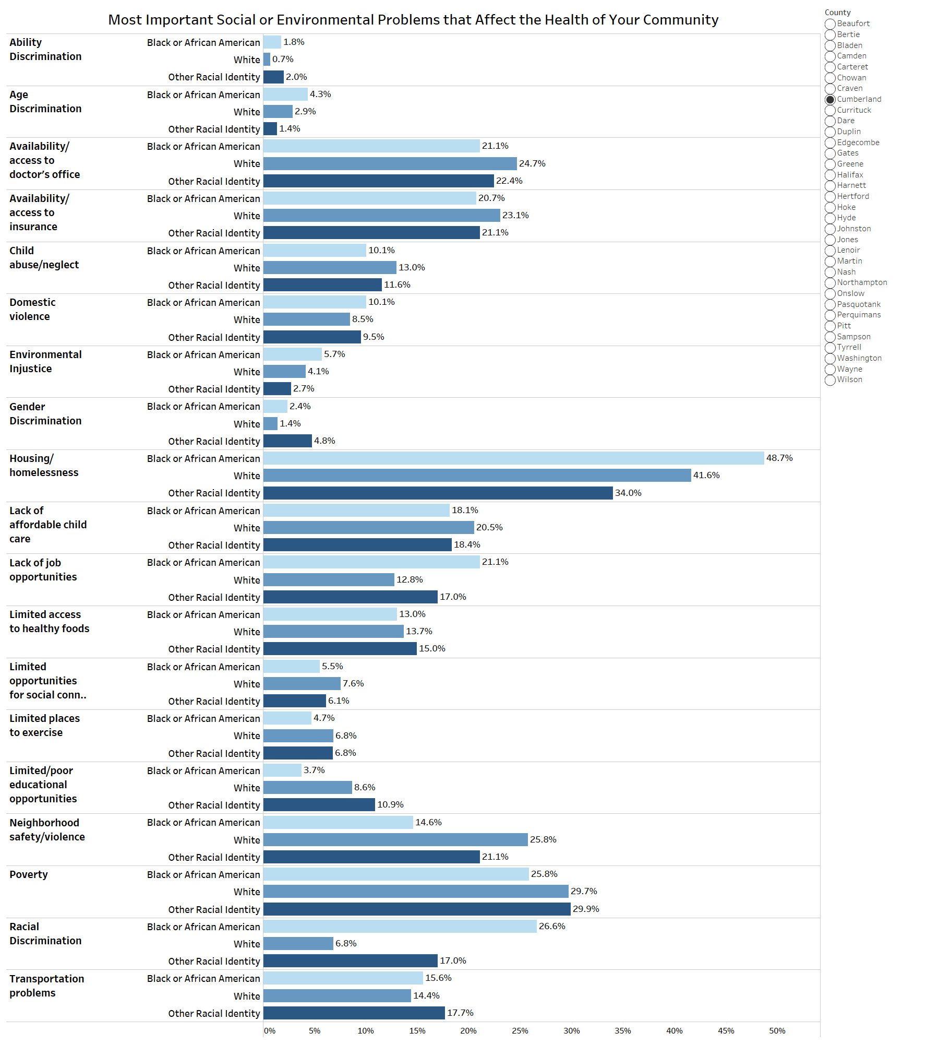
Figure A5.14: What are the three most important social or environmental problems that affect the health of your community (By ethnicity)? Please select up to three.

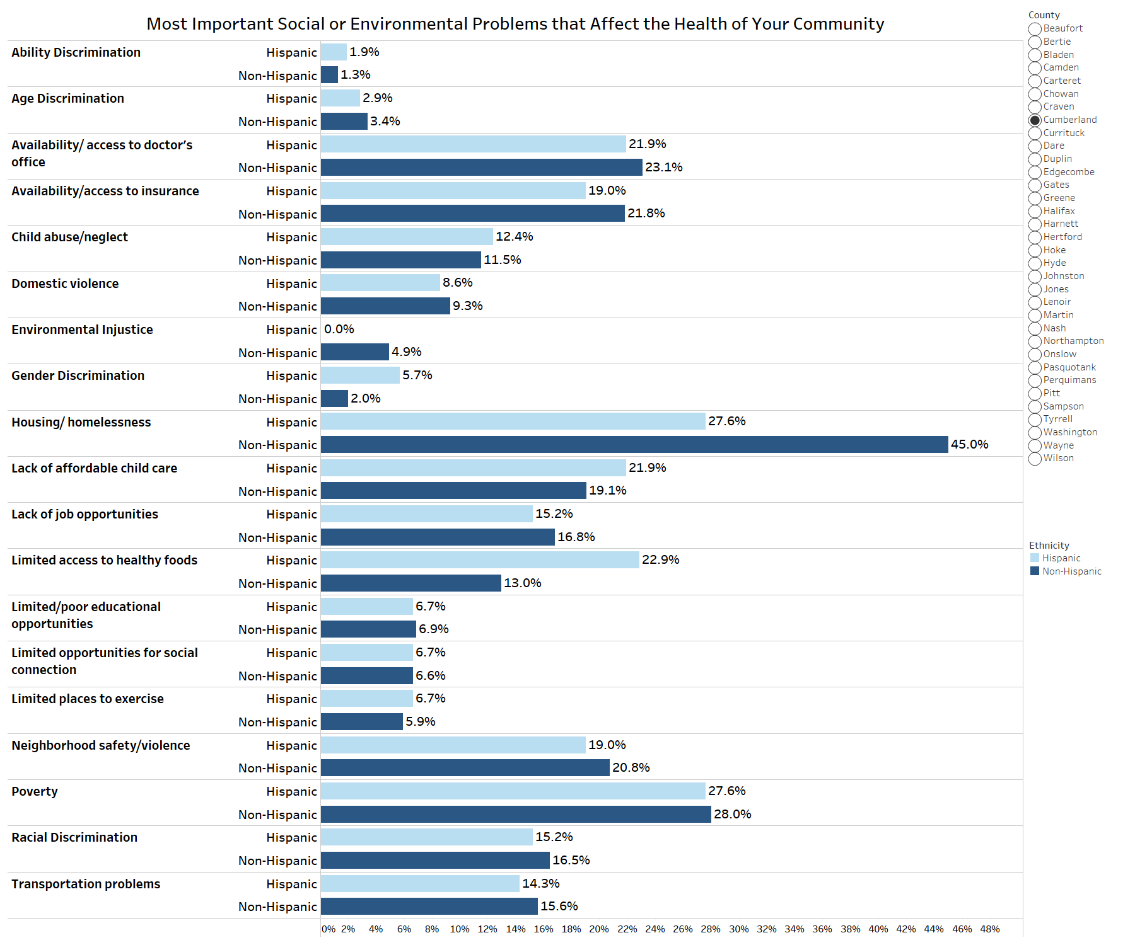

Figure A5.15: What are the three most important reasons people in your community do not get health care when they need it? Please select up to three.
Other (please specify):
Major themes included
- Lack of trust in the health system and with providers
- Lack of education of the health system
- Lack of health literacy
- Providers not accepting new patients or long wait times to be seen

Full “Other” responses below:
- "AWARENESS"
- "Because the government leverages it to gain more control over American citizens."
- "can’t afford because the job doesn’t pay enough for it to be taking out of check. And then you still have to pay copays EACH time you go back. even follow up appointments"
- "Cultural differences"
- "Customer service. Kindness of support staff in medical office."
- "Deductibles are too expensive"
- "Difficult to miss work to go to appointments"
- "discrimination"
- "Distrust of medical providers."
- "Doctor gives pain medication instead of diagnosis, it’s been a waste of time and money to go"
- "Doctor's Office and Hospital Primary Cares are only open at the same time someone works. Therefore you have to take time off from work to go to the doctor, and then when you get there, offices are always running behind."
- "Don’t have late hours for working parents or weekend appointments."
- "Drs inattentive, flippant, don't care or unprofessional"
- "education, changing the mindset from I only see a doctor when I am sick to preventive measures."
- "False Reporting"
- "Fear"
- "Fear of going to see a doctor"
- "get bounced around without resolution"
- "health care bills insurance will not cover (radiology) and Lab testing"
- "I can't find a doctor that I can trust to take care of me. I don't mind seeing their PA if I have a sick visit but I want to have an actual doctor take care of me for my annual well visits and chronic illness management."
- "I have insurance and live alone. I cannot afford to get medical help because I can't pay my bills/rent if I don't work full time."
- "I have work medical insurance but copays are killing me."
- "Insurance coverage is limited to what it will cover."
- "insurance won't cover much"
- "It has been said the staffing and medical providers are over worked and underpaid."
- "Just don’t want to go"
- "Knowledge deficit"
- "Lack of awareness"
- "lack of concern for own health"
- "lack of education and knowing what to do or who to call"
- "Lack of knowledge on early signs / symptoms"
- "lack of preventative measures taken and people need education about preventative medicine"
- "Lack of trust"
- "Lack of trust"
- "Lack of trust in the health system"
- "Lack of trust in the healthcare system"
- "Lack of trust of health system"
- "Lack of trust with providers"
- "limited hours of operation for providers"
- "Limited time off of work"
- "Many medical practices in the area aren't accepting new patients. There is often a 6-month (or more) wait to be seen by a doctor if you try to see a physician or PA as a new patient. As a result patients visit local emergency rooms with non-emergency medical concerns."
- "Mental health; neglect; lack of trust"
- "Must take time off from work and lose wages."
- "need better hospital"
- "No qualified doctors with updated equipment"
- "No schedule flexibility (e.g. very few offices open on fridays/weekends)"
- "No time"
- "Not a priority"
- "Not comfortable calling physician office"
- "Poor health literacy i.e. lack of knowledge of how and when to use health care"
- "priorities"
- "Providers not accepting new patients"
- "Stigma"
- "they don't have healthcare access"
- "Too distracted by short term entertainment"
- "transphobia"
- "Uneducated about care"
- "Wait times with drs and then they don’t listen to patients"
- "We all have health care"
- "Work does not allow"

Figure A5.16: What are the three most important reasons people in your community do not get health care when they need it (By age)? Please select up to three.

Figure A5.17: What are the three most important reasons people in your community do not get health care when they need it (By gender)? Please select up to three.
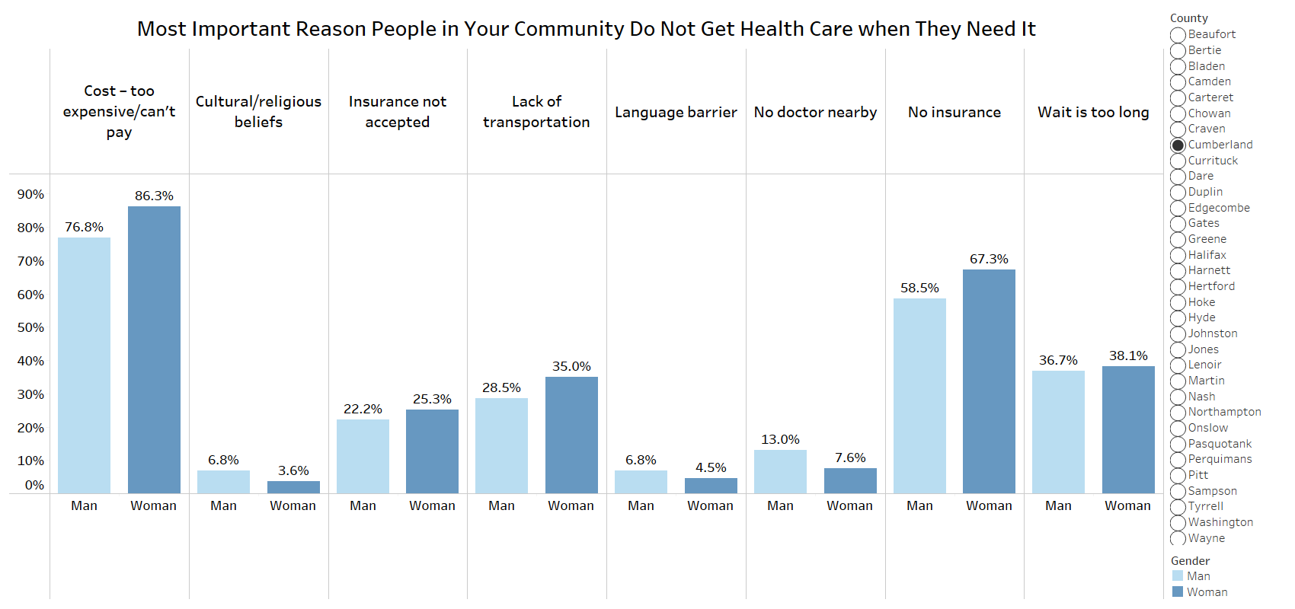

Figure A5.18: What are the three most important reasons people in your community do not get health care when they need it (By race)? Please select up to three.

Figure A5.19: What are the three most important reasons people in your community do not get health care when they need it (By ethnicity)? Please select up to three.
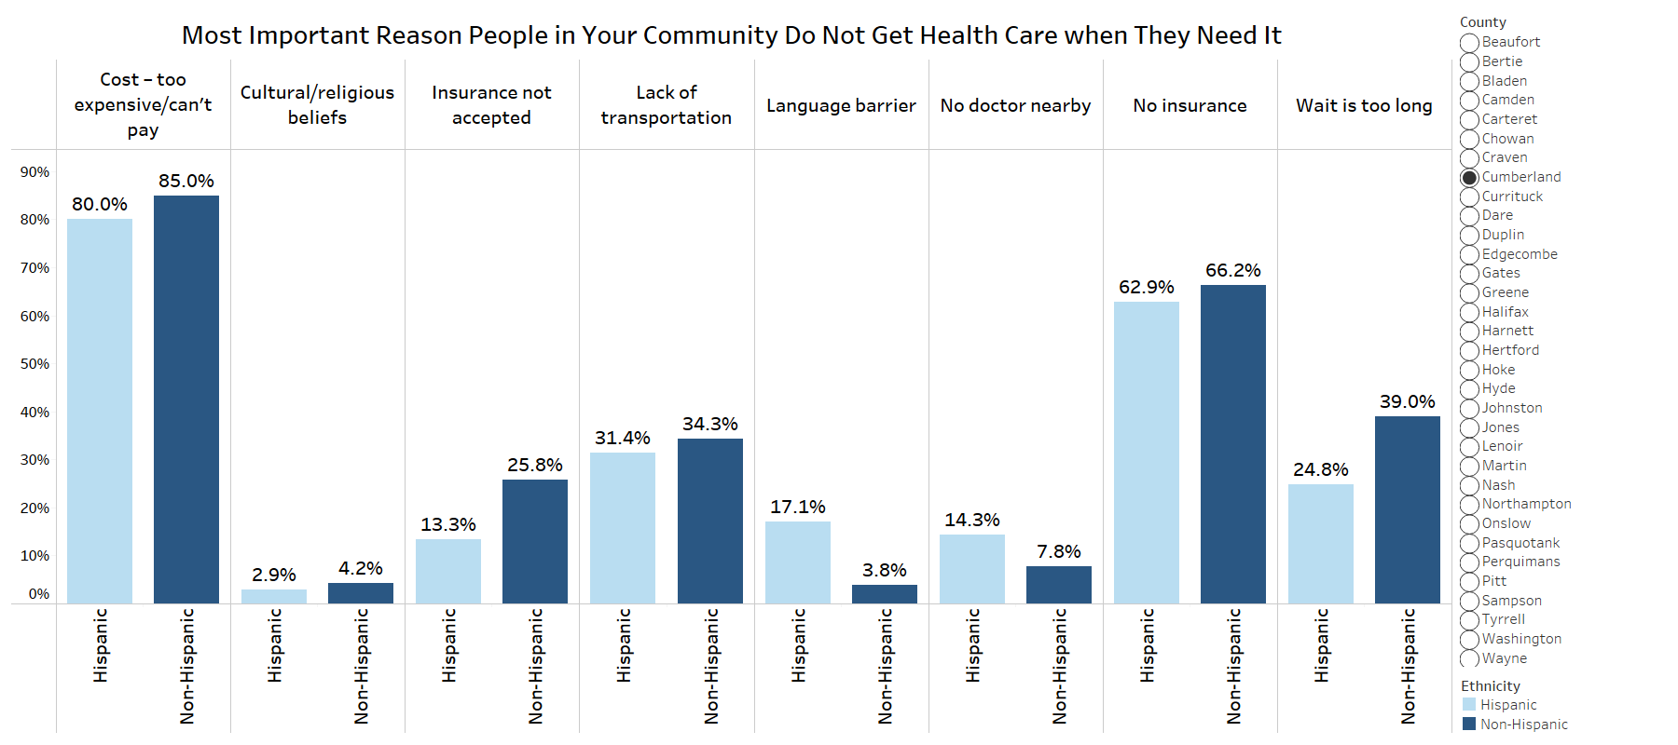
Topic: Income
Figure A5.20: How often do you have someone you can rely on to help with the following items, as needed?
Rated on a score from 1 to 5 with 1 being “Never” and 5 being “Always”
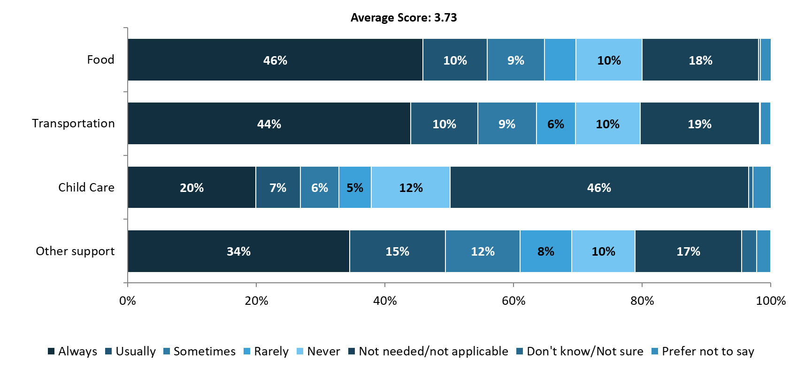

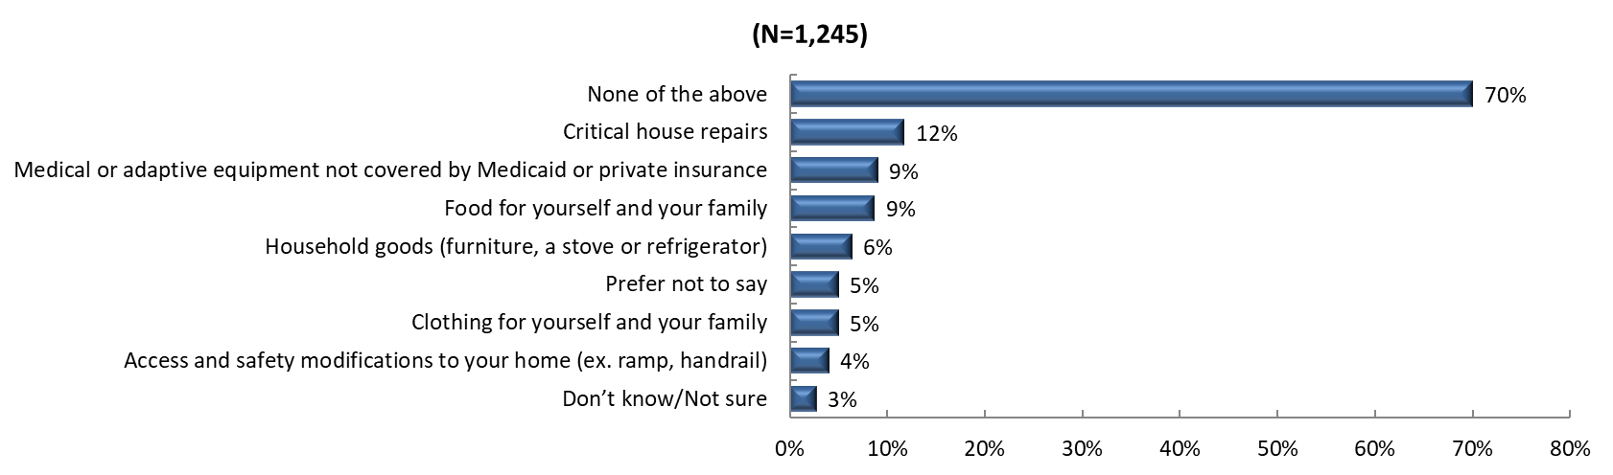
Figure A5.21: In the past year, did you have any of the following assistance needs NOT met? (Select all that apply.)

Topic: Mental Health
Figure A5.22: Now thinking about your MENTAL health, which includes stress, depression, and problems with emotions, for how many days during the past 30 days was your mental health NOT good?
(N=1223)

Figure A5.23: Was there a time in the past 12 months when you needed mental health care or counseling, but did not get it at that time?
Note: only participants who responded that they had experienced at least one poor mental health day in the previous question were asked the current follow-up question

Figure A5.24: What was the MAIN reason you did not get mental health care or counseling?
Note: only participants who answered "YES" to previous question were asked the current follow-up question
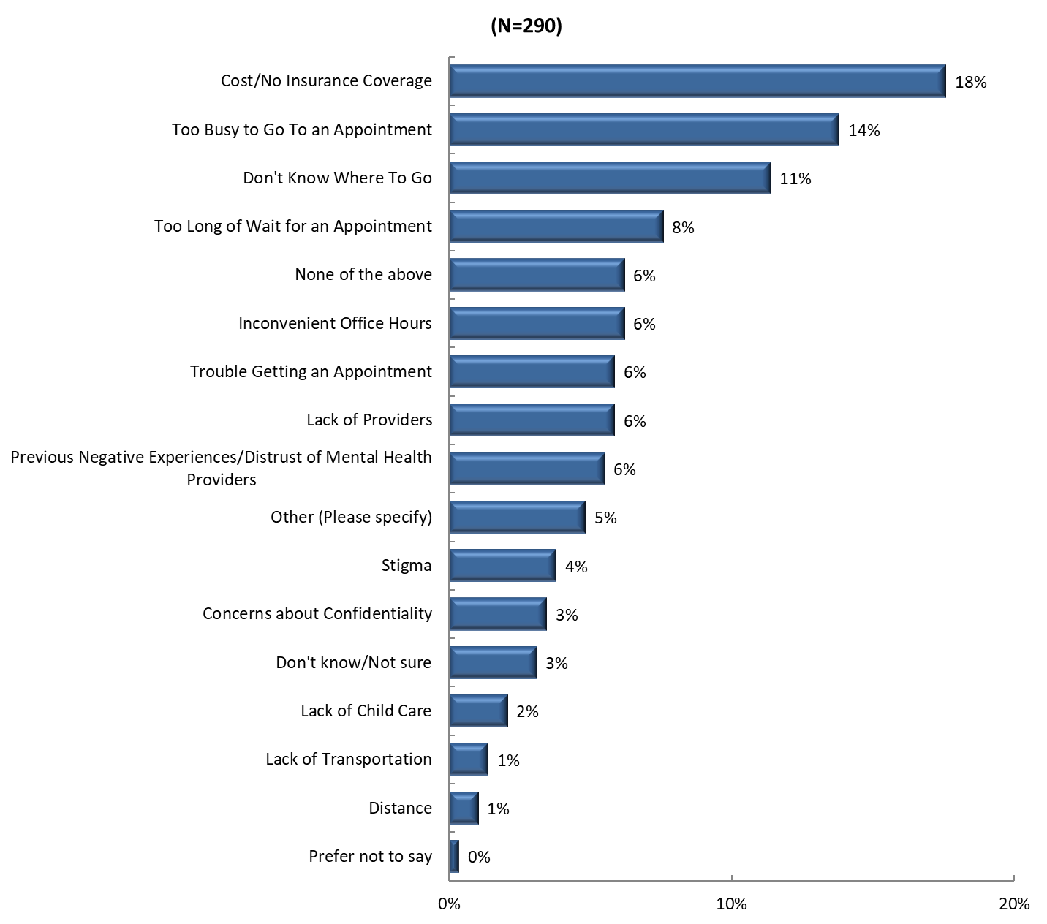
Other (please specify):

- “It is hard to determine who the best providers are.”
- “Lots of reasons. Not covered by insurance so it's too expensive. No where is accepting new Patients or they're booked for 6 months or more out.”
- “Unable to take the time away from work.”
- “PA would not take me seriously”
- “Providers unprofessional and unqualified even with credentials”
- “Know how to handle to low days”
- “Working and no childcare”
- “Trying to not be dependent on counselors to get me through tough stress and depression.”
- “The first available appointment isn't until late July. This appointment has been booked months in advance.”
- “UNPROFESSIONAL”
- “Don’t want to be put on meds”
- “Lack of providers of color that take my insurance”
- “I believe that ‘This shall pass’”

Figure A5.25: Are you currently taking medication or receiving treatment, therapy, or counseling from a health professional for any type of MENTAL or EMOTIONAL HEALTH NEED?
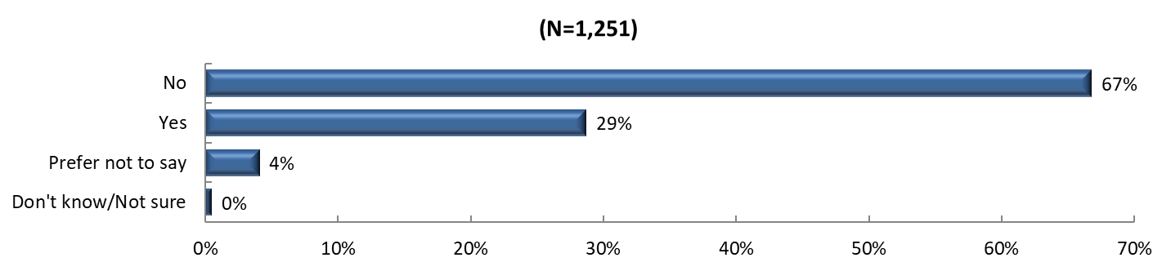
Topic: Safety
Figure A5.26: The following statements describe what your neighborhood might be like. Tell us how much you agree or disagree.
Rated on a scale from 1 to 5 with 1 being “Strongly Disagree” and 5 being “Strongly Agree”
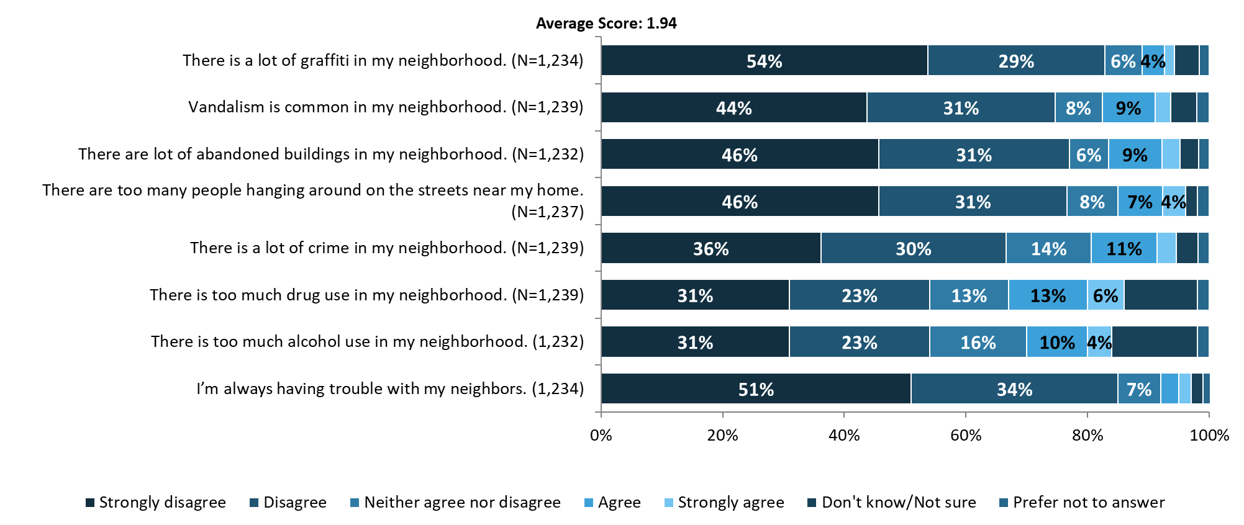

Figure A5.27: The following statements ask about safety. Tell us how much you agree or disagree.
Rated on a scale from 1 to 5 with 1 being “Not at all” and 5 being “To a great extent”
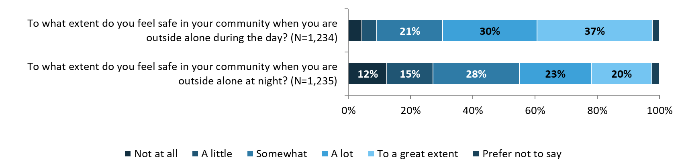

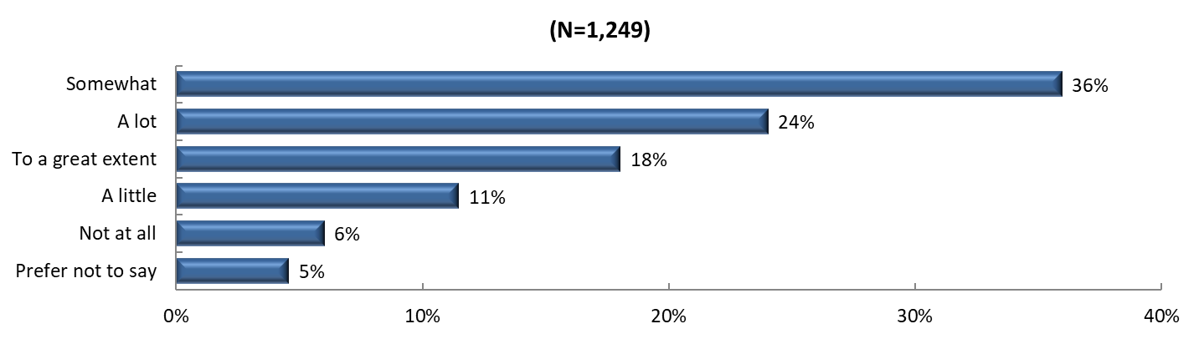
Figure A5.28: How much do you trust your local law enforcement agency?
Topic: Substance Use
Figure A5.29: Considering all types of alcoholic beverages, how many times during the past 30 days did you have 4 (females)/ 5 (males) or more drinks on an occasion?
- (N = 1226)
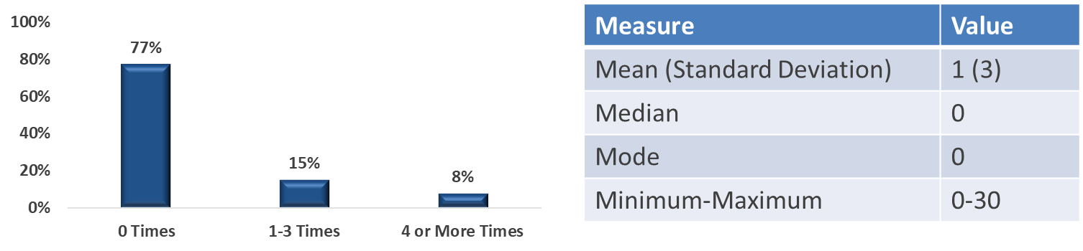

Figure A5.30: How often do you consume any kind of alcohol product, including beer, wine or hard liquor?
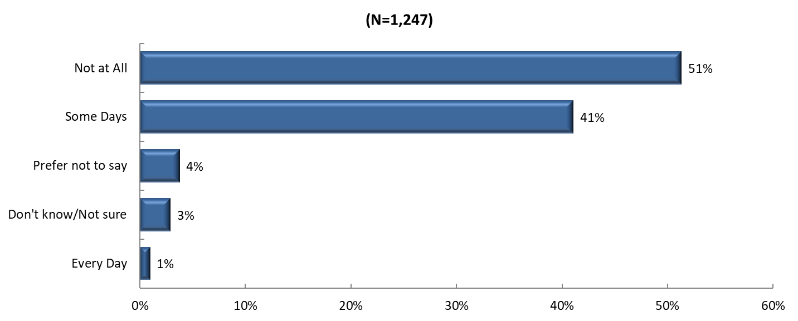
Figure A5.31: In the past year, have you or a member of your household misused any form of prescription drugs (e.g. used without a prescription, used more than prescribed, used more often than prescribed, or used for any reason other than a doctor’s instructions)?
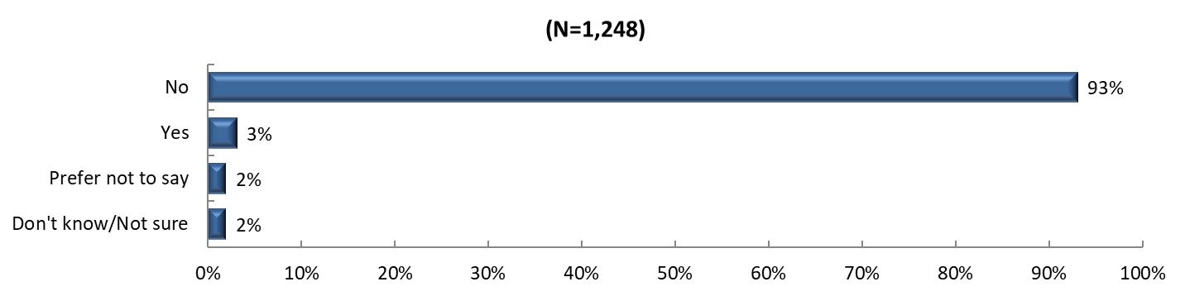
Figure A5.32: To what degree has your life been negatively affected by YOUR OWN or SOMEONE ELSE's substance abuse issues, including alcohol, prescription, and other drugs?
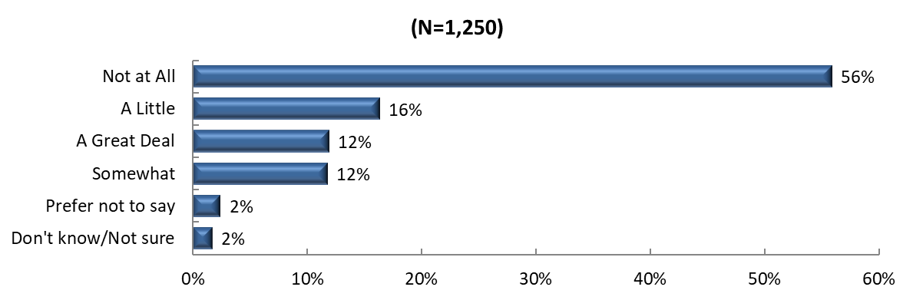

APPENDIX 6 | SUMMARY OF DATA FINDINGS ACROSS SOURCES

Primary and Secondary data findings are summarized in full by the table below.

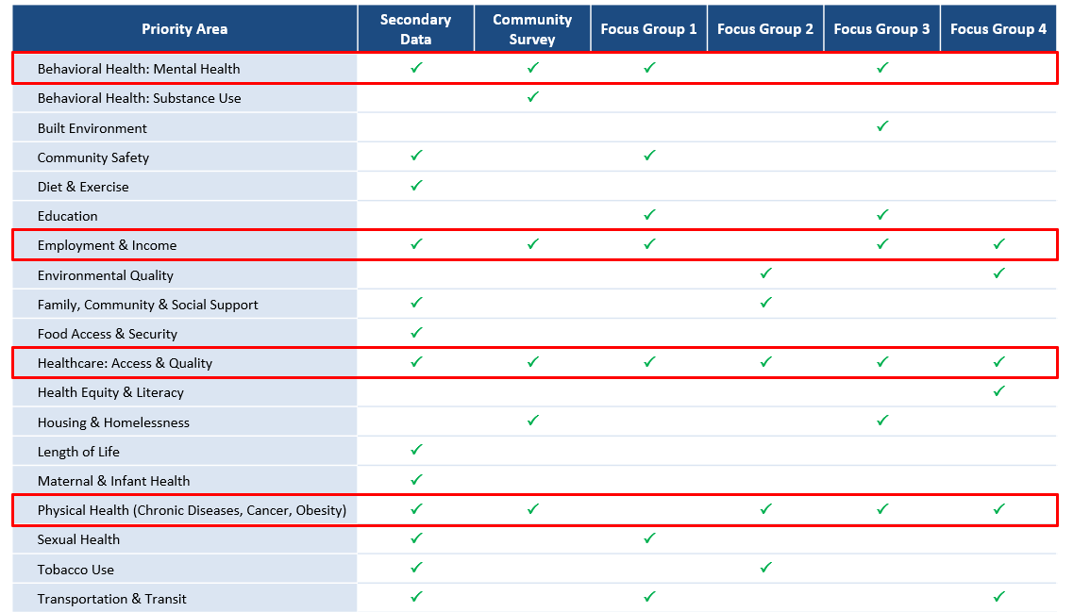

Source: NCLHDA Health Department Self-Assessment Instrument Interpretation Document 2024.
Source: Community Health Needs Assessment for Charitable Hospital Organizations – Section 501®(3) (2023). Internal Revenue Service. Retrieved February 13th, 2024 from https://www.irs.gov/charities-non-profits/community-health-needs-assessment-for-charitable-hospital-organizations-section-501r3.
Source: CDC (2022). Social Determinants of Health at CDC. Accessed March 7th, 2024 via https://www.cdc.gov/about/sdoh/index.html
Source: Esri 2023
Source: U.S. Census Bureau (2022)
Source: American Community Survey (ACS) 2018-2022 5-Year Estimates
Disability status is classified in the ACS according to yes/no responses to questions about six types of disability concepts. For children under 5 years old, hearing and vision difficulty are used to determine disability status. For children between the ages of 5 and 14, disability status is determined from hearing, vision, cognitive, ambulatory, and self-care difficulties. For people aged 15 years and older, they are considered to have a disability if they have difficulty with any one of the six difficulty types.
Source: North Carolina Department of Health and Human Services, Social Service Division
Source: North Carolina Office of State Budget and Management
U.S. Totals combine GED with High School Diploma
Source: Federal Reserve Economic Data (FRED)
Source: Robert Wood Johnson County Health Rankings 2024
CDC/ATSDR Social Vulnerability Index (SVI). Retrieved from https://www.atsdr.cdc.gov/placeandhealth/svi/index.html.
U.S. Environmental Protection Agency (2024). Retrieved from https://www.epa.gov/environmentaljustice
Source: American Medical Association (2022). What is behavioral health? Retrieved September 13th, 2023, from https://www.ama-assn.org/delivering-care/public-health/what-behavioral-health.
Source: CDC. (2024). About mental health. Retrieved October 1, 2024, from: https://www.cdc.gov/mentalhealth/learn/index.htm
Source: National Institute of Mental Health (2023). Mental Illness. Retrieved September 13th, 2023, from https://www.nimh.nih.gov/health/statistics/mental-illness.
Source: CDC. (2024). Mental health. Retrieved October 1, 2024, from https://www.cdc.gov/mentalhealth/learn/index.htm
RHI Hub. (2023). Rural mental health. Retrieved October 1, 2024 from: https://www.ruralhealthinfo.org/topics/mental-health
Source: NAMI (2023). Mental Health in North Carolina. Retrieved October 10, 2024, from https://www.nami.org/wp-content/uploads/2023/07/NorthCarolinaStateFactSheet.pdf
Source: American Psychiatric Association (2024). Addiction and Substance Use Disorders. Retrieved January 16, 2024, from https://www.psychiatry.org/patients-families/addiction-substance-use-disorders.
Source: SAMHSA (2024). Highlights from the 2023 National Survey on Drug Use and Health. Retrieved October 10th, 2024 from https://www.samhsa.gov/data/sites/default/files/reports/rpt42731/2022-nsduh-main-highlights.pdf.
Source: National Center for Drug Abuse Statistics (2023). Drug Abuse Statistics. Retrieved January 8th, 2024, from https://drugabusestatistics.org/.
Source: Cleveland Clinic. (2024). Substance Use Disorder (SUD). Retrieved October 1, 2024, from https://my.clevelandclinic.org/health/diseases/16652-drug-addiction-substance-use-disorder-sud
Source: KFF. (2023). Saunders, H., Rudowitz, R. (2023). Will the availability of Over-The-Counter Narcan increase access? Retrieved October 1, 2024 from https://www.kff.org/policy-watch/will-availability-of-over-the-counter-narcan-increase-access/
Source: NCDHHS. (2022). Overdose epidemic. Retrieved October 3, 2024 from: https://www.ncdhhs.gov/about/department-initiatives/overdose-epidemic#:~:text=Combating%20North%20Carolina's%20Opioid%20Crisis,is%20devastating%20families%20and%20communities.
Source: Panchal, N., Saunders H., Rudowitz, R. and Cox, C. (2023). The Implications of COVID-19 for Mental Health and Substance Use. Kaiser Family Foundation. Retrieved from https://www.kff.org/mental-health/issue-brief/the-implications-of-covid-19-for-mental-health-and-substance-use.
Source: National Institutes of Health office of Research on Women’s Health. (2021). Maternal Morbidity and Mortality: What do we know? How are we addressing it? Retrieved October 4, 2024 from https://orwh.od.nih.gov/sites/orwh/files/docs/ORWH22_MMM_Info_Factsheet_508.pdf
Id. 79
Source: North Carolina Medical Society. (2024). NC Maternal Mortality Report. Retrieved October 3 , 2024 from https://ncmedsoc.org/just-released-nc-maternal-mortality-report/
Source: HRSA. (2022). Infant health. Retrieved October 4, 2024 from https://mchb.hrsa.gov/programs-impact/focus-areas/infant-health
Source: Centers for Disease Control and Prevention. (2023). Taking care of your body. Retrieved October 3, 2024 from: https://www.cdc.gov/howrightnow/taking-care/index.html
Source: U.S. Department of Veterans Affairs. (2023). Healthy living overview. Retrieved October 10th, 2024 from https://www.prevention.va.gov/Healthy_Living/index.asp
Source: CDC (n.d.) Health behaviors in rural America. Retrieved October 3, 2024 from https://www.cdc.gov/rural-health/php/public-health-strategy/public-health-considerations-for-health-behaviors-in-rural-america.html#:~:text=People%20living%20in%20rural%20areas,and%20getting%20regular%20health%20screenings.
Source: Eat Smart Move More North Carolina. (2017). The roles of nutrition and physical activity in Chronic Disease in North Carolina. Retrieved
Zip codes with fewer than five respondents were not displayed for privacy reasons.
The U.S. Census Bureau defines “Hispanic or Latino” as “a person of Cuban, Mexican, Puerto Rican, South or Central American, or other Spanish culture or origin regardless of race.”
Survey results captured here reflect major findings from the Community Health Opinion Survey questions. Red boxes indicate categories identified as high need consistently across data sources.

