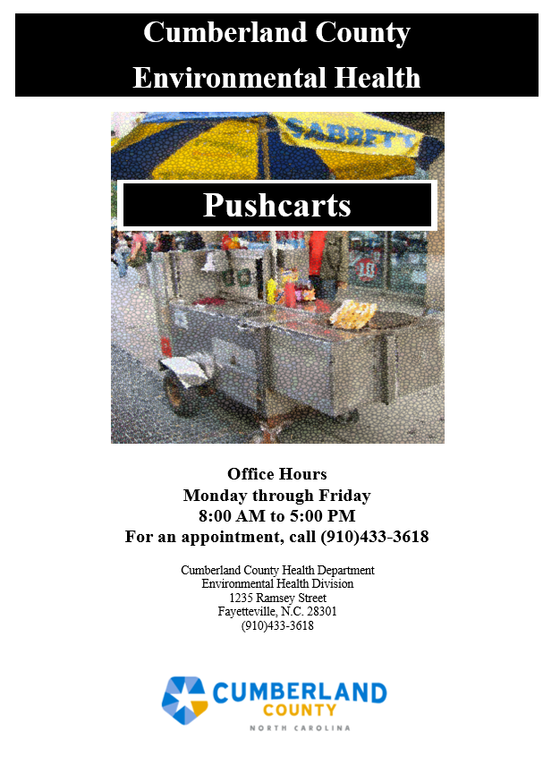

DEPARTMENT OF PUBLIC HEALTH

PUSHCART PLAN REVIEW APPLICATION
Pushcart – A unit designed to be maneuvered by one person. Only hot dogs can be prepared and served on this unit. Pre-packaged items such as canned drinks and bagged chips may be sold off this unit.

Commissary – A food service establishment that services and serves as a base for mobile food units and pushcarts selling potentially hazardous foods (ice cream trucks exempt). The commissary may or may not serve customers at the base location. Every mobile food unit and pushcart is required to operate from an approved commissary and report to the commissary at least once during each operating day. All support and servicing activities must be carried out at the approved commissary. These activities include washing, rinsing, and sanitizing food equipment and utensils, wastewater disposal, cart washing, recharging the potable water tank, food storage, food preparation (i.e., dicing tomatoes, onions, etc.). These servicing activities cannot be done at a private residence. A written agreement from an approved commissary must be provided to this Department prior to permit approval.

Applicant Information:

Name of Pushcart:
Operator Name:
Operator Address:
City: State: Zip Code:
Home Phone: Cell Phone:
Email:

Acknowledgement (Initial beside):
I understand and certify that the information provided within this application is accurate.

-Any deviation or variance from the information contained in this application may void the operation permit for the unit.
-Multiple inspections of the unit prior to permitting may be required.
-If the unit is not in compliance with Rules Governing the Sanitation of Food Service Establishments 15A NCAC 18A .2600, the operation permit will not be issued or may be revoked.
-Approval of these plans and issuance of a permit does not relieve me of the obligation to comply with all other application code, law, or regulation imposed by other jurisdictions.
-A completed operational schedule will be submitted to the Department each month.

Completed Commissary Agreement Form
Pushcart Specification Sheet (manufacturer can provide for specific model) Provide top and side view identifying all components (cooking equipment, bun storage, cooler, sink(s), water pump, potable and wastewater tanks, etc.) (See example attached)
Signed and dated menu (include all food, drinks, and condiments)

A fee of $150 will be assessed after the inspection is completed.

Commissary Information:

The pushcart must be taken to the commissary each day of operation for serving, supplies, and cleaning.

Proposed Commissary:
Commissary Address:
City: State: Zip Code:
Phone Number: Owner/Manager Name:

Operational Location:

Proposed address of operation:
City: State: Zip Code:
Days of Operation:
Hours of Operation:
Are approved toilet facilities available? Yes No

Additional Locations:

Proposed address of operation:
City: State: Zip Code:
Days of Operation:
Hours of Operation:
Are approved toilet facilities available? Yes No

Proposed address of operation:
City: State: Zip Code:
Days of Operation:
Hours of Operation:
Are approved toilet facilities available? Yes No

Pushcart Information:

Manufacturer:
Model:

Hand sink on unit: Yes No
Utensil sink on unit: Yes No

Potable Water Tank and Waste Water Tank (if present)
Water tank storage capacity: gallons
Waste water tank storage capacity: gallons
Water Heater Specification (if applicable):
Umbrella or Canopy? Yes No

Secondary Cover (i.e., plexi glass or stainless steel food shield/sneezeguard) for Cooking Area: Yes No

Initial Date

Is there a grill attached to the pushcart? Yes No
Is there a grill A.N.S.I/NSF approved or equivalent? Yes No
Is the grill protected on top, side(s), and rear Yes No

Printed Name of Pushcart Owner:
Signature of Pushcart Owner:

STATEMENT: I hereby certify that the information provided within this application is accurate and I fully understand that any deviation or variance from this application without prior written permission from Cumberland County Environmental Health will prevent issuance of an operational permit for the unit. I understand that this application will be returned to me if incomplete and will delay processing. I also understand that multiple inspections of the unit may be required and that if the unit is not in compliance with Rules Governing the Sanitation of Food Service Establishments 15A NCAC 18A .2600 and the North Carolina Food Code, an operational permit will not be issued. Approval of these plans and specifications by Cumberland County Environmental Health does not indicate compliance with any other code, law, or regulation that may be required (i.e., federal, state, or local).

Signature: Date:

DEPARTMENT OF PUBLIC HEALTH

Plan Review Application for Mobile Food Units and Pushcarts

MOBILE FOOD UNIT/PUSHCART COMMISSARY AGREEMENT
Pushcarts and mobile food units shall operate in conjunction with a permitted food service establishment and shall report at least daily to the commissary for supplies, cleaning, and servicing.
To be completed by the mobile food unit/pushcart operator:
Check one: □Mobile Food Unit □Pushcart
Name of Mobile Food Unit or Pushcart:
Operator Name:
Mailing Address:
Email: Phone Number:
Signature of owner/operator or designee: Date:

Completed by the permittee or owner of the commissary located in Cumberland County:
As the permittee or operator of the food service establishment noted below, I agree to serve a commissary for the Mobile Food Unit or Pushcart named above. I understand that as a commissary for the Mobile Food Unit or Pushcart, I must allow access for the Mobile Food Unit or Pushcart to return for servicing on a daily basis.

I will do the following (Initial beside each):
Provide a designated protected area for food and utensil storage, including refrigeration/freezer and dry storage area.
Label the designated storage spaces for the unit’s exclusive use. Provide use of the utensil sink to wash utensils used on the unit. Provide use of the kitchen facilities including prep sinks for food preparation.
Provide an exterior wastewater collection system for disposal of wastewater.
Provide a protected connection to the potable water supply.
Provide commissary access for the Mobile Food Unit/Pushcart necessary to maintain rule compliance.

Name of Commissary:
Commissary Address:
Email: Phone Number:
Signature of Commissary Owner or Permittee: Date:

(Office Use Only) Commissary: Approved Disapproved (give reason)

By: Date:
REHS Signature

