CUMBERLAND COUNTY ENVIRONMENTAL HEALTH
Application Guidance for Septic System and Well

THE FOLLOWING INSTRUCTIONS ARE FOR GUIDANCE ONLY AND SHOULD NOT BE SUBMITTED WITH THE APPLICATION

PREPARING YOUR PROPERTY FOR EVALUATION:

• A completed Site Plan (instructions to follow)
• FOR NEW SYSTEM EVALUATIONS:
- Property must be cleared (mowed, bush-hogged, etc.) to permit easy access. This may require
mowing tall weeds in a field or cutting bushes and limbing trees in a wooded area. If wooded
lots are cleared, it is very important not to disturb existing soil or reshape lots in any way.
Clearing with heavy equipment should only be done in dry conditions. Disturbance of soil may
cause sites
to be unsuitable for a septic system or may require a more expensive system. A permit that has
been issued could be revoked due to site disturbance or construction in the area permitted for
the septic system or repair area.
- Property corners must be flagged. If owner/agent cannot find irons, then a licensed surveyor may be hired by the applicant to identify irons.
- Include a completed site plan to include location of septic system and any wells.
• FOR REPAIR EVALUATIONS:
- Please indicate on the application what type of problem you are having (backing up in the house, in the yard, at the tank, etc.).
- Provide a site plan or GIS map indicating the locations of building structure, current septic system(septic tank, distribution box and drain lines-entire length) and any wells.
- Property corners must be easily identifiable. If owner/agent cannot find irons, then a licensed surveyor may be hired by the applicant to identify irons.
- FOR EXPANSION/RELOCATION EVALUATIONS:
- Please indicate on the application the reason for the expansions (bedroom addition, mother-in-law suite, swimming pool, relocation of lines, etc.,)
- If our office has no septic records on file or if the owner has no record of system installation, the septic system (septic tank, distribution box, and drain lines-entire length) will need to be flagged. If the owner cannot locate the system, then a septic contractor may be hired by the applicant to locate and flag the septic system.
- Property corners must be easily identifiable. If the owner/agent cannot find irons, then a licensed surveyor may be hired by the applicant to identify irons.
- Include a completed site plan to include location of septic system and any wells.
- FOR EXISTING SYSTEMS(e.g., OCCUPANCIES OR AUTHORIZATION IN WRITING
- Septic tank(s), and distribution box will need inspecting.

- FOR WELLS
- Include a completed site plan with location of septic system identified (if applicable) and location of any above ground or underground fuel tanks (if applicable).
- Location of septic system will be verified upon visit. If our office has no septic records on file or if the owner has no record of system installation, the septic system (septic tank, distribution box, and drain lines-entire length) will need to be flagged. If the owner cannot locate the system, then a septic contractor may be hired by the applicant to locate and flag the septic system.

EXAMPLE OF A SITE PLAN REQUIRED FOR SUBMITTAL OF A SEPTIC AND WELL APPLICATION:

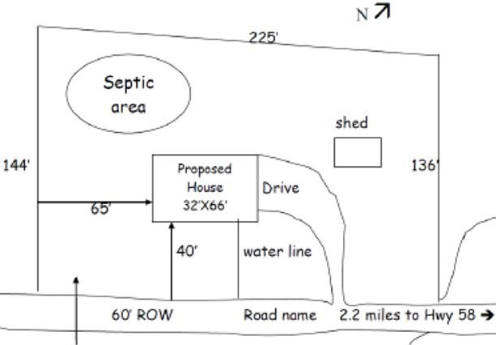

Make sure to indicate the following items on the site plan:
• Property Dimensions
• Proposed location of all structures on the property (garages, workshops, outbuildings, pools, water lines)
• The site you would prefer your septic permit to go
• The preferred location of the driveway
• The proposed well location
• A north arrow or other sufficient directional indicator
• The location of any existing septic tanks within 100 feet of your property line
• The location of any easements or rights of way on the property or any designated wetland

