 |  |  | Residential Deck / Porch Permits
Required Documentation for a Deck/Porch permit |  |  |  |  |  | when An addition permit is required
 | Site Plan/Plot Plan  This document may be hand-drawn, but must adhere to an engineering scale of 1:20, 1:30, 1:40, 1:50, 1:60, etc. It should clearly depict the placement of the home on the lot, as well as its distances from all property lines and from any existing structures on the property.  Environmental Health approval if septic/well on property. For approval of plot plans and possible relevant permits, please contact Environmental Health at 910.433.3660. Approved well and septic permits are to be obtained from the Environmental Health Department, located in the basement of 130 Gillespie Street, Fayetteville NC 28301. Historic Courthouse. |  |  |  |  |  |  | If attaching to a house or extending a roofline  Then an addition permit would be required… NOT a  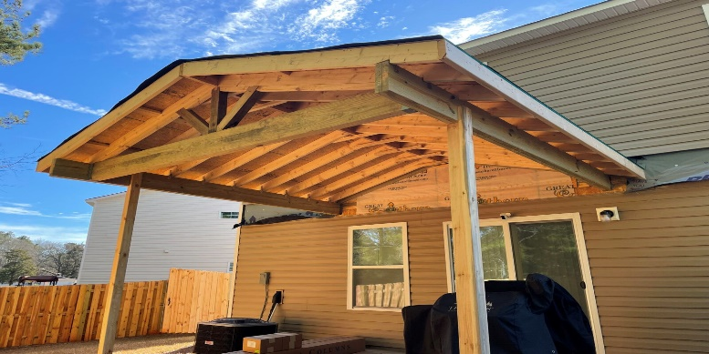  deck/porch permit. |  |  | Department of Environmental Quality  (If applicable)  If a parcel is 1 acre or larger, please see the attached document (memorandum by county insert) for what we can accept for permitting purposes: https://www.deq.nc.gov/about/divisions/energy-mineral-and-land-resources/erosion-and-sediment-control  If a parcel is smaller than 1 acre, no DEQ approval is necessary prior to permit issuance.
 | Contacts/Contractors/Trade Contractors  Please provide the following information for all contacts to include building contractors and trades. Required details include the company name (if applicable), contact name, contact number. If homeowner is to act as contractor, please see requirements below.  Owner Affidavit (if applicable) The affidavit must be  completed in full and notarized. Must reside in the home  as primary residence for one year after Certificate of  Occupancy is issued. See the link to the Owner Exemption  Affidavit under G.S. 87-14.  Building Plans /Engineered Sealed Truss plans  Full set of building plans/ blueprints/ floorplans to  include all trades (if applicable). Scope of work / detailed plans on how being built  if stick built to include foundation plans.  Liens NC  Is a lien agent required? Yes, if job valuation is $40,000.00 or more, and must be posted on the job site (unless exempt) you can obtain a lien by visiting www.LiensNc.com or contacting 1-888-690-7384 for more information. |  |  |  |  |  | 