 |  | Residential Fence Permit
Required Documentation for a fence permit |  |  |  |  | fences that do not require a permit
 | Site Plan/Plot Plan  This document may be hand-drawn but must adhere to an engineering scale of 1:20, 1:30, 1:40, 1:50, 1:60, etc. It should clearly depict the placement of the home on the lot, as well as its distances from all property lines and from any existing structures on the property. |  |  |  |  |  |    |  |  |  |  | Department of Environmental Quality  (If applicable)  If a parcel is 1 acre or larger, please see the attached document (memorandum by county insert) for what we can accept for permitting purposes: https://www.deq.nc.gov/about/divisions/energy-mineral-and-land-resources/erosion-and-sediment-control  If a parcel is smaller than 1 acre, no DEQ approval is necessary prior to permit issuance.
 | Contacts/Contractors/Trade Contractors  Please provide the following information for all contacts to include building contractors and trades. Required details include the company name (if applicable), contact name, contact number. If homeowner is to act as contractor, please see requirements below |  |  |  |  |  |  | 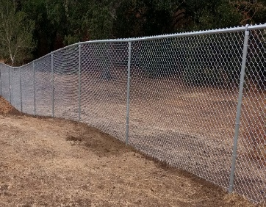    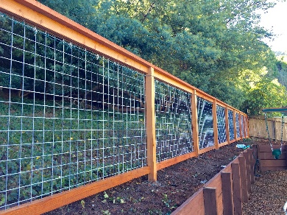
 | Owner Affidavit  (If no General Contractor retained and Owner is building)  The Owner Affidavit must be completed in full and be  notarized. The owner must own the home and reside in the home for 1 year after the Certificate of Occupancy is issued.  See the link to owner exemption affidavit under G.S. 87-14.  See Samples of fences that require permits below |  |  |  |  |  |  | 
 | 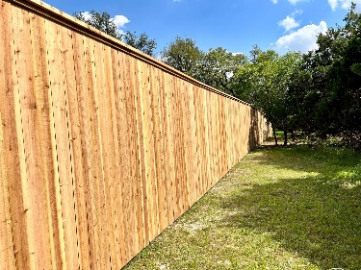  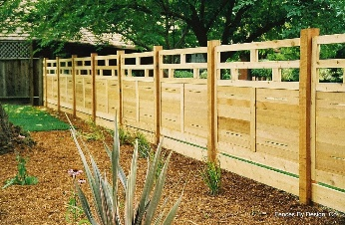 |  |  |  | If any questions please reach out to  Cumberland County Planning and inspections office at  910-321-6636
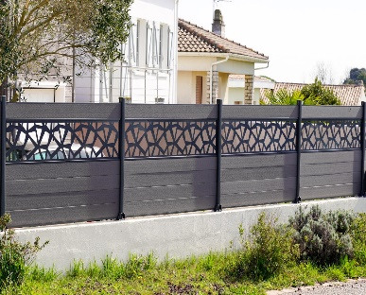
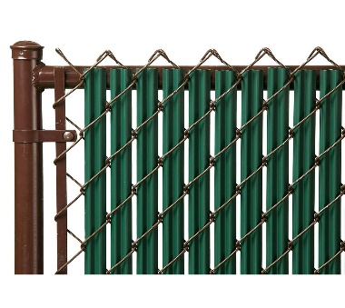
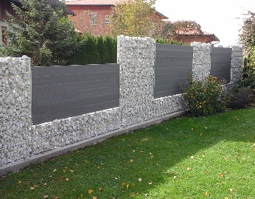
 | 