 |  | Residential Solar Panels Permit
Required Documentation for Roof mount residential solar panels |  |  |  | REQUIRED DOCUMENTATION FOR Ground MOUNT RESIDENTIAL SOLAR PANELS
 | 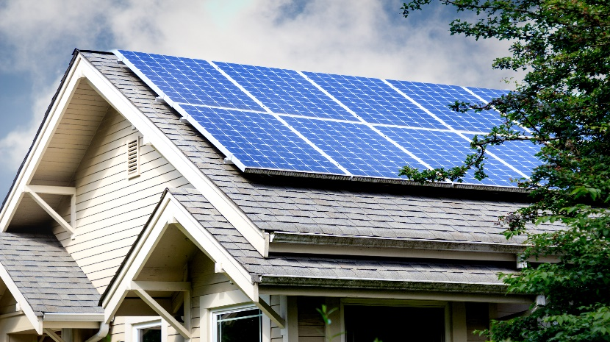  Liens NC  Is a lien agent required? Yes, if job valuation is  $40,000.00 or more, and must be posted on the job site (unless exempt) you can obtain a lien by visiting  www.LiensNc.com or contacting 1-888-690-7384  for more information.  Contacts/Contractors/Trade Contractors  Please provide the following information for all contacts to include building contractors and trades. Required details include the company name (if applicable), contact name, contact number. If homeowner is to act as contractor, please see requirements below.  Owner Affidavit (if applicable) The affidavit must be  completed in full and notarized. Must reside in the home  as primary residence for one year after Certificate of  Occupancy is issued. See the link to the Owner Exemption  Affidavit under G.S. 87-14.  Building Plans /Engineered Sealed Plans  Full set of building plans to include all trades (if applicable).  - Engineered sealed plans with sealed letter  - Scope of work / detailed plans on how being built  if stick built to include foundation plans |  |  |  |   Site Plan/Plot Plan  This document should clearly depict the placement of solar  panels on the home or on the ground. If ground mount: must  provide a to engineer scale site plan showing the distance from  all property lines and from any existing structures on the property.  Environmental Health approval if Septic/Well  (ONLY IF GROUND MOUNT & SEPTIC OR WELL ON PROPERTY)  For approval of plot plans and possible relevant  permits, please contact Environmental Health at 910.433.3660.  Approved well and septic permits are to be obtained from the  Environmental Health Department, located in the basement of  130 Gillespie Street, Fayetteville NC 28301. Historic Courthouse.  Liens NC  Is a lien agent required? Yes, if job valuation is  $40,000.00 or more, and must be posted on the job site  (unless exempt) you can obtain a lien by visiting  www.LiensNc.com or contacting 1-888-690-7384  for more information.  Contacts/Contractors/Trade Contractors  Please provide the following information for all contacts to  include building contractors and trades. Required details  include the company name (if applicable), contact name,  contact number. If homeowner is to act as contractor,  please see requirements below.  Building Plans /Engineered Sealed Plans  Full set of building plans to include all trades (if applicable).  - Engineered sealed plans with sealed letter  - Scope of work / detailed plans on how being built  if stick built to include foundation plans |  | Department of Environmental Quality  (If applicable)  If a parcel is 1 acre or larger, please see the attached document (memorandum by county insert) for what we can accept for permitting purposes: https://www.deq.nc.gov/about/divisions/energy-mineral-and-land-resources/erosion-and-sediment-control  If a parcel is smaller than 1 acre, no DEQ approval is necessary prior to permit issuance.

